Trustworthy Software

By

Aketa Parikh

A THESIS

Submitted to the faculty of Stevens Institute of Technology
In partial fulfillment of the requirement of the degree of

MASTER OF SCIENCE (Computer Science)

--------------------------------------
Student Name, Candidate

ADVISORY COMMITTEE

--------------------------------------
Advisor Date

--------------------------------------
Reader, Date

--------------------------------------
Reader, Date

Stevens Institute of Technology
Castle Point on Hudson
Hoboken, NJ 07030
2004
Contents
1 Introduction 7
1.1 Introduction 7
1.2 Characteristics of Trustworthiness 13
1.3 Problem Statement 14
1.4 Organization of the thesis 15
2 Related Works 16
2.1 Reliability 16
2.2 Safety 28
2.3 Security 31
3 Software without Trustworthy Frame 37
3.1 Reliability: 38
3.1.1 Software Development Process 38
3.1.1.1 Requirements capture: 38
3.1.1.2 Design: 38
3.1.1.3 Coding: 39
3.1.1.4 Integration: 39
3.1.2 Reasons for Systems Failure: 40
3.1.2.1 Difficulty 40
3.1.2.2 Complexity 41
3.1.2.3 The Chaotic Nature of Software Development 42
3.1.2.4 Coding: 43
3.1.2.5 Assurance: 43
3.1.2.6 Integration: 44
3.2 Safety: 44
3.3 Security 46
3.3.1 Protocol weaknesses 46
3.3.2 Software Engineering Problems 47
3.3.3 Local and Remote Buffer Overflows 47
3.3.4 Unstable code 49
3.3.5 Race Conditions and Mutual Exclusion 50
3.3.6 Problems of Trust Relations and Models 50
3.3.7 Hidden backdoors and alikes 51
4 Software with Trustworthy Frame 52
4.1 Software Reliability 52
4.1.1 Classification of software faults 52
4.1.1.1 Heisenbugs (Non-Permanent) 53
4.1.1.2 Bohrbugs (Permanent) faults 54
4.1.2 Approaches in making Software Trustworthy 56
4.1.2.1 Fault avoidance 57
4.1.2.2 Fault Removal 59
4.1.2.3 Fault tolerance: 63
4.1.2.3.1 Single version fault-tolerant: 65
4.1.2.3.1.1 Fault detection: 65
4.1.2.3.1.2 Damage assessment: 66
4.1.2.3.1.3 Fault Recovery 66
4.1.2.3.1.4 Fault repair: 67
4.1.2.3.1.5 Defensive programming and Exception Managment: 67
4.1.2.3.1.6 Environment diversity 68
4.1.2.3.2 Multiple version fault-tolerant: 70
4.1.2.3.2.1 N-version programming: 72
4.1.2.3.2.2 Recovery block: 73
4.1.2.3.2.3 N-self checking programming: 76
4.2 Software Safety 77
4.2.1 Hazard and risk analysis 78
4.2.1.1 Fault-tree analysis (FTA): 79
4.2.1.2 Failure Mode and Effect Analysis (FMEA): 80
4.2.2 Safety Requirements Analysis 83
4.2.3 Design and Code Analysis 84
4.2.4 Safety Validation 86
4.2.4.1 Static analysis: 87
4.2.4.2 Dynamic Analysis: 87
4.3 Software Security 88
4.3.1 Security assurance Vulnerability avoidance: 90
4.3.1.1 Defending against buffer-overflows: 90
4.3.1.2 Defending against race conditions and weak protocol 92
4.3.1.3 Secure Programming Practices 92
4.3.1.4 Use Encrytion 95
4.3.2 Attack detection and elimination: 99
4.3.3 Exposure limitation: 100
5 Experiment on Student Project 102
5.1 Tools Used In the Experiments 102
5.1.1 eValid 102
5.1.2 Rats 103
5.1.3 BlocksIM 6 103
5.2 Project Overview 104
5.2.1 Citigroup’s Low Cost Development Project 104
5.2.2 ACS 105
5.2.3 Gameboy 106
5.3 Experiment one: Citigroup Project 108
5.3.1 Reliability Analysis 108
5.3.2 Security Analysis 122
5.3.3 Safety Analysis 140
5.4 Experiment two: ACS Project 146
5.4.1 Reliability Analysis 146
5.4.2 Security Analysis 159
5.4.3 Safety Analysis 169
5.5 Experiment two: Gameboy Project 174
5.5.1 Reliability Analysis 174
5.5.2 Security Analysis 181
5.5.3 Safety Analysis 182
Conclusion and Future work 183
References 1

Trustworthy Software

Aketa Parikh

(ABSTRACT)

The demand of Secure, Reliable and Safe (SRS) software system is increasing everyday and in order to put our trust in any software application, it’s time to build Trustworthy software. In this study we characterize Trustworthy system and examine the effects of Security, Reliability and Safety in software application. Based on studies with three student projects, we show what are the causes of faults which lead to failures, how those failures affect system and countermeasure to remove those faults. Also we show that how system is vulnerable to possible attacks with current implemented security features and the available techniques to countermeasure those vulnerabilities. We also characterize the effect of failures on human life or system damage. This study finds that to make system more reliable and safe, design time faults should be minimized by using appropriate software engineering approaches and systems should be fault tolerant such that it should able to withstand a considerable degree of error without crashing. Also systems should be designed and implemented with inbuilt security features in a way that it will not open any holes for attack and user’s data (stored as well as passing through network) should secure and consistent all the time.

Acknowledgements
I thank Professor Larry Bernstein, my advisor, for his help and support during my thesis and throughout my graduate program in the Department of Computer Science at Stevens Institute of Technology, Hoboken, NJ. I also thank the member of my advisory committee Professor Chandra M. R. Kintala and Professor David Klappholz for their comments and suggestions.
Finally, many thanks go to Arpan Parikh, my husband for his understanding and support during the course of my graduate studies.

Chapter 1

Introduction

Introduction
Software become more pervasive as now software drives not just healthcare machinery, our cars and our household appliances but it runs elevators and amusement park rides as well. It controls just about every manufacturing plant, utility and business office in the country. All critical infrastructures use software heavily and failures in these infrastructures become severe. Even as the use of internet is increasing, lack of security leads to company’s data being destroyed, customers identity being stolen, trading lines brought down, home page being defaced or important data be in the hand of unauthorized person. The threat of physical harm and crippled lives is escalating, its reliability and security becomes an issue for business executives, product managers, factory floor supervisors and anyone who uses software in the workplace. Also if we look at out past, we have lots of examples of faulty systems and damages because of these faulty systems. Following are some recent major computer system failures caused by software bugs, bring up by softwareqatest.com [1].
- “According to Microsoft, because of bug in timing algorithm, Windows 95 based computer may stop responding after 49.7 days of continues operation.” (Reliability)
- “Oracle, The database giant, has issued a security alert and downloadable patch release in August 2004. Oracle officials said network access without a valid user account can be used to exploit some of the vulnerabilities to hijack services, manipulate data, expose sensitive system information and perform Denial of Service attacks on variety of Oracle’s Database, Application server, Collaboration Suite and Enterprise Manager.” (Security)
- “A major U.S. retailer was reportedly hit with a large government fine in October of 2003 due to web site errors that enabled customers to view one another’s online orders.” (Reliability + Security)
- “In January of 2001 newspapers reported that a major European railroad was hit by the aftereffects of the Y2K bug. The company found that many of their newer trains would not run due to their inability to recognize the date '31/12/2000'.”(Safety + reliability)
- “In October of 1999 the $125 million NASA Mars Climate Orbiter spacecraft was believed to be lost in space due to a simple data conversion error. It was determined that spacecraft software used certain data in English units that should have been in metric units.” (Safety + reliability)
- “The computer system of a major online U.S. stock trading service failed during trading hours several times over a period of days in February of 1999 according to nationwide news reports. The problem was reportedly due to bugs in a software upgrade intended to speed online trade confirmations.” (Reliability)
- “In November of 1997 the stock of a major health industry company dropped 60% due to reports of failures in computer billing systems, problems with a large database conversion, and inadequate software testing. It was reported that more than $100,000,000 in receivables had to be written off and that multi-million dollar fines were levied on the company by government agencies.” (Reliability)
- “On June 4 1996 the first flight of the European Space Agency's new Ariane 5 rocket failed shortly after launching, resulting in an estimated uninsured loss of a half billion dollars. It was reportedly due to the lack of exception handling of a floating-point error in a conversion from a 64-bit integer to a 16-bit signed integer.” (Reliability)
- “Software bugs caused the bank accounts of 823 customers of a major U.S. bank to be credited with $924,844,208.32 each in May of 1996, according to newspaper reports. A bank spokesman said the programming errors were corrected and all funds were recovered.” (Reliability)
- “Software bugs in a Soviet early-warning monitoring system nearly brought on nuclear war in 1983, according to news reports in early 1999. The software was supposed to filter out false missile detections caused by Soviet satellites picking up sunlight reflections off cloud-tops, but failed to do so.” (Reliability + safety)
- “According to R. Needleman, the system crash of AT&T's long distance telephone network happened on January 15th, 1990 [2]. Its cause was because one of AT&T's 3ESS toll switching systems in New York City had an actual, legitimate, minor problem (a missing break in a C switch statement) and went into fault recovery routines. This was the kickoff for a series of fallouts, and like in a chain reaction one machine after the other went down leading to an immense collapse of the US telephone system. The shut down lasted for 9 hours, leading to some 74 million uncompleted calls, which resulted in the most severe breakdown in the US telephone network ever [3].” (Reliability)
As we have seen above, computer programs often don't work as they should, and too much buggy software reaches the end user [4]. An important area of computer application is the governmental and commercial domain of everyday computing. Errors in these systems often affect many people, but fortunately, their consequences are not lethal. We are using software from around decades and as seen in above incidents the failures are because of lack of requirements, bad system design, malicious code etc... In contrast to the governmental and commercial mishaps reported above, increased media attention is focused on reports about the scene of hackers and phreaks [5]. From past few years, the use of Internet and high-speed connection is blooming and millions of new computing devices come together to create global computing network. According to Microsoft [6], “a virus or worm can circle the world in a matter of minutes and virus like blaster can hijack individual computers, turning innocent users into unknowing and innocent propagators.”
“An increasing number of customers for software intensive systems want to know ‘how well’ their systems in development are going to behave in operation.” – John Gaffney [7]. These increasing number of customers’ demands to run all system infrastructures smoothly, securely and with highest risk avoidance, all IT Professionals need to innovate and develop new solutions. That’s why Professor like Larry Bernstein of Stevens Institute of Technology are urging all software practitioners to read ‘Code of Ethics and Professional Practice’ and beating the drum to make software Trustworthiness the next major focus for academic and industry – for national security reason, as well as to ensure that the US software industry maintains its leadership. To develop trustworthy systems, it must be reliable, secure and safe. This is not simply a turn-the-crank process, and requires great ingenuity, experience, discipline, and above all management understanding. Furthermore, vision is needed to avoid excessive costs and delays in development and serious risks in operation; to manage development efforts; to inspire relevant long-term research; and above all, to enable the creation of effective long-term strategies and to recognize that short-term strategies are often counterproductive [8]. All the software should be built as an engineering product by applying all the concept of software engineering. We will discuss a combination of approaches that can address many of these challenges. Trustworthiness of software by doing experiment on couple of software project and want to derive one frame work with all the important concept that any trustworthy software should satisfy which are being ignored in today’s industry. Untrustworthy systems may be rejected by their users. Untrustworthy systems may cause loss of valuable information. It may be more cost effective to accept untrustworthy systems and pay for failure costs. A survey by the Standish Group, which examined 175,000 software development projects in 1995 [19]. The results of this research revealed, that 31% of these projects were cancelled before completion with a financial loss of US$81 billion. Of the remaining projects, more than 52% suffer significant cost overruns, with an average of 189% more than estimated, resulting in a US$59 billion loss. In 2000 study shows that cost overruns have gone down to 45%. 2000 surveys result shows that 78,000 U.S. projects were successful however; 137,000 projects were late and/or over budget, while another 65,000 failed outright.
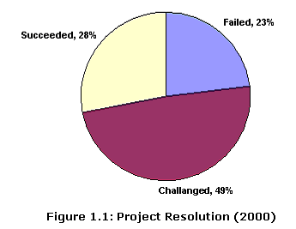
Many generic classes of vulnerabilities and faults in software seem to persist. The reason most of these projects failed for lack of skilled project management and executive reports [19]. It is time to change that unfortunate situation, remember the code of Ethics and Professional Practice, apply engineering approaches and honor the principles.

Characteristics of Trustworthiness
Trustworthiness has following major characteristics:
Reliability: Trustworthy system should perform a required function under stated conditions for a stated period of time and handle abnormal situations (robustness). Put more simply, reliability is the absence of crashes or hangs. Measure of reliability is the probability of failure-free system operation over a specified time in a given environment for a given purpose. A reliable system should have all of these characteristics.
Availability. A reliable system provides promised levels of service. Availability means that the computer system`s hardware and software keeps working efficiently and that the system is able to recover quickly and completely if a disaster occurs. The probability that a system, at a point in time, will be operational and able to deliver the requested services. Availability, A, is defined as: A = MTBF/(MTBF+MTTR)
Where MTBF = Mean Time Between Failure and MTTR = Mean Time To Repair
Security: Trustworthy system should be prevent or protect against access to information by unauthorized recipients, and intentional or unauthorized destruction or alteration of the computer information. Also Trustworthy system should not allow behavior that violates the confidentiality, integrity or availability of the application.
Reputation. Secure systems must develop and maintain a reputation for trust. What’s the use of being secure in fact when nobody believes you are?
Survivability The ability of a system to continue to deliver its services to users in the face of deliberate or accidental attack.
Secrecy and confidentiality: A secure computer system must not allow information to be handled by anyone who is unauthorized to access it. This is called as secrecy. Confidentiality or Privacy ensures the protection of private information such as payroll data and competitive strategy documents.
Accuracy, integrity and authenticity : A secure computer system must maintain the continuing integrity of the information stored in it. Accuracy or integrity means that the system must not corrupt the information or allow any unauthorized malicious or accidental changes to it.
Safety: Trustworthy system should not fail in such a way as to compromise the safety of people or property and that system failure can be caused or fail to be prevented by software.

Problem Statement
A majority of works on characterizing Trustworthy system was devoted to characterize Security, Reliability and Safety (SRS). These studies are very important to understand concept of reliability, security and safety, their importance in any application and how to build trustworthy application with all these qualities from the beginning.

Organization of the thesis
The remainder of this thesis is divided into six chapters. Chapter 2 is a literature review. Chapter 3 describes the experimental design. Chapter 4 presents Software without Trustworthy frame. Chapter 5 discusses Software with trustworthy frame. Chapter 6 concludes the thesis.
Chapter 2

Related Works
Trustworthiness Characterizations
Many studies have characterized various aspects of the Trustworthy System. Main components of Trustworthy systems are Reliability, Security and Safety. We summarize some of the key findings for each of these aspects.

Reliability
Blanchard says “reliability is the probability that a system or product will perform in a satisfactory manner for a given period of time when used under specified operating conditions." The standard definition of reliability is, "the probability that an item will perform a required function without failure under stated conditions for a stated period of time."
The Reliability of the whole system mainly depends upon hardware reliability, software reliability and operator reliability.
• Hardware reliability: Hardware reliability is defined as the probability of a hardware component failing and the time it take to repair that component. Hardware components fail mainly because of physical faults or hardware design faults. It is possible to keep hardware design failures low because hardware is generally less complex logically than software [12].
Bathtub Curves for hardware reliability
Over time, hardware exhibits the failure characteristics shown in Figure 2.2, known as the bathtub curve. Period I, II and III stands for early-life, Useful life and End-of-life.
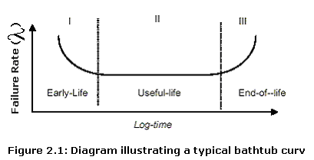
The bathtub curve shows three distinct failure regions.
- The early life or infant mortality region where the failure rate starts out high near time zero and decreases.
- The useful life region where the failures rate is characterized as being a constant represented by the flat portion of the curve.
- The wear out region and is that part of the bathtub curve where the failure rate increases.
• Software reliability: Software reliability is defined as the ability of a system or component to perform its required functions under stated conditions for a specified period of time [10]. Software failures are different from hardware failures in that software does not wear out. It can continue in operation even after an incorrect result has been produced. Software reliability increases during testing and operation since software faults can be detected and removed when software failure occurs. But software is approaching obsolescence; there is no motivation for any upgrades or changes to the software or when they no longer run on the latest operating system released by a vendor that is currently adopted and supported by Information Technology (IT). Also as per Jiantao Pan “software will experience a drastic increase in failure rate each time feature upgrade is made.”[46] Because For feature upgrades, the complexity of software is likely to be increased, since the functionality of software is enhanced. The failure rate levels off gradually, partly because of the defects found and fixed after the upgrades.

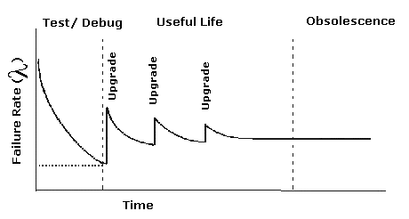
Figure 2.2 Bathtub Curves for software reliability
• Operator reliability: Operator reliability is defined as probability Operator will not make an error. For example Context-sensitive commands i.e. issuing the right command at the wrong time often the result of operator error. Failure because of operator is mainly because over reliance on the software system by Operator- The operators expect their software system to work in all conditions. Another reason is inadequate training given to the operators - The people who have to use the software are not taught properly how to use the software system or they are expected to learn on their own.
• Software Faults: Software fault is uncovered when either a failure of the program occurs, or an internal error (e.g., an incorrect state) is detected within the program. The cause of the failure or the internal error is said to be a fault. It is also referred as a “bug.” In most cases the fault can be identified and removed; in other cases it remains a hypothesis that cannot be adequately verified (e.g., timing faults in distributed systems). For example programmers make mistakes and mistakes result in faults. Faults can cause failures.
• Software Failures: Software failure occurs when the user perceives that a software program ceases to deliver the expected service. Failures are observed as errors. A software failure is an incorrect result due to errors in its specification, design or implementation or unexpected software behavior perceived by the user at the boundary of the software system.
• Software Errors: Errors occur when some part of the computer software produces an undesired state. Examples include software produce undesirable result by the activation of existing software faults, and incorrect computer status due to an unexpected external interference.
“Debra Herrmann’s view for Software Reliability – a measure of confidence that the software produces accurate and consistent results that are repeatable under low, normal and peak loads and results are consistent in the intended operational environment” – Prof. Linda Laird [9]
In an attempt to unify hardware and software for overall system reliability, hardware reliability focused on physical phenomena because failure resulting from these factors is much more likely to occur than design-related failures. As John J. Marciniak said [12] “It was possible to keep hardware design failure low because hardware was generally less complex than software.” Software faults are design faults that are harder to visualize, classify, detect, and correct. As a result, software reliability is a much more difficult measure to obtain and analyze than hardware reliability. This makes software reliability a challenging problem that requires an employment of several methods to attack. To get better understanding of software reliability, let’s see theory behind software reliability.
Theory of Software Reliability
To build reliable system and to analyze the reliability of a system, let’s first understand the basic elements required to incorporate reliability into a system design.
Reliability is the probability, assuming the system was operating at time zero, that it continues to operate until time t=Tu and after that it enters into unreliable state and at t = Tf it fails. Here Tf is a random variable and represents the time to failure. At t = 0, system is in reliable state and N(0) identical units are in operation. At t = Tu, system enters into unreliable state but still operating and N(t) units are still operating. And at t = Tf system fails.
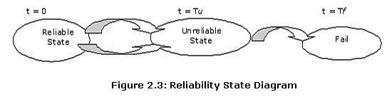
Because the failure time of a software system is a random variable, this variable has an associated probability density function f(t) and cumulative distribution function F(t) is the probability that the system will fail by time t i.e. it has not failed from 0 to t.
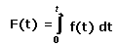
The reliability function R(t) is the probability the software has not failed by time t i.e. the reliability function R(t), of a system at time t is the cumulative probability that the system has not failed from 0 to t. This can be represented as:
Lets say the conditional probability that software will fail in an interval (t, t+∆t), given that it has not failed before time t, is ג_{T}(t). If T is the time at which failure occurs, then
ג_{T}(t) ∆t = P(t < T < T+∆t | T >t)
Dividing both sides by ∆t and assumes ∆t approaches zero, we have
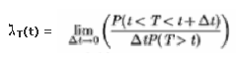
ג_{T}(t) = f_{T}(t) / (1 - F _{T}(t))
ג_{T}(t) = f_{T}(t) / R _{T}(t)
From the above function we see that the failure rate function is simply the conditional probability density function for the failure of the system given no failure have occurred up to time t. Now if we take derivation at both the side of the above equation, then we have
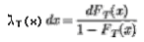
The probability of failing in any given time interval is found by integrating the failure density over the time interval as shown in below equation
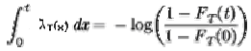
And so,
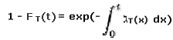
The above equation we can write as follow also,
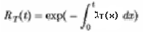
R(t) =e ^{–גt} where ג is the instantaneous failure rate.
Suppose there are N functions that run during the time period T. Let λi be the execution-time failure rate for the i-th function. Let μ (T) be the expected number of failures during that period. The expected number of failures contributed by the i-th function is λiuiT. Thus
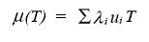
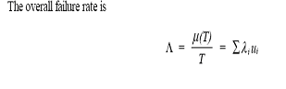
The sum Σλiui is seen to be the sum of the functions’ system-operating-time failure rates.
The Series-connected System
Consider a system such that any single component failure causes the whole system to fail. In other words, all modules have to function correctly for the result to be correct. This type of system is referred to as a series-connected system (Figure 2.4)
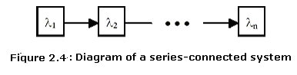
Now suppose that n units have been put into service. The probability P of success of the whole is the probability of success of each unit (assuming that they are independent units). The solution for the reliability of an aggregate of series functions 1... N is calculated by first determining the average failure rate
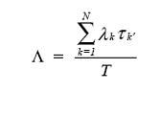
where λk is the failure rate of the i-th function and τk' is the amount of time function k is active during period [0,T].
Sequentially active software model
In this situation, software functions 1 through N are active one after the other. The time tk is the point at which function k finishes and function (k+1) is activated.
The mission time T will lie between the times ti and ti+1. The average failure rate is

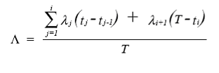
Sometimes the functions are not active consecutively; a period during which no program is active can be represented by a pseudo-function whose failure rate is zero. If a function is active intermittently, that is, for several piece-wise continuous periods, then a pseudo-function can be created for each such period. All pseudo-functions created for a particular function will have the same failure rate as that function.
The Parallel-connected System
Consider a system such at least one module is necessary to assure functionality of entire system (linear system). This type of system is referred to as a parallel-connected system ( Figure 2.5)
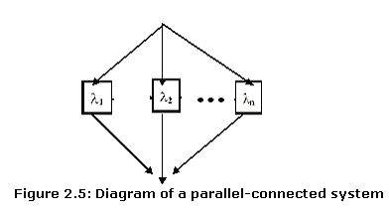
Now suppose that n units have been put into service. The probability of failure is the probability unit₁, unit₂…unit_{n}, all are failing.
Probability of Unit₁ having a failure = 1 – R (Unit₁ , t )
So, R(t) = 1 - ∏ (1 – Ri (t))
So, if the system has components where only one out of many must work for the system to be successful, the reliability is 1 – Prob (all the components fail at the same time). Therefore, it is easier to have high system reliability.
To illustrate the concepts further, plots for f(t), F(t), and R(t) are shown below for the case where h(t) = λ = 0.05 in Figures 2.6 and 2.7.
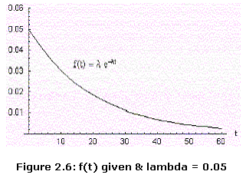
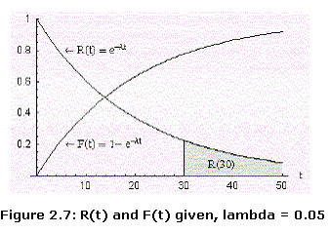
(Mean time between failures) MTBF
MTBF represents the average or mean lifetime of a unit. Finding the expected value of the failure density given by Equation yields the desired MTBF:
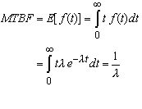
Consider now the series-connected system with n elements. Defining λ = (λ₁+λ₂+...λ_{n}) and The total failure rate is the sum of the failure rates of the individual units. The MTBF is then the inverse of the total failure rate, as shown in below Equation:
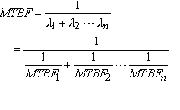
The composite MTBF for the series connection with n identical units is therefore:
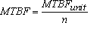
MTBF is an important system characteristic which can help to quantify the suitability of a system for a potential application.

Safety
Safety is a property of a system that reflects the system’s ability to operate, normally or abnormally, without danger of causing human injury or death and without damage to the system’s environment. It is increasingly important to consider software safety as more and more devices incorporate software-based control systems. Safety requirements are exclusive requirements i.e. they exclude undesirable situations rather than specify required system services.
“Debra Herrmann’s view for Software Safety – features and procedures that ensure a product performs predictably under normal and abnormal conditions, thereby preventing accident injury or death. Features and procedures are both needed.” – Prof. Linda Laird [9].
Features –such as range checking on inputs, displays which monitor operational conditions to make sure, they are within specified limits and issue a warning/alarm if not
Procedures – such as ensuring the system is used, in an operational environment for which it was intended, for a task for which it was intend
The safety attribute only applies to a sub-set of critical systems called critical system. Critical systems are the systems controlled or monitored by software and failure of such software could compromise the safety of people (safety critical system) or property (business critical) or result in mission failure (mission critical).
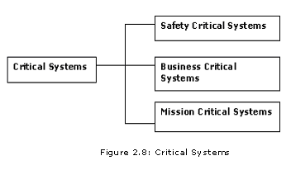
Safety Critical Systems: A system whose failure may result in the loss of human life, injury or major environmental damage. Examples of Safety Critical Systems are Communication systems such as telephone switching systems, aircraft radio systems, Ambulance system etc. If a telephone system fails, it may be impossible to report an accident to the emergency services.
Business Critical Systems: A system whose failure may result in the failure of the business that is using that system. Examples of Business Critical Systems are Financial systems such as foreign exchange transaction systems, account management systems.
The consequences of such system failure (lack of information, incorrect information) may mean that the organization as a whole cannot function properly
Mission-critical systems: A system whose failure may result in the consequent failure of a goal-directed activity. Example of Mission Critical Systems are Embedded control systems for process plants, medical devices, Command and control systems such as air-traffic control systems, disaster management systems.

An obvious example of a mission critical system is an aircraft flies by wire control system, where the pilot inputs commands to the control computer using a joystick, and the computer manipulate the actual aircraft controls. The lives of hundreds of passengers are totally dependent upon the continued correct operation of such a system. In critical system, software failures can cause human injury or in some cases they even killed people. As Lee described in his book [26], massive Therac-25 radiation therapy machine was hit by software errors in its sophisticated control systems and claimed several patients' lives in 1985 and 1986. Software may also be involved in providing humans with information, such as information, which a doctor uses to decide on medication. Both types of system can impact the safety of the patient.
As Sommerville described in his book [34], the cost of failure in a critical system is likely to exceed the cost of the system itself because of costs for investigating the cause of the problem, repairing the system, loss of revenue while the system is out of service, compensation costs for people/things damaged by the failure, legal costs associated with compensation claims, re-design and change costs for other systems which may be vulnerable to the same type of fail.

Security
Software security is the action of software (either a single piece or the collection of software on a computer) to
- Prevent outsider from reading or manipulating the content or sequence of messages
- Ensuring integrity of data passed through network and access to subscribed services.
- Saving data stored in computer correctly and safely, so that data cannot be read or compromised by any individuals without authorization.
In sort, computer security refers to protect computer and everything related with it. Usually for one computer’s security, authentication mechanism to perform login and managing resource access based on authentication is widely used and is enough only when it is not connected with any network. Security defects are errors which allow behavior that violates the confidentiality, integrity or availability of the application, its host system or user data. Security is becoming increasingly important as the use of e-commerce is increasing fast and almost all systems are networked so that external access to the system through the Internet is possible. In networked system, if information passing through the networked is insecure then information that is protected securely on the one computer becomes vulnerable and easy to attack. Security of internet is not guaranteed. Also security is concern about securing your data from all kinds of threats like viruses, worms, Trojan horse etc... A security breach is unauthorized access to protected resources and/or successful attacks to deny service requests of network service clients. Security breaches are said to be the results of successful attacks to systems over the network. A knowledgeable hacker can breach the security of your distributed system and gain important privileges [14]. It is estimated that total credit card fraud in the U.S. exceeded $1.6 billion in 2000, and could reach $15.5 billion by 2005 [Source: Meridien Research http://www.finfacts.com/intcard.htm]
Below is the Top Ten Internet Fraud in 2003.
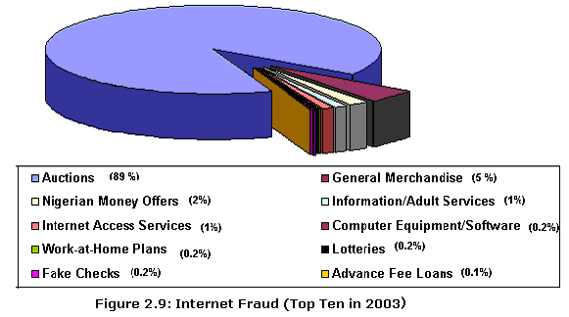

Passive attacks (Sniffing or Eavesdropping)
Attacker tries to gather information (like credit card number, SSN etc.) by monitoring and copying data transmissions. In this attack, an attacker is able to view request and response messages as they flow across the network to and from the remote component. An attacker can use network monitoring software to retrieve sensitive data. This might include sensitive application level data or credential information. Using network monitoring software, hacker can capture traffic leading to host which is on the same network and can hack important information [15]. Passive attacks are difficult to detect since they do not involve any alteration of the data.
Active attacks
Attacker obtains the user ID and password of a legitimate user and logs on to the network to modify the data being transmitted, or to obtain additional privileges.
Information that is managed by the system may be exposed to people who are not authorized to read or use that information using Active attacks. For example, storing sensitive information in the session objects leads to potential threats like Session Hijacking, Session Replay, and Man in the middle attack.
Below are some examples of Active attacks.
Denial of service (DoS) : Rendering a server unavailable to others. DoS attacks can be done by flooding a server with multiple bogus connection requests. DoS (Denial-of-Service) attacks are probably the nastiest, and most difficult to address. These are the nastiest, because they're very easy to launch, difficult (sometimes impossible) to track, and it isn't easy to refuse the requests of the attacker, without also refusing legitimate requests for service.
The premise of a DoS attack is simple: send more requests to the machine than it can handle. There are toolkits available in the underground community that make this a simple matter of running a program and telling it which host to blast with requests. The attacker's program simply makes a connection on some service port, perhaps forging the packet's header information that says where the packet came from, and then dropping the connection. If the host is able to answer 20 requests per second, and the attacker is sending 50 per second, obviously the host will be unable to service all of the attacker's requests, much less any legitimate requests (hits on the web site running there, for example).
Man in the Middle attack: A man-in-the-middle attack involves intercepting the messages and masquerading as the parties concerned. It is possible because of the nature of the Internet and the popularity of public key crypto. Theoretically, the man-in-the-middle (MITM) could block a message from Alice (A) to Bob (B). He (C) could then masquerade as Bob (B) to Alice (A), and as Alice (A) to Bob (B).
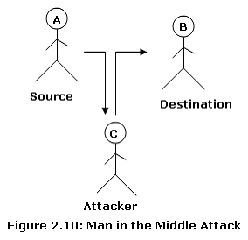
Without proper authentication (see digital certificates) this could be possible. MITM could receive and read messages from Alice before sending them on the Bob (and vice versa). If MITM never alters the messages, Alice and Bob may never know that their messages are being intercepted.
SQL Injection: Using this attack, the attacker can run the code of his choice in the database. Typical scenarios where this could be exploited are application that constructs dynamic SQL statements based on the user input and application that executes stored procedure with arguments based on the user input. The attacker can go to a maximum extent of running operating system commands if the account under which the SQL statements executed were over privileged. The extent to which the data being destroyed, manipulated and retrieved is based on the privilege of the account under which the SQL command is being executed.
Following snippet of code shows explain by Krishnan V R [15], shows how this vulnerability can be exploited.
SqlDataAdapter myCommand = new SqlDataAdapter(“select * from tablename where fieldname = ‘” + userinput + “’”, myConnection);
The above code gets executed based on the user input. This code can be exploited if the input is entered/passed as value as value’; Any valid SQL command.
Brute force attacks: In this attack, the sensitive data like password or other such secrets can be hacked by relying upon the computational power to identify the hash string and encryption technique used for securing the sensitive information.
Dictionary attacks: Generally the application normally uses a hashing technique and stores the hashed strings. According to Krishnan V R [15], “If an attacker gains the access to hash strings stored in the application, a dictionary attack can be performed. That is, iterate through all the words in a dictionary of all possible languages to arrive to the hashed string retrieved by the attacker.”
Cookie replay attacks: The attacker can read authentication information that is submitted for the application to gain access. The attacker can then replay the same information to the application causing cookie replay attacks

Software without Trustworthy Frame
Software at present being increasingly used in a wide range of business applications from online inventory system to medical industry and safety critical applications. The increasing popularity of software is because of its flexibility but reliability, security and safety is critical for all software application. Implementation of any one property (reliability, security, safety) is not enough to make that system a Trustworthy system. To put our trust in any software application, all three properties are required. We can see from below figure that if Software is Reliable, Safe and secure then only we can put our trust in system. Why we need these characteristics, what kind of problem occurred in our history because of lack of any of these characteristics and what are the causes, which lead out attention to these characteristics, lets see each characteristic, the causes which weaken it and its importance in any application.
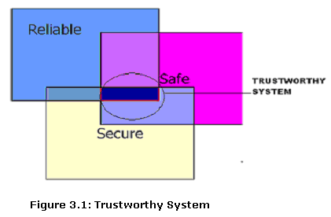

Reliability:
The strategy used to develop the software (process model) is chosen based on the particular characteristics. Regardless of the process model chosen, actual development of the software has four main processes: requirements capture, design, coding, and integration.

Software Development Process

Requirements capture:
The high-level software requirements are developed during the requirements capture process. These requirements include functional, performance, interface and safety requirements derived from the system level analysis and development. According to Wilfredo Torres-Pomales, “The capturing of requirements is usually an iterative process with corrections being added to rectify omissions, ambiguities, and inconsistencies found during the other processes.” Also corrections and additions to the requirements can originate from changing system-level requirements and design.

Design:
The design process produces the software architecture and corresponding lower level requirements for the coding process, data design, interface design and procedural design.. The architectural design is a modular hierarchical decomposition of the software, including the control relationships and data flow between the modules. The data design is the selection of the data structures to be used and the identification of the program modules that operate directly on these structures. The interface design considers the interactions between software modules, between the software and other non-human external entities, and between the computer and human operators. Procedural design is the selection of the algorithms to be used by the software components. As Wilfredo Torres-Pomales said [16], the design process should allocate requirements to software elements, identify available system resources with their limitations and selected managing strategies, identify scheduling procedures and inter-processor and/or inter-task communication mechanisms, and select design methods and their implementation.

Coding:
As Wilfredo Torres-Pomales said [16], “The coding process develops the source code implementing the software architecture, including the data, interface, and procedural designs together with any other low-level requirements. If the output of the design process is detailed enough, the source code can be generated using automatic code generators.”

Integration:
The integration process is the phase of development when the source code is linked and transformed into the executable object code to be loaded on the target computer hardware. As Wilfredo Torres-Pomales said, “If the design and coding were done properly, this step should flow smoothly. However, errors in integration do appear often, and any interfacing problem found during this process should generate a problem report to be resolved by the previous development processes.”

Reasons for Systems Failure:
Yet everyday life now can’t run without reliable software: in appliances, tools and toys; in pacemakers, infusion pumps and radiation-therapy machines; in factories, power plants and office campuses; in trains, planes and automobiles [17]. If software systems failure can be so dangerous why can they not be completely eliminated? According to Parnas, "The main reason is that software can never be guaranteed to be 100% reliable.” There's a financial cost to all organizations that use badly designed and deployed software as well. There are two types of software systems failure. These are in the design stage of the software or in the implementation of the software. These are the main reasons for systems failure, so let’s see what the root cause of these failures is.

Difficulty
Software is used to implement difficult functionality that would be inconceivable in older technologies - e.g., enhanced support to pilots in fly-by-wire and unstable aircraft control, dynamic control of safe separation between trains in ‘moving block’ railway signaling. According to Bev Littlewood and Lorenzo Strigini [18], “The more difficult and novel the task, of course, the more likely that mistakes will be made, resulting in the introduction of faults which cause system failure when triggered by appropriate input conditions.”
As software is invisible, all the requirements may not be captured at early stage. These missing requirements are difficult to detect analytically and can escape functional and structural test, resulting in Failures that are difficult to diagnose and cause human injury or system damage. For example missing requirements for labeling the field for hours, minutes or seconds in the software used to program some synchroMed implantable pumps, led to two death and seven injuries. Medtronic said it learned 13 months ago that some user had mistakenly entered a delivery time into a minute’s field instead of an hour field, resulting in overdoses to patient. Medtronic Inc. recalled the software on September 24, 2004 to replace with new software, which labels the time fields. Also, poor user-interface makes software difficult or even impossible for the user to operate the software system.

Complexity
Software complexity is defined in IEEE Standard 729-1983 [11] as: "The degree of complication of a system or system component, determined by such factors as the number and intricacy of interfaces, the number and intricacy of conditional branches, the degree of nesting, the types of data structures, and other system characteristics." Most importantly, the trends toward new and increased functionality in computer-based systems are almost unavoidably accompanied by increased complexity. It is usually the case that four distinct areas are held to be responsible for the rise of complexity in software:
Context coupling: the degree to which a software element uses or is used by other software elements.
Control flow: the complexity of the control structure and control elements.
Data structures: the number and complexity of the data elements. Poor software design is the fundamental flaws in the design of the software. For example the real Y2K problem is bad software design and implementation. According to Dr. Steve G. Belovich [20] “Poorly architect software is the reason that we have the Y2K problem.”
Size: The volume of the system under consideration. For example, the growth in packages such as MS Office from one release to another. Great complexity brings many dangers. The root cause of software design errors is the complexity of the systems. Compounding the problems in building correct software is the difficulty in assessing the correctness of software for highly complex systems. Even many specifications aren't thought out well enough . The result is poor software design practices, incomplete designs, and poor-quality products.

The Chaotic Nature of Software Development
Software systems are discrete-state systems that do not have repetitive structures [47]. The mathematical functions that describe the behavior of software systems are not continuous (non-linear), and traditional engineering mathematics do not help in their verification." Complex systems exhibit a chaotic dynamic behavior, where a high number of elements interact in a multi-dimensional network. Also, the occurrence of failures is dependent on the operational profile, which is defined by input states. As John J. Marciniak [12] said, “It is usually not known which input state will occur next, and sometimes an input state may occur unexpectedly. These events make it impossible to predict where a fault is located or when it will be evoked to cause a failure in a large software system.”

Coding:
As John J. Marciniak said [12], “The location of design faults within the software is random because the overall system design is extremely complex.” The programmers who introduce the design faults are human, and human failure behavior is so complex that it can best be modeled using a random process.
Many specifications and designs aren't thought out well enough. According to Debbie Gage and John McCormick [21], “Programmers, no matter how good, make logical mistakes. In addition, testing procedures often aren't rigorous enough.” And today, with so many software programs interacting with other software programs, there's no way to predict what will happen when two pieces of code come in contact with each other for the first time. According to William Guttman, the director of the SCC, a group of businesses and academic institutions, “For every thousand lines of code developed by commercial software makers or corporate programmers there could be as many as 20 to 30 bugs.” Many common programs have a million or more lines of code. Sun says its Solaris operating system has more than 10 million lines of code. Even a high-end cell phone can have 1 million.

Assurance:
Not properly tested software implemented in a high-risk environment - This is almost guaranteed to lead to systems failure. Formal design and code inspections have average about 65% in defect removal efficiency. Most forms of testing are less than 30% efficient. —“Software Quality: Analysis and Guidelines for Success,” by Capers Jones . 38% of organizations believe they lack an adequate software quality assurance program. —Cutter Consortium. And 27% of organizations do not conduct any formal quality reviews. —Cutter Consortium

Integration:
Independently, software might function normally, but when connected to code in other machines, it may act unpredictably.

Safety:
Reliability is concerned with conformance to a given specification and delivery of service while safety is concerned with ensuring system cannot cause damage irrespective of whether or not it conforms to its specification. A reliable system may be quite unsafe and a safe system may be very unreliable, for example, a nuclear power plant that continues to operate despite cracked containment housing is reliable but safety would require a shutdown.
As we have seen above, faults exist in system either because of missing requirements, poor design or lack of proper coding. “They exist whether or not the system is ever in operation. There are no methods of removing software defects or errors that are 100% effective.” —Software Quality: Analysis and Guidelines for Success by Capers Jones. But these faults may cause failures in operation and if failures are the cause of hazard, then they are potential danger. For example failures can create a hazardous condition such as database corruption in storing incorrect employee information or ordering information, which in turn can lead to more costly “accident”.
Below is the Eight Fatal Software-Related Accidents By Debbie Gage and John McCormick [11] in which software-related problems were reported to have played a role.
Date | Deaths | Detail
2003 | 3 | Software failure contributes to power outage across the Northeastern U.S. and Canada.
2001 | 5 | Panamanian cancer patients die following overdoses of radiation, amounts of which were determined by faulty use of software.
2000 | 4 | Crash of a Marine Corps Osprey tilt-rotor aircraft partially blamed on “software anomaly.”
1997 | 225 | Radar that could have prevented Korean jet crash hobbled by software problem.
1997 | 1 | Software-logic error causes infusion pump to deliver lethal dose of morphine sulfate. Gish Biomedical reprograms devices.
1995 | 159 | American Airlines jet, descending into Cali, Colombia, crashes into a mountain. Jury holds maker of flight-management system 17% responsible. A report from Aeronautica Civil of the Republic of Colombia, digitized by the University of Bielefeld in Germany found that the software presented insufficient and conflicting information to the pilots, who got lost.
1991 | 28 | Software problem prevents Patriot missile battery from picking up SCUD missile, which hits U.S. Army barracks in Saudi Arabia.
1985 | 3 | Software-design flaws in Therac-25 treatment machine lead to radiation overdoses in U.S. and Canadian patients.

Security
Consumers and businesses started to demand faultless products that are not easily attacked and vulnerable to computer worms. According to Gary McGraw and John Viega [22], “Security holes and vulnerabilities—the real root causes of the problem—are the result of bad software design and implementation.” Bad software opens door for all malicious attacks. More complex is the system; more vulnerability are in the system. Like NT itself consists of approximately 35 million lines of code, and applications are becoming equally, if not more, complex. Exacerbating this problem is the widespread use of intermediate programming languages, such as C or C++, that do not protect against simple kinds of attacks (most notably, buffer overflows). According to Robert H. Morris, “if our software is buggy, what does that say about its security? However, even if the systems and applications codes were bug free, improper configuration by retailers, administrators, or users can open the door to attackers.”

Protocol weaknesses
Protocol problems and weaknesses can be a major security problem. Example of protocol weakness exist in the Address Resolution Protocol {ARP} used on local area networks. ARP is used to match IP addresses to MAC addresses on an Ethernet network. ARP protocol weakness leading to "Man in the middle" attack and DoS attacks. For example, in web application, communication that happens through http protocol between client and server is transmitted as a plain text over the network. Information captured from the user is either sent in the form of query string, form fields manipulation, cookies manipulation and HTTP headers in the communication channel .

Software Engineering Problems
“Security problems in the area of software engineering are mainly the results of false assumptions on data type, data size and data contents as well as wrong beliefs in atomicity of operations” - Burak DAYIOĞLU – Mustafa YAVAŞ [14]. In this section, software engineering problems are discussed from the attacker’s point of view.

Local and Remote Buffer Overflows
Basically a buffer-overflow occurs because of bad programming practices. Assume that we have a limited size of buffer for some data to be put in. When a too-long data string goes into the buffer, any excess is written into the area of memory immediately following that reserved for the buffer and as Russell Kay [24] said “which might be another data storage buffer, a pointer to the next instruction or another program's output area.” Whatever is there is overwritten and destroyed. And possibilities are there that the program crashes. Following piece of code demonstrates the example for occurrence of Buffer Overflows.
// Vulnerable function in ‘ C ’
void vulnerable(char *str)
{ char buffer[15];
strcpy(buffer, string1); // overrun buffer !!!
}
int main()
{ // declare buffer that is bigger than expected
char large_buffer[] = "This string is longer than 15 characters!!!";
vulnerable(large_buffer);
}
For most hardware architectures, the stack consists of the return address of the current subprogram with the automatic variable set over the return address. If one sets up a proper data structure to overflow a buffer which is implemented as an automatic variable, it is possible to modify the current subprogram's return address, thus executing arbitrary instructions with the privilege of the victim program. According to Russell Kay [24] “Even if a program doesn't check for overflow on each character and stop accepting data when its buffer is filled, a potential buffer overflow is waiting to happen. We're still running a lot of code written 10 or 20 years ago, even inside current releases of major applications.”
C subroutine calls that copy data but do no bounds checking like strcat(), strcpy(), sprintf(), vsprintf(), bcopy(), gets(), and scanf() calls can be exploited because these functions don’t check to see if the buffer, allocated on the stack, will be large enough for the data copied into the buffer .
A buffer overflow exploit can be constructed for both network service software and priveleged applications which are run locally. Examples of remote buffer overflow exploits are bind DNS server exploit, POP3 e-mail access service exploit and IMAP e-mail access service exploit.
No single techniques can completely eliminate this type of vulnerability which allow too much data to be copied into areas of the computer’s memory.
Microsoft is employing a number of security technologies to mitigate these attacks. First, core Windows components have been recompiled with the most recent version of our compiler technology to protect against stack and heap overruns. Microsoft is also working with microprocessor companies, including Intel and AMD, to help Windows support hardware-enforced data execute protection (also known as NX, or no execute). NX uses the CPU to mark all memory locations in an application as non-executable unless the location explicitly contains executable code. And according to Starr Andersen [25] “This way, when an attacking worm or virus inserts program code into a portion of memory marked for data only, it cannot be run.”

Unstable code
An untestable error is an error in a piece of software (or hardware, for that matter) that no amount of testing can ever be assured of revealing. The most common cause of untestable errors is when an erroneous part of the program happens to produce the right result by coincidence - Andrew Koenig.
Here’s an example in C. Suppose x is an array and we write
x[i++] = i;
In C (and also in C++), the effect of this statement is undefined. That is, the implementation is permitted to do absolutely anything it pleases.
Of course, most implementations increment i either before or after the assignment, and are consistent about whether they do so. That means that if your program contains a statement like this, and it happens to give the result you expect, and your implementation is consistent about giving that result, your program contains an untestable error: No test that you can devise will detect this error unless you happen to run the program on a different implementation that behaves differently.
Untestable errors are a significant contributor to lack of trustworthiness in software.

Race Conditions and Mutual Exclusion
Some operations required to run group of commands in one stop without any interrupt like if one process writes to a file while another is reading from the same location then the data read may be the old contents, the new contents or some mixture of the two depending on the relative timing of the read and write operations or if because of some interrupt or unpredicted behavior of Operating System, this operation interrupted then it may cause security problems. An attacker can exploit a race condition to elevate privileges, create denial of service, execute arbitrary code.

Problems of Trust Relations and Models
While accepting the input from data, if application trust the input blindly (without checking the input type, length,format or range) then may be application is susceptible for threats like buffer overflow, Cross-site scripting, SQL Injection and Canonicalization. Also Authenticating clients (validating the user to whom s/he claims to be) over a network will, obviously, require trust. Trust relationships might be good a cause for security breaches like Denial of service, Corruption of programs or data.
A knowledgeable hacker can exploit these trust relationships between host computers. An advanced technique, named IP spoofing, can be used to generate and send forged TCP packets. By IP spoofing rsh (remote shell) requests, false authorizations can be gathered and arbitrary commands can be executed on a remote server. While rsh communication is just as simple as request-response, generating a single forged TCP package is good enough to fool a server [23]. When passwords and other sensitive information are passed in plain text format from client to server, they are vulnerable to attacks like Network eavesdropping, Brute force attacks, Dictionary attacks, Cookie replay attacks or Credential theft.

Hidden backdoors and alikes
Backdoors is a mechanism which is done secretly to facilitate unauthorized access into the system adn it is normally done by the attackers. It might be possible that some network service software have hidden backdoors to enable remote debugging. If these backdoors will be found by hackers then it can break security and can gain access of the system.
According to CERT (Computer Emergency Readiness Team), 70%+ of all security breaches are caused by legal users (who have some but not enough privilege) of the system and only a small percentage as 30% is caused by outsiders. Security breaches are because of many faults in software design, programming language, public networks etc.

Software with Trustworthy Frame

Software Reliability
Software is a relatively new industry, less than fifty years old, and it has spent much of that time trying to figure out how to create reliable software applications with minimum errors. Most of the time developers focused on customer requirements and less focus on error prevention. Testing is conducted to look for bugs in order to fix them, but nothing is done to alter the process that allowed those bugs to be created in the first place - Adam Kolawa. What really needs to be addressed with the software industry is the question of “How can software be better manufactured?” The only answer is minimized or prevents faults in software.
Software faults are most often caused by incorrect specification, design or coding of a program. Design faults occur when a programmer either misunderstands a specification or simply makes a mistake. As J. Gray and D. P. Siewiorek described in their book [28] “It is estimated that 60-90% of current computer errors are from software faults.”

Classification of software faults
Gray [29] classifies software faults into Bohrbugs and Heisenbugs that affects functional behavior of the system.
- Heisenbugs (Non-Permanent faults)
- Bohrbugs (Permanent faults)

Heisenbugs (Non-Permanent)
Heisenbugs are bugs occur at random moments. They affect a system's behavior for an unspecified period of time. The detection and localization of Heisenbugs faults are extremely difficult. They are essentially permanent faults whose conditions of activation occur rarely or are not easily reproducible. Hence Heisenbugs are bugs, which may or may not cause a fault for a given operation. Heisenbugs could resurface if the conditions, which lead to the failure reappear. It is very difficult to recreate the conditions which existed when the fault first happened. In case of a Heisenbug, the error could vanish on a retry, i.e., failures may not recur if the software is restarted. Many of these faults can be latent in the code and show up only during operation, specially under heavy or unusual workloads and timing contexts or due to a phenomenon known as process aging [30]. The bugs of non-deterministic nature which are also called Heisenbugs (as opposite to Bohrbugs that predictably lead to failures) are the most difficult ones to eliminate by verification, validation or testing and therefore they are something the system has to live with. Software Rejuvenation technique is the also one to cope with Heisenbugs.
There are two types of Heisenbugs faults:
- Transient fault
- Intermittent fault
Transient faults are hard to detect, and there are no well-defined faults to detect. Some typical situations in which Transient faults might surface are boundaries between various software components, improper or insufficient exception handling and interdependent timing of various events. As Kishor Trivedi explain in classification of software faults [35] ”Most recent studies on failure data have reported that a large proportion of software failures are transient in nature [28], caused by phenomena such as overloads or timing and exception errors [31]. The study of failure data from Tandem's fault tolerant computer system indicated that 70% of the failures were transient failures, caused by faults like race conditions and timing problems [32].”
Intermittent faults are caused by non-environmental conditions such as deteriorating or aging components, critical Timing etc.

Bohrbugs (Permanent) faults
Bohrbugs are essentially permanent design faults and hence almost deterministic in nature and always cause a failure when a particular operation is performed. They can be identified easily and weeded out during the testing and debugging phase (or early deployment phase) of the software life cycle. Bohrbug is also called a permanent fault. Bohrbug in software application is caused by incorrect requirement and specifications, missing requirement, poor software design etc.
As Michael Scheinholtz [41] said, “Software faults may also occur from hardware; these faults are usually transitory in nature, and can be masked using a combination of current software and hardware fault tolerance techniques.”
According to Adam Kolava, “Neither traditional process improvement nor development dynamics focus on error prevention. They are a step in the right direction, certainly, but they do not address fixing the actual software development lifecycle when a development error or application bug is found. What really needs to be addressed with the software industry is the question of “How can software be better manufactured?” The only answer is: through error prevention or error removal or fault tolerant.

Approaches in making Software Trustworthy
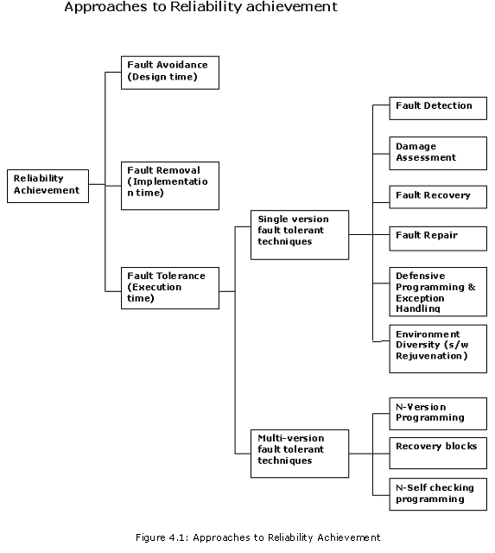
Achieving the goal of trustworthiness requires effort at all phases of a system's development from design time to execution time and also during maintenance and enhancement. At design time, we can increase the reliability of a system through fault avoidance techniques. At implementation time, we can increase the reliability of the system through fault removal techniques. At execution time, fault tolerance and fault evasion techniques are required.

Fault avoidance
These methods aim to prevent faults in the final system by avoiding introducing them in the first place. Fault avoidance is the best way to improve software quality and reliability. Preventing errors rather than chasing them dramatically improves software reliability, allowing you to stay competitive and not risk your valuable reputation on unforeseen bugs [24]. Fault avoidance for software may include good software architecture, formal specification, use of design methodologies, use of data abstraction and modularity and use of project support environments. The reliable Design is the one, which includes simplicity, use of safe language and use of reliable architecture and design patterns.
Simplicity: We need to minimize complexity in the design to reduce faults, which in turns reduce failures and increase reliability. To minimize complexity in design, minimizing size of the application by decomposing the problem into smaller pieces and try to achieve loose coupling (reduce the degree of dependence among components) and high cohesion (the method must do only a single conceptual task).
Use safe language: Use language with features like strong type checking(which prevents buffer overflow and memory corruption), secure Name space(prevent overwritten by other modules), memory garbage collection etc.
Use Reliable Architecture and Design patterns: Good software architecture is the key framework for all technical decisions and it makes communication easy among stakeholders. Use patterns that have been tested and work well and develop operational profile. When making choice for components of the system for system architecture, choose resilient components because if you make poor choice for your components, no matter how well you build your application, you will not hit your reliability target.
Bound execution domain: To prevent the propagation of errors to other modules, do the checks that ensure output is within execution domain for given input such that output will not introduce any errors or failure.
“after 30 seconds of a planned 90 flights, the clock was not properly reset and the missile blew up. Some twenty-five years later AT&T experienced a massive network failure caused by a similar problem in the fault recovery subsystem they were upgrading. There was not enough testing of the recovery subsystem before it was deployed. In both the cases, the system failed because there was no limit placed on the result the software could produce. There was no boundary condition set [33]” – Larry Bernstein.
Some types of checking which ensures that output is within domain are as follow. – Prof. Linda Laird
Timing: To ensure that events happen within certain ‘window’. For example watchdog timers are used to monitor for “lost or locked out” components.
Reversal Checks: Calculate the input given the output and then compare.
Reasonableness Checks: Checking based on semantic properties of data including boundary conditions.
Structural Checks: Checking integrity of data structures like linked lists etc.
Run time checks: checking of divide by zero and other checks at run time.
“Checking can also cause failures as with Airbus A320 crash during its first public demonstration flight. The reason for the crash was that the flight controls had software limits in them that were there for the purpose of bounding the control’s behavior so that they would do no harm. Unfortunately, the people who designed that software did not take into account that pilots at air shows routinely maneuver in ways that pilot carrying passengers do not. Accordingly, when the pilot made a low pass over the runway and tried to pull up sharply at the end, the software said “you don’t want to make abrupt maneuvers of this kind this close to ground” and restricted the rate of climb so that the airplane hit the trees at the end of runway.”– Andrew Koenig.

Fault Removal
These methods aim to remove faults after the development stage is completed. Fault removal depends on fault identification in the developing system and this is done by applying algorithmic techniques to remove faults from design. Common Fault removal techniques are verification (reviews, inspections, modeling and analysis, formal proofs, testing like unit testing, integration testing, regression testing, and back-to-back testing), diagnosis, debugging and corrections. Verification is the process of checking whether the systems adhere to properties, termed the verification conditions which can be done statically or dynamically. Diagnosis will be taken whenever the system does not succeed in verification step. Correction should be then performed to fulfill verification conditions.
For fault minimization, it is clear that the process activities should include significant verification and validation. Reliability validation involves exercising the program to assess whether or not it has reached the required level of reliability. Verification and validation techniques that increase the probability of detecting and correcting errors before the system goes into service are used.
Verification and Validation techniques
Obviously, errors in software are unavoidable and very likely to take place in general. Software verification and validation techniques are used to ensure software quality and performance. It evaluates the products against system requirements. Verification and validation is summarized by the following questions:
Validation: Are we building the right product?
Verification: Are we building the product right?
Verification is a way of confirming that the program follows its specification and it is a static activity while Validation involves checking that the program as implemented meets the expectations of the software customer and it is a dynamic activity [34]. Static verification is done at all stages and dynamic validation is done on an executable program.
Static validation techniques
Static validation is concerned with finding errors in the system and identifying potential problems that may arise during system execution by analyzing the system documentation (requirements, design, code, test data).
• Design reviews and program inspections (Code Inspection)
• Mathematical arguments and proof (Formal Verification)
Following figure shows where in the development process static verification and dynamic validation are applied.
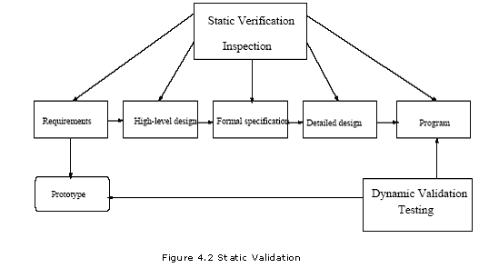
Software Inspection
Software Inspection is a static analysis technique that relies on visual examination of development products to detect errors, violations of development standards, and other problems [IEEE Std 610.12-1990]. Inspections cannot replace testing, but they help projects to get the most out of testing by removing defects at an early stage. They are also valuable tools for evaluating the status of the project. Sommerville refers to inspections and test as static verification and dynamic validation [34]. One way to make an inspection effective is, according to D, to introduce an informal walkthrough after one third of the time before the inspection.
Review: The IEEE Standard 1028-1988 (Software Reviews and Audit book) defines review as an evaluation of software element(s) or projects status to ascertain discrepancies improvement. There are a number of different review methods in practice, for example, peer review, management reviews, technical reviews, walkthroughs, and so on. Peer reviews are more informal inspections performed between colleagues. It is an exchange of services. Findings are normally not documented and corrections are not reported. The most extreme usage of peer reviews can be found in eXtreme Programming (XP) that describes a Pair Programming strategy where two colleagues, or more, work in pair or groups cooperating in analysis, design, coding and test all the time
Walkthrough: A review of the concept, examining the validity of proposed solutions and the viability of alternatives.
Formal Methods
Formal methods used in developing computer systems are mathematically based techniques for describing system properties. Formal methods, based upon elementary mathematics, can be used to produce precise, unambiguous documentation, in which information is structured and presented at an appropriate level of abstraction. This documentation can be used to support the design process, and as a guide to subsequent development, testing, and maintenance.
Formal methods play a very critical role in examining whether a system (or one of the various software development artifacts) is ambiguous, incorrect, inconsistent or incomplete. Hence, the importance of applying formal methods, particularly for critical software systems, cannot be overemphasized.
Dynamic techniques
Dynamic validation involves running tests on executable programs, hence a finished free-standing part of the application or a prototype must be accessible [34]. Dynamic validation is performed by testing, running test cases against an executable program.

Fault tolerance:
In spite of the best efforts to avoid or remove them, software will always contain latent bugs, which tend to be transient, environmentally dependent, boundary conditions, aging related bugs etc. High reliability and availability requires systems designed to tolerate faults - to detect a fault, report it, and recover from the fault in order to continue service while the faulty component is repaired off line. Even if the system seems to be fault-free, it must also be fault tolerant as there may be specification errors or the validation may be incorrect. Some faults cannot be removed from design because they are due to hardware failure, software corruptions, message losses etc.
Fault-tolerant architectures:
Fault-tolerant architectures are Hardware and software system architectures that support hardware and software redundancy and a fault tolerance controller that detects problems and supports fault recovery. These are complementary rather than opposing techniques
Hardware fault-tolerant:
The traditional approach to achieving high availability in stand-alone systems is with fault tolerant hardware. With this technique, redundant hardware is built into the hardware platform, and the active hardware is constantly monitored for failures. When a failure is detected, switchover to the redundant hardware must occur seamlessly (i.e., no calls being handled by the component are impacted). Hardware fault tolerance measures include redundant communications, replicated processors, additional memory, and redundant power/energy supplies. Hardware fault tolerance was particularly important in the early days of computing, when the time between machine failures was measured in minutes.
Software fault-tolerant:
Fault tolerant hardware platform does not guarantee high availability to the system user. It is still important to structure the computer software to compensate for faults such as changes in program or data structures due to transients or design errors.
According to Linda Laird, recovery code, 3rd party code, boundary conditions and bug-fix patches are typical fault triggers.
Fault-tolerant software monitors the "health" of individual software elements, transferring the affected functions to a different or new process upon the detection of a problem. The switchover may be made to a different version of software or the same version that was originally experiencing problems. Detecting software problems is much more complex than detecting hardware problems. And while switchover can still be done in a matter of seconds, it is not necessarily instantaneous as with fault-tolerant hardware.
Fault-tolerant software provides additional benefits. Fault-tolerant software mechanisms can be used to execute different versions of the software as the primary and backup processes, thereby providing the ability to gracefully upgrade the system's software without interrupting normal operation. Mechanisms such as checkpoint/restart, recovery blocks and multiple-version programs are often used at this level.

Single version fault-tolerant:
Single-version fault tolerant is based on the use of redundancy applied to a single version of a piece of software to detect and recover from faults. In single-version technique, fault tolerance requires failure detection, damage assessment, recovery and repair

Fault detection:
Fault detection involves detecting an erroneous system state (an incorrect system state) and throwing an exception to manage the detected fault. Languages such as Java and Ada have a strict type system that allows many errors to be trapped at compile-time. However, some classes of error can only be discovered at run-time. Fault detection mechanism can be initiated before the state change is committed (Preventative fault detection) or after the system state has been changed (Retrospective fault detection). In Preventative fault detection, if an erroneous state is detected, the change is not made. Retrospective fault detection is used when an incorrect sequence of correct actions leads to an erroneous state or when preventative fault detection involves too much overhead.

Damage assessment:
The parts of the system state affected by the fault must be detected either by static damage assessment or by dynamic damage assessment. Static damage assessment technique estimates damage based on types of error. It is specified at design time. Dynamic Damage assessment technique explores data structures for errors using checks. It does more accurate estimate of damage but more difficult to implement. This technique is used to identify flow of erroneous information.

Fault Recovery
To correct damage state and bring the system to known safe state, Fault recovery technique is useful. Fault recovery can be achieved by either forward or backward error recovery. Backward recovery is used to restore the system state to a known safe state using recovery blocks. The recovery block uses checkpoints in its implementation. Check pointing involves occasionally saving the state of a process in stable storage during normal execution [22]. If an error occurs, the system is left in the state preceding the transaction. Periodic checkpoints allow system to 'roll-back' to a correct state (last save point). This thus reduces the amount of lost work. The system must restore its state to a known safe state. To correct damage state, Forward recovery is used which is highly application dependent and usually application specific domain knowledge is required to compute possible state corrections.

Fault repair:
The system may be modified to prevent recurrence of the fault. That’s the reliability of software is increased by masking the current failures and then by preventing future failures. Typically two phases are involved:
Fault Location: To find fault location, either diagnostic checking is used to locate faulty component or input is provided to component and check the outputs.
System Repair: System repair can be done by reconfiguration (eg. by switching components) to keep the system operational. (Note need for diversity).

Defensive programming and Exception Managment:
Defensive programming is an approach to fault tolerance that relies on the inclusion of redundant checks in a program. Programmers assume that there may be faults in the code of the system and incorporate redundant code (Exception handling) to check the state after modifications to ensure that it is consistent. Defensive programming cannot cope with faults that involve interactions between the hardware and the software. Misunderstandings of the requirements may mean that checks and the associated code are incorrect.
There is one other programming technique called failfast is used to cause an exception to be thrown or other redirection of control to occur upon meeting certain conditions. For example, modification to a collection that is being iterated over in another thread may immediately cause an exception to be thrown, rather than allowing clients to continue using the now-invalid iterators. Using Failfast an application or system service terminates itself immediately upon encountering an error. This is done upon encountering an error so serious that it is possible that the process state is corrupt or inconsistent, and immediate exit is the best way to ensure that no (more) damage is done. Common errors that cause failfast include access violations and numeric exceptions, but may also involve internal consistency checks. This is an easy way to increase the reliability and predictability of a system.
Even though software has a reliable design, when the software is developed and used in the field, its reliability may be unsatisfactory. The reason for this low reliability may be that the software was poorly developed. So, even though the software has a reliable design, it is effectively unreliable when fielded which is actually the result of a substandard manufacturing process. Just like a chain is only as strong as its weakest link, a highly reliable product is only as good as the inherent reliability of the product and the quality of the manufacturing process. Reliability is desirable in software construction regardless of the approach.

Environment diversity
Most software failures are transient in nature which occurs due to design faults in software and result in unacceptable and erroneous states in the OS environment. According to Kishor Trivedi [35], “Therefore environment diversity attempts to provide a new or modified operating environment for the running software. Usually, this is done at the instance of a failure in the software. When the software fails, it is restarted in a different, error-free OS environment state which is achieved by some clean up operations.”
Software aging is deterioration in the availability of OS resources, data corruption and numerical error accumulation. Potential fault condition gradually accumulating over time leading to either performance degradation or transient failures or both because of memory leaks, unreleased file locks, data corruption, storage space fragmentation, accumulation of round of errors. Phenomenon of Software aging that has been reported in widely used software and also in high availability and safety critical systems. To counter act this phenomenon a proactive technique called software rejuvenation (A specific form of environment diversity) was introduced in 1995 by Prof. Kintala and his colleagues in Bell Labs.
Software Rejuvenation: As described in ‘Software Rejuvenation: Analysis, Module and Applications’ [36] – “Software rejuvenation is a cost effective technique for fault management aimed at cleaning up the system internal state to prevent the occurrence of more severe crash failure in the future and protection against failure and performance degradation.”
Also as explain in CrossTalk – The Journal of Defense Software Engineering by Lawrence Bernstein and Dr. Chandra M. R. Kintala [37], “Fault Tolerant is a reactive approach while software rejuvenation is a proactive approach. Software rejuvenation technology became modern realization of this early design that restart align before the hang to avoid potential secondary problems is a low cost easy to implement technology that makes system more trustworthy. Software rejuvenation is also implemented in IBM’s director response manager for use in applications built on Netfinity. Netfinity director provides an interface to rejuvenate an application using a time interval as well as prediction based on number operating system resource values. According to prof. Bernstein and prof. Kintala, software rejuvenation is ready for industry wide deployment. It can make software systems more trustworthy. Good designer will use it and move from the state of the practice. It is a good design practice for individual systems.”

Multiple version fault-tolerant:
Multi-version fault tolerance is based on the use of two or more versions (or “variants”) of a piece of software, executed either in sequence or in parallel. Traditional hardware fault tolerance tried to solve a few common problems like manufacturing faults and transient faults using redundant hardware of the same type, however, redundant hardware of the same type will not mask a design fault. Fault tolerance is accomplished using redundancy when errors which are not caused by design faults because replicating a design fault in multiple places will not aide in complying with a specification. Exception handling deviates from the specification and fault tolerance attempts to provide services compliant with the specification after detecting fault. [28]
For computer-based applications, it is generally accepted that it is more effective to vary a design at higher levels of abstraction (i.e., by varying the algorithm or physical principles used to obtain a result) than to vary implementation details of a design (i.e. by using different programming languages or low level coding techniques). Since diverse designs must implement a common system specification, the possibility for dependencies always arises in the process of refining the specification to reflect difficulties uncovered in the implementation process. Truly diverse designs would eliminate dependencies on common design teams, design philosophies, software tools and languages, and even test philosophies.
Design and Data diversity
Design diversity techniques are developed to tolerate design faults in software arising out of wrong specifications and incorrect coding while data diversity techniques are developed to eliminate software failure, which are because of certain values in the input.
In design diversity two or more variants of software are developed by different teams but to a common specification are used. According to Kishor Trivedi, “These variants are then used in a time or space redundant manner to achieve fault toleranc.” Popular techniques which are based on the design diversity concept for fault tolerance in software are: N-version programming, Recovery blocks and N-self checking programming.
Data diversity approach uses only one version of the software and use the principal of redundancy to detect input data and tolerate software faults arise from those input data.
N-copy programming is used to produce different representations of a module’s input data, which is acceptable to the software. N-copy programming has N copies of a program executing in parallel, but each copy running on a different input set produced by a diverse-data system. The diverse-data system produces a related set of points in the data space. Selection of the system output is done using an enhanced voting scheme, which may not be a majority voting mechanism [35]. But Data diversity does not work well because each version is correlated.

N-version programming:
The N-version software concept attempts to parallel the traditional hardware fault tolerance concept of N-way redundant hardware. In an N-version software system, each module is made with up to N different implementations. Each variant accomplishes the same task, but hopefully in a different way. Each version then submits its answer to voter or decider, which determines the correct answer, (hopefully, all versions were the same and correct,) and returns that as the result of the module. This system can hopefully overcome the design faults present in most software by relying upon the design diversity concept. An important distinction in N-version software is the fact that the system could include multiple types of hardware using multiple versions of software. The goal is to increase the diversity in order to avoid common mode failures. Using N-version software, it is encouraged that each different version be implemented in as diverse a manner as possible, including different tool sets, different programming languages, and possibly different environments.
The dependence on appropriate specifications in N-version software, (and recovery blocks,) cannot be stressed enough. The delicate balance required by the N-version software method requires that a specification be specific enough so that the various versions are completely inter-operable, so that a software decider may choose equally between them, but cannot be so limiting that the software programmers do not have enough freedom to create diverse designs. The flexibility in the specification to encourage design diversity, yet maintain the compatibility between versions is a difficult task, however, most current software fault tolerance methods rely on this delicate balance in the specification.
The N-version method presents the possibility of various faults being generated, but successfully masked and ignored within the system. It is important, however, to detect and correct these faults before they become errors. Detecting, classifying, and correcting faults are an important task in any fault tolerant system for long term correct operation.
It is possible for a limited class of design faults to be recovered from using distributed N-version programming, like memory leaks (memory leak is a bug in a program that prevents it from freeing up memory that it no longer needs. As a result, the program grabs more and more memory until it finally crashes because there is no more memory left.) is one kind of design faults and can cause a local heap to grow beyond the limits of its computer system. Using distributed N-version programming or one of its variants, it is possible that distributed heaps could run out of memory at different times and still be consistent with respect to valid data state [38].

Recovery block:
The recovery block operates with an adjudicator which confirms the results of various implementations of the same algorithm. In a system with recovery blocks, the system view is broken down into fault recoverable blocks. The entire system is constructed of these fault tolerant blocks. Each block contains at least a primary, secondary, and exceptional case code along with an adjudicator. (It is important to note that this definition can be recursive, and that any component may be composed of another fault tolerant block composed of primary, secondary, exceptional case, and adjudicator components.) The adjudicator is the component which determines the correctness of the various blocks to try. The adjudicator should be kept somewhat simple in order to maintain execution speed and aide in correctness. Upon first entering a unit, the adjudicator first executes the primary alternate. (There may be N alternates in a unit which the adjudicator may try.) If the adjudicator determines that the primary block failed, it then tries to roll back the state of the system and tries the secondary alternate. If the adjudicator does not accept the results of any of the alternates, it then invokes the exception handler, which then indicates the fact that the software could not perform the requested operation.
Recovery block operation still has the same dependency which most software fault tolerance systems have: design diversity. The recovery block method increases the pressure on the specification to be specific enough to create different multiple alternatives that are functionally the same. This issue is further discussed in the context of the N-version method.
The recovery block system is also complicated by the fact that it requires the ability to roll back the state of the system from trying an alternate. This may be accomplished in a variety of ways, including hardware support for these operations. This try and rollback ability has the effect of making the software to appear extremely transactional, in which only after a transaction is accepted is it committed to the system [28]. There are advantages to a system built with a transactional nature, the largest of which is the difficult nature of getting such a system into an incorrect or unstable state. This property, in combination with checkpointing and recovery may aide in constructing a distributed hardware fault tolerant system.
The differences between the recovery block method and the N-version method are not too numerous, but they are important. In traditional recovery blocks, each alternative would be executed serially until an acceptable solution is found as determined by the adjudicator. The recovery block method has been extended to include concurrent execution of the various alternatives. The N-version method has always been designed to be implemented using N-way hardware concurrently. In a serial retry system, the cost in time of trying multiple alternatives may be too expensive, especially for a real-time system. Conversely, concurrent systems require the expense of N-way hardware and a communications network to connect them. Another important difference in the two methods is the difference between an adjudicator and the decider. The recovery block method requires that each module build a specific adjudicator; in the N-version method, a single decider may be used. The recovery block method, assuming that the programmer can create a sufficiently simple adjudicator, will create a system which is difficult to enter into an incorrect state. The engineering tradeoffs, especially monetary costs, involved with developing either type of system have their advantages and disadvantages, and it is important for the engineer to explore the space to decide on what the best solution for his project is. Recovery blocks may be a good solution to transient faults; however, it faces the same inherent problem that N-version programming does, in that they do not offer (sufficient) protection against design faults because human designs are correlated –PARNAS

N-self checking programming:
In N-self checking programming, multiple variants of software are used in a hot-standby fashion as opposed to the recovery block technique in which the variants are used in the cold-standby mode. Self-checking software are the extra checks, often including some amount checkpointing and rollback recovery methods added into fault - tolerant or safety critical systems. A self-checking software component is a variant with an acceptance test or a pair of variants with an associated comparison test. Fault tolerance is achieved by executing more than one self-checking component in parallel. According to Kishor Trivedi [35], “These components can also be used to tolerate one or more hardware fault.”
As design diversity is the approach to error compensation and data diversity is approach to fault treatment category but still some failure occurs and the system must restore its state to a known safe state. Combination of techniques fault detection, damage assessment, fault recovery and fault repair are used to find the error which cause failure and restore the system to safe state.

Software Safety
Reliability is concerned with conformance to a given specification and delivery of service while safety is concerned with ensuring system cannot cause damage irrespective of whether or not it conforms to its specification. A reliable system may be quite unsafe and a safe system may be very unreliable, for example, a nuclear power plant that continues to operate despite cracked containment housing is reliable but safety would require a shutdown. The purpose of the software safety activities is to ensure that software does not cause or contribute to a system reaching a hazardous state; that it does not fail to detect or take corrective action if the system reaches a hazardous state; and that it does not fail to mitigate damage if an accident occurs [39].
All high-risk systems should be concerned with safety. Safety can be defined as being free of accidents or loss [40]. The most difficult thing about safety is that it’s an emergent property of the system's behavior and one component cannot make a system safe. An emergent property is one that is not the result of any one-sub system; it is a result of the interaction of many sub-systems. According to Michael Scheinholtz [41], “This interaction presents a number of problems to designers because it breaks through the layers of abstraction they use to combat complexity.” On a large design team, this means many of the smaller design groups must be able to understand how the system works as a whole. This makes the job of making a safe system much more difficulty, and one component can not make a system safe. Verifying a complex piece of software through testing is effectively impossible [40].
Software can cause harm for two main reasons: it may have been erroneously implemented, or it may have been designed incorrectly. There is an important distinction between the two. Software that was designed incorrectly most likely had incorrect requirements; there was something about the system's environment that the designers didn't understand or didn't anticipate. According to Michael Scheinholtz [41] “Erroneously implemented software-- software that deviates from the requirements-- can produce incorrect responses in know or unknown situations. Both can cause serious safety problems, and both are nearly impossible to eliminate. What follows is a more detailed examination of the unique safety problems software presents.”
Software safety shall be an integral part of the overall system safety and software development efforts [42]. Critical systems attributes are NOT independent - the systems development process must be organized so that all of them are satisfied at least to some minimum level. Therefore, software safety activities take place in every phase of the system and software development life cycle beginning as early as the concept phase and on through to operations and maintenance. According to NASA’s SOFTWARE ASSURANCE GUIDEBOOK [42] “Up-front participation, analyses, and subsequent reporting of safety problems found during the software development life cycle facilitates timely and less costly solutions.”

Hazard and risk analysis
System hazard analysis may indicate that some software requires a more formal safety program because it is included in a safety critical system component. The first step in developing a system is performing a preliminary hazard analysis, to determine whether the system could present a hazard to safety. The purpose of the preliminary software safety analysis is to identify software controlled functions that affect the safety critical component and the software components that execute the functions. These preliminary analyses and subsequent system and software safety analyses identify when software is a potential cause of a hazard or will be used to support the control of a hazard [42]. During If PHA identify any hazard then detailed hazard analysis is required to find out what level of safety is required for that application otherwise hazard analysis need go no further, other than to periodically review the validity of this decision. Many safety analysis methods like FTA (Fault Tree Analysis), FMEA (Failure Mode and Effect Analysis), exist to help designers identify potential safety problems. None of these methods will find every single potential hazard, but they help. According to Michael Scheinholtz [41] “Some of the methods, such as fault tree analysis, can be used to isolate the parts of the software that can directly cause an unsafe state. These sections are called the safety critical functions.”

Fault-tree analysis (FTA):
Fault Tree Analysis (FTA) is a method of hazard analysis, which starts with an identified fault and works backward to the causes of the fault. It focuses on one particular accident or top event at a time and provides a method for determining causes of that accident. The purpose of the method is to identify combinations of component failures and human errors that can result in the top event. The fault tree is expressed as a graphic model that displays combinations of component failures and other events that can result in the top event. FTA can begin once the top events of interest have been determined. It can reveal when a safe state becomes unsafe and shows clearly the reasons for a hazardous event.
According to Timo Malm and Maarit Kivipuro [43] “It may be difficult to identify all hazards, failures and events of a large system and it is difficult to invent new hazards, which the participants of the analysis do not already Know.”

Failure Mode and Effect Analysis (FMEA):
FMEA is a bottom-up method, which begins with single failures, and then the causes and consequences of the failure are considered. In the FMEA, all components, elements or subsystems of the system under control are listed. FMEA can be done on different levels and in different phases of the design, which affects the depth of the analysis. In an early phase of the design, a detailed analysis cannot be done, and also some parts of the system can be considered so clear and harmless that deep analysis is not seen as necessary. However, in the critical parts, the analysis needs to be deep and it should be made on a component level. FMEA is intended mainly for single random failures and so it does not support detection of common cause failures and design failures (systematic failures). Using this method human errors are usually left out; the method concentrates on components and not the process events. A sequence of actions causing a certain hazard are difficult to detect. FMEA is probably the best method to detect random hardware failures, since it considers all components (individually or as blocks) systematically. As explained in NASA’s SOFTWARE ASSURANCE GUIDEBOOK [42], Some critical parts can be analyzed on a detailed level and some on a system level. If the method seems to become too laborious, the analysis can be done on a higher level, which may increase the risk that some failure effects are not detected.
When a safety critical software component is identified, then software safety activities are initiated on that component and continued through the requirements, design, and code analyses and testing phases in the software development process.
A reasonable starting position is that a software-based system should be at least as safe as any system it replaces as explained in IPL Paper [13]. The level of safety integrity required varies from none through to a very high level of integrity. Standards for safety critical software (table 1) have now standardized on a scale of five discrete levels of safety integrity, with an integrity level of 4 being "very high", down to a level of 0 for a system which is not safety related. The term "safety related" is used to collectively refer to integrity levels 1 to 4. Further analysis will assign an integrity level to each component of a system, including the software.

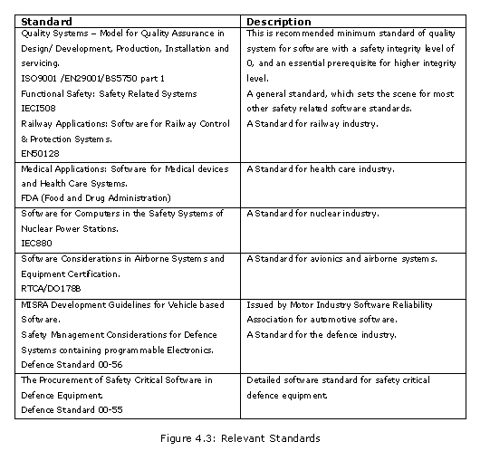
Differing constraints are placed on the methods and techniques used through each stage of the development lifecycle, depending on the required level of safety integrity. For example, formal mathematical methods are "highly recommended" by most standards at integrity level 4, but are not required at integrity level 0 or 1. The required integrity level can consequently have a major impact on development costs, making it important not to assign an unnecessarily high integrity level to a system or any component of a system. According to IPL Paper [13] “This is not just limited to deliverable software. The integrity of software development tools, test software and other support software may also have an impact on safety.”

Safety Requirements Analysis
Software safety requirements analysis is intended to identify errors and deficiencies in the software requirements that could result in the identified hazardous system states. The process of development of software safety requirements involves analysis of system safety requirements, hardware, software, and user interfaces, and areas of system performance where software is a potential cause of a hazard or supports control of a hazard identified by the system safety analyses [39]. These system requirements, interfaces, and areas of performance should be analyzed to develop the software requirements necessary to ensure that the related hazards are properly resolved and should be documented as software requirements as explained in SOFTWARE ASSURANCE GUIDEBOOK [42]. Techniques employed in performing requirements analysis include criticality analysis; specification analysis; and timing, sizing, and throughput analysis. Criticality analysis evaluates each requirement in terms of the safety objectives derived for a given software component. This evaluation is to determine whether the requirement has safety implications. If so, the requirement is deemed critical and must be tracked throughout the software development cycle; that is, through design, coding, and testing. It must be traceable from the highest-level specification all the way to the code and documentation. Specification analysis evaluates the completeness, correctness, consistency, and testability of identified software safety critical requirements. Specification analysis considers each requirement singly and all requirements as a set. Timing, sizing, and throughput analysis evaluates software requirements that relate to execution time, memory allocation, and channel usage. Timing, sizing, and throughput analysis focuses on noting and defining program constraints based on maximum required and allowable execution times, maximum memory usage and availability, and throughput considerations based on I/O channel usage.
Reliable software does not mean safe software, and buggy software can still operate without producing safety hazards. Requirements misunderstandings can lead to some of the most difficult safety problems and that’s why a great emphasis must also be placed on communication between project groups. The software engineers must understand the system they control, and the other system engineers must understand the software. As Michael Scheinholtz [41] said “Without outside input it would be impossible to generate good requirements for the software no matter what analysis method is used.”

Design and Code Analysis
The system design should includes protection features that minimise the damage that may result from an accident designing systems so that a single point of failure does not cause an accident is a fundamental principle of safe systems design. The design process should include identification of safety design features and methods (e.g., inhibits, traps, interlocks, and assertions) that will be used throughout the software to implement the software safety requirements. Safety-specific coding standards will also be developed that identify requirements for annotation of safety-critical code and limitation on use of certain language features that can reduce software safety. During this phase, test planning to verify the correct implementation of the software safety requirements shall be completed. This planning shall include identification of tests that will be used to verify all software safety requirements and evaluate the correct response of the software to potential hazards [39].
Design analysis verifies that the program design correctly and it implements safety critical requirements. Design analysis is performed by analyzing design logic, design data, design interface and design constraint.
Design logic analysis evaluates the equations, algorithms, and control logic of the software design. Design data analysis evaluates the description and intended usage of each data item used in design of the critical component. Interrupts and their effect on data must receive special attention in safety critical areas to verify that interrupts and interrupt handling routines do not alter critical data items used by other routines. Design interface analysis verifies the proper design of a software component’s interfaces with other components of the system, including hardware, software, and operators. Design constraint analysis evaluates the design solutions against restrictions imposed by requirements and real-world limitations. The design must be responsive to all known or anticipated restrictions on the software component. These restrictions may include timing, sizing, and throughput constraints, equation and algorithm limitations, input and output data limitations, and design solution limitations [41]. Design team should understand all safety issues and should consider those issues from the design process because most costly mistakes are made on the first day of design.
Code analysis verifies that the coded program correctly implements the verified design and does not violate safety requirements. The software implementation translates the detailed design into code in the selected programming language. The code shall implement the safety design features and methods developed during the design process. According to SOFTWARE ASSURANCE GUIDEBOOK [42] “Safety-critical code shall be commented in such a way that future changes can be made with a reduced likelihood of invoking a hazardous state. Verification of each code unit must be completed prior to the unit's incorporation in the main code package.”

Safety Validation
Safety validation should be performed to check the overall safety and to verify correct incorporation of software safety requirements. Software safety testing verifies analysis results, investigates program behavior, confirms that the program complies with safety requirements and verifies hazards have been eliminated or controlled to an acceptable level of risk. According to SOFTWARE ASSURANCE GUIDEBOOK [42] “Special safety testing, conducted in accordance with the safety test plan and procedures, establishes the compliance of the software with the safety requirements. Safety testing focuses on locating program weaknesses and identifying extreme or unexpected situations that could cause the software to fail in ways that would cause a violation of safety requirements.” Demonstrating safety by testing is difficult because testing is intended to demonstrate what the system does in a particular situation. Testing all possible operational situations is impossible. Ensure that the results of the software safety verification effort are satisfactory. Safety reviews for correctness may be used to make sure unsafe situations never arise.
Safety reviews are intended to verify algorithm and data structure design against specification, to check code consistency with algorithm and data structure design and to review adequacy of system testing.
Developing a formal model of a system requirements specification forces a detailed analysis of that specification and this usually reveals errors and omissions. Mathematical analysis of the formal specification is possible and this also discovers specification problems. Formal verification: Mathematical arguments are used to demonstrate that a program or a design is consistent with its formal specification.

Static analysis:
Static Analysis is the analysis of program source code before it is executed. For safety critical software, more complex static analysis techniques such as control flow analysis, data flow analysis, and checking the compliancy of source code with a formal mathematical specification can be applied. Static analysis looks over the code and design documents of the system. Systems can be proven to match requirements, but it will not catch any safety states that the requirements miss. Some examples are fault tree analysis, HAZOP, or formal code proving methods.

Dynamic Analysis:
Dynamic analysis requires the execution of the software to check all of the systems safety features. It has the ability to catch unanticipated safety problems, but it cannot prove that a system is safe. Some examples would be injecting a fault into a system to see how it responds, general software testing, or user testing.

Software Security
As described in Toward a Reusable and Generic Security Aspect Library [27] “Software security usually can be viewed as the combination of two critical factors: security mechanisms and tools constructed from various security technologies (e.g. encryption/decryption, authentication and authorization, etc), and applying these technologies to software in a globally consistent way.”
To apply security mechanism and tools, the first step is to build a firewall as a barrier to entry point to network.
Use Firewalls
A firewall is a security device that is designed to allow safe access to the Internet by enforcing a set of rules that prevent unrestricted access to a private network. It also allows a single point of entry, which can be monitored. A firewall provides some important features like
Traffic filtering: Traffic filtering decides which network packets are allowed to pass through the firewall in accordance with applied rules. Rules can be based on the source Internet Protocol (IP) address, destination IP address, the protocol, ports, or the time of day.
Stateful inspection: Stateful inspection, also known as dynamic packet filtering, is used to check every new, incoming flow. Stateful refers to a firewalls ability to remember the status of a flow.
Network Address Translation (NAT): NAT is the substitution of IP addresses in a packet so that the remote end of a packet flow sees a different pair of IP addresses to the ones used in the packet originally.
Application gateways: Application gateways are used by applications such as the File Transfer Protocol (FTP) and the Real Time Streaming Protocol (RTSP).These protocols send packets that contain embedded IP addresses. Application gateways understand enough about the application to find the embedded IP addresses, and replace them with the IP address of the gateway device.
Proxy servers: Proxy servers have an in-depth understanding of an application, and can ensure that the way an application is used conforms to a specific security policy. For example, a Hyper Text Transfer Protocol (HTTP) proxy can be used to filter the URLs that are requested in HTTP traffic. This effectively blocks access to sites that do not match the security policy, and can block HTTP cookie requests. A Simple Mail Transfer Protocol (SMTP) proxy can be used to identify and terminate incoming mail traffic that has malicious intentions.
Access lists: Access lists provide a useful way to apply common constraints to a large group of users that are on the public side of a firewall.They are also useful for users that are identified by their MAC address. A security policy can be applied to an access list that consists of IP addresses, or MAC addresses.
Most software security material focuses on the implementation errors leading to problems such as buffer overflows, race conditions, and randomness. To defense these errors secure programming practices needed.
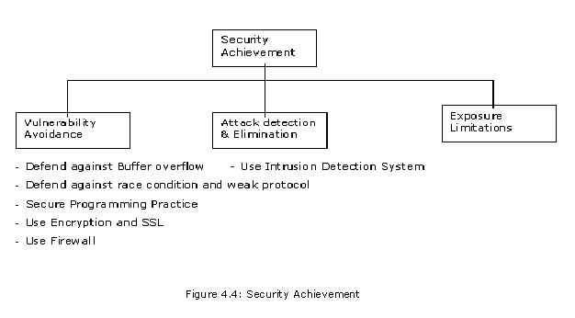

Security assurance Vulnerability avoidance:
The system is designed so that vulnerabilities do not occur. For example, if there is no external network connection then external attack is impossible.

Defending against buffer-overflows:
Buffer Overflows constitute for about 50% of the vulnerabilities reported by CERT (Coordination Center at CMU) and to defend against this problem
To defend against most widely known buffer overflow problem during developing any application is either select programming language which is immune to buffer overflow or always use function that makes the boundary check for arrays or count bytes of data (input validation) before copying them onto the stack. Programming languages like Perl automatically resizes arrays, and Ada95 detects and prevents buffer overflows. The most widely used programming language “C” has no built-in bound checking. If you prefer the C programming language, always use a system library functions version that makes the check (such as strncpy(), snprintf() ) or to count the bytes of data before copying them onto the stack.
Range checking compilers: To check buffer over flow problems at compile time, we need range checking compilers that checks buffer over flow by adding code to check bounds, or to arrange data structures in memory to cause hardware faults if bounds exceeds. For example Compile your code with /GS flag if it is developed in Microsoft Visual C++ system. The /GS option detects some buffer overruns, which overwrite the return address — a common technique for exploiting code that does not enforce buffer size restrictions. This is achieved by injecting security checks into the compiled code.
Although using a range-checking compiler is a good step to avoid buffer overflows it is still not a complete solution. Range checking compilers are not smart enough to catch all possible overflows as well as they are unable to simulate run-time behavior [32]. The only problem with using a range checking compilers is that compilation process becomes slow.
Using separate address/data stacks : Using separate data and system stacks is another method to defend against buffer overflow problem. In this scheme, user data stack is strictly separated from that of the system. This makes buffer overflow exploits impossible but requires special hardware support. Data in user stack should be restricted from being pointed by the instruction pointer. Conversely, data stored in the system stack, while it is only managed by a priveleged process most likely by the operating system itself, will be safe [14].

Defending against race conditions and weak protocol
To avoid race condition, while running the operations which required group of commands to be run in one stop, either disable the interrupts before enabling those kind of operations or lock buffer and temporary files used by that operations either using semaphores in producer and consumer process or some other method.
Most protocol weaknesses are the results of bad design. When designing a new protocol for distributed systems consider even the most awkward situations. To overcome protocol weakness problems, extreme care should be taken in the design phase. According to Burak DAYIOĞLU – Mustafa YAVAŞ [14], “Implementation problems can be solved in time, but design problems cannot be solved after wide deployment of protocol implementations.”
For web appliaction which are using http protocol for communication between client and server, use encryption to send the security related information passed via query string or communication channel, to prevent attack like query string manipulation or cookie manipulation. Do not use HTTP Headers to make security decisions.

Secure Programming Practices
Based on web attacks today, it would be negligent to not build hacker resistant code. Educating programmers to avoid common security mistakes and pitfalls and solutions that can be utilized to alleviate those mistakes. By performing security code reviews, and testing applications for security bugs, organizations can move quickly to eliminate many of the vulnerabilities commonly exploited today and designing and building secure application. Some of the technique that applied immediately to software development projects, so that future software developers won’t repeat past mistakes, are like use clean, clear and precisely defined interface module, take great care when need to use Error-prone constructs such as Floating-point numbers, Pointers, Dynamic memory allocation, Recursions, Interrupts etc, be careful on reference through the null pointer. While designing the system, ensure that application gains access only to least privileged process, services and user accounts to prevent elevation of privilege. Also perform thorough input validation on form fields, query strings, cookies. Always check for scripting tags and filter the same. Regular expression is the best way of validating input and to prevent XSS, SQL Injection. To prevent SQL Injection attack, set appropriate privileges to execute the SQL commands and to execute stored procedures using arguments always use parameterized stored procedures. According to Burak DAYIOĞLU – Mustafa YAVAŞ [14], “Some machines do not care this option and you may access machine instructions while other machines crash your program.” Also don’t leave in vulnerabilities like password, file etc. on memory. To remove these vulnerabilities, Clear the important data (as passwords) from the memory by using bzero or memset functions, clean out the files by overwriting if they contain sensitive data. Even most system penetrations caused by known vulnerabilities, for which patches already exist, so always install all the patches recommended by vendors.
If programming language is C or C++, write better C/ C++ code like use C++ with the string class, use StackGuard( StackGuard is a compiler that emits programs hardened against "stack smashing" attacks.) or GS, use the bounds-checking C compiler. If possible use strong programming languages like C# and Java. In Java Applets also, there is too much trusted code like class loader, byte code verifier, run-time library etc. but browser in which these byte code runs, are still vulnerable. So use a system call model – promotes cleaner, clearer interface and implement a lot of the run-time library in Java. While programming, handle all types of exception in your application through out the code base to prevent denial of service as well as important information being shown in exception to users because when the exceptions are thrown from the application, it might reveal the SQL information like tables, connection strings, column names, etc… that will become a open door for an attacker to take the entry into the application. Also log all the exceptions that rose in the application for internal use. However, show appropriate information in the front end to the user who received this exception. Also avoid accepting file name as input to prevent canocalization attack. When there is a need for accepting input to grant access, convert the name to canonical form prior providing security decisions. Also assure well formed filenames are received and check whether they are within your application’s directory hierarchy and the character encoding is set correctly to limit how input can be represented.
Enable auditing and logging to prevent the issue of repudiation that concerned with user denying that he/she performed an action or initiated a transaction, a defense mechanism should be in place to ensure that all the user activity can be tracked and recorded But do not keep the log files in the default location folder. Move it to a different location. Set the expiry property for the content rendered in the browser or force the browser not to cache the information. For example always use timeout property for the cookie information. This will reduce the probability of attack like session reply attack.

Use Encrytion
Encryption is the most effective way to keep sensitive data private and secure by encrypting it before it is sent to make sure that it cannot be read by anyone other than intended recipient(s). By encrypting critical data stored on system, it difficult for attackers to access confidential data or to eavesdrop as well as making it impossible to replay listened messages. Encryption operates by applying an encryption algorithm and key to the original data to convert it into an encrypted form, known as ciphertext.
There are two main classes of encryption algorithm in use:
Symmetrical (Secret-key) encryption
The same key is used to encrypt and decrypt messages and two sides must coordinate to send an encrypted message.
For example in below figure Alice wants to send message to Bob. Alice has an encryption key (key_{e}) and Bob has decryption key (key_{d}) where key_{e} = key_{d}. Using key_{e}, Alice encrypt the message to E(key_{e}, text). Bob gets this encrypted message E(key_{e}, text) and decrypts an encrypted message using decryption key (key_{d}). So, after decryption D(key_{d}, E(key_{e}, text)) = text, Bob gets original text message.
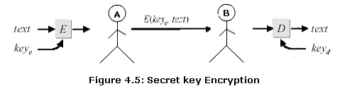

The most common symmetrical encryption system is the Data Encryption Standard (DES).The DES algorithm has been optimised to produce very high-speed hardware implementations, making it ideal for networks where high throughput and low latency are essential. Other examples of symmetrical encryption are: Triple DES (3DES) and Advanced Encryption Standard (AES), which are intended to eventually replace DES.Triple DES was created to extend the life of DES.
Issue in Symmetrical (Secret-key) encryption
The main problem with secret-key cryptosystems is that the sender and receiver must agree on the secret key without anyone else finding out. Anyone who overhears or intercepts the key in transit can later read, modify, and forge all messages encrypted or authenticated using that key
Asymmetric (Public-Key) encryption.
In Public Key encryption, each user has two keys: a public key_{e} and
a private key_{d}. The pubic key is available to everyone, but the private key remains a secret known to the user only. Public-key encryption makes key distribution among communicating pairs easier.
For example in below figure Alice wants to send message to Bob. Alice looks up Bob’s public key key_{Be}, encrypt the message using key and send encrypted message E(key_{Be}, text) to Bob. Bob reads the message D(key_{Bd,} E(key_{Be}, text)) = text using his private key key_{Bd.}
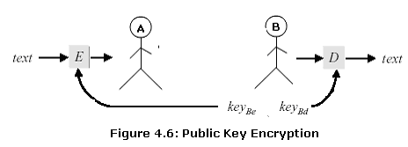
The most common asymmetrical encryption is RSA. Authentication is needed to verify that sensitive data has not been altered, and that the message comes from an authorized user. It operates by calculating a Message Authentication Code (MAC), commonly referred to as a hash. Examples of hashes are: Secure Hash Algorithm (SHA), Message Digest 5 (MD5), and Hashed Message Authentication Code (HMAC).
Issue in Symmetrical (Secret-key) encryption
RSA cryptography ensures the secure transmission of data as long as large prime numbers are used. AS per RSA [44] “to break the 512-binary-bit key, equivalent to 155 decimal digits, the team (an international team of cryptographic researchers ) took a total elapsed time of 5.2 months, not including nine weeks needed for preliminary computations, and was accomplished using 292 individual computers located at 11 different sites in The Netherlands, Canada, the United Kingdom, France, Australia and the United States. These latest results were achieved using about 160 175-400-MHz SGI and Sun workstations, eight 250-MHz SGI Origin 2000 processors, 120 300-450-MHz Pentium II PCs and four 500-MHz Digital/Compaq CPUs, and required approximately 8000 MIPS-years of CPU effort. The specific approach used to determine the prime factors was based on the work done to solve the RSA-140 Challenge earlier this year.” Prior to this, the largest RSA key length to be factored was 140 decimal digits long in February of this year [44]. RSA's recommended key lengths are 230 digits or more because the larger the prime number used in the calculations, the more difficult the encrypted message is to decode. However, large prime numbers also make decryption more cumbersome.
The security of an encryption system depends on the secrecy of its key information, because it is easy to discover what type of algorithm is being used. When the ciphertext is received the decryption algorithm and key are used to recover the original plaintext.
But an attacker can decrypt to original information, if they get access to either encryption key or they can intercept or arrive to encryption key from the encrypted information. Attacker can identify this key only if they are poorly managed or they were not generated in a random fashion. Therefore use strong random key generation functions and store the key in a restricted location — for example By using public key encryption, such as the X.509 digital certificates with secure socket layer (SSL), communication security can be achieved. The emerging electronic commerce market makes high use of SSL with X.509 certificates both for authentication and secrecy purposes [14].
Key Management is used to create, distribute, store and delete encryption keys. Keys that are changed frequently make it difficult for attackers to get to encrypted data.

Attack detection and elimination:
The system should be designed so that attacks on vulnerabilities are detected and neutralized before they result in an exposure. For example, virus checkers find and remove viruses before they infect a system Virus checking software will pick up many of the Trojan Horses that might be installed during such an attack. Firewalls may or may not protect against these attacks. Run the minimum number of services, disable automatic execution of software upon the receipt of e-mail, do not blindly start up software such as NetMeeting, and install security patches as soon as possible. Even businesses are expanding exponentially using the Internet as a resource. Because of its quick evolution, system monitoring and administration is becoming an endless task. Firewalls are good, but when malicious traffic originates from inside your network or enters through a hole in the firewall you may need another line of defense to protect you. Intrusion Detection is the process and methodology of inspecting data for malicious, inaccurate or anomalous activity that must be executed by system administrators in order to maintain secure networks. Intrusion Detection is a necessary process that must be fully understood and executed to maintain network security. The purpose of an intrusion detection system (or IDS) is to detect unauthorized access or misuse of a computer system. Intrusion detection systems are kind of like burglar alarms for computers. They sound alarms and sometimes even take corrective action when an intruder or abuser is detected. Many different intrusion detection systems have been developed but the detection schemes generally fall into one of two categories, anomaly detection or misuse detection. Anomaly detectors look for behavior that deviates from normal system use. Misuse detectors look for behavior that matches a known attack scenario. Intrusion Detection systems generate by far too many false alarms, and rarely suggest effective reactions on true alarms. More R&D is needed that improves the quality and meaningfulness of alarms, eg, by considering semantically richer layers and specific applications.

Exposure limitation:
The system is designed so that the adverse consequences of a successful attack are minimized. For example, a backup policy allows damaged information to be restored. Since a computer system or a network consists of many parts in which all parts usually need to be present in order for the whole to be operational, much planning for high availability centers around backup and fail over processing and data storage and access. For storage, a redundant array of independent disks (RAID) is one approach. A more recent approach is the storage area network (SAN). Some availability experts emphasize that, for any system to be highly available, the parts of a system should be well designed and thoroughly tested before they are used. For example, a new application program that has not been thoroughly tested is likely to become a frequent point-of-breakdown in a production system.
Firewall can also be used to prevent viruses from entering a user's internal system, but you may have the world’s best firewall, but if you let people access an application through the firewall and the code is remotely exploitable, then the firewall will not do you any good (not to mention the fact that the firewall is often a piece of fallible software itself). The same can be said of cryptography. In fact, 85% of CERT security advisories could not have been prevented with cryptography [Schneider, 1998]. Data lines protected by strong cryptography make poor targets. Attackers like to go after the programs at either end of a secure communications link because the end points are typically easier to compromise. As security professor Gene Spafford puts it, “Using encryption on the Internet is the equivalent of arranging an armored car to deliver credit card information from someone living in a cardboard box to someone living on a park bench.”
Weak passwords or bad key management practices can circumvent even the strongest cryptography schemes. So use strong passwords with that are complex. Use mixture of uppercase, lowercase, numerals, and special characters in the password that makes difficult to crack to prevent dictionary attacks. Unused software/tools/commands should be removed, and network services should be disabled. If it is not there, it can't be exploited. A Web server does not need X11, games, etc. The system should be built for one purpose, exposing it to the least amount of risk. It is also important to ensure that all configurations are correct. On many distributions, the default settings are generally calibrated for usability, rather than high security. Finally, it is imperative that the system is protected from remote network attacks. A properly configured, restrictive, firewall can go a long way in improving a systems security posture. In several situations, by taking simple precautions, security can greatly be improved [45].
Chapter 5

Experiment on Student Project
The main purpose of this thesis is to assert how any System is best built so that System becomes Trustworthy System. Three questions are concentrated on: How to build a reliable system, how to secure system and consider all possible safety concerns. In order to answer these questions, data from three projects performed at Stevens Institute of Technology has been collected and analyzed.
To understand all the problems using some application and find the solution to the questions raised in chapter 1, we use some mathematical models and checklist to study, gather and adapt the nature of software and how we can control.

Tools Used In the Experiments

eValid
eValid is Browser-Based Client-Side WebSite Mapping & Analysis, Functional Testing and Validation, Server Loading, Page Timing/Tuning, and Quality Monitoring tool. According to eValid [48] “eValid’s Web Browser™ is a test engine that provides you with browser based 100% client side quality checking, site mapping, dynamic testing, content validation, page performance tuning, and webserver loading and capacity/performance analysis.”. We used eValid tool in experiment to measure Total time taken by application Module to run using normal operational profile.

Rats
RATS - Rough Auditing Tool for Security, developed by Secure Software Inc. According to RATS [49] “It is a tool for scanning C, C++, Perl, PHP and Python source code for buffer overflows errors and TOCTOU (Time Of Check, Time Of Use) race conditions.”
When started, RATS will scan each file specified on the command line and produce a report when scanning is complete. What vulnerabilities are reported in the final report depend on the data contained in the vulnerability database or databases that are used and the warning level in use. For each vulnerability, the list of files and line numbers where it occurred is given, followed by a brief description of the vulnerability and suggested action. We use RATS tool in experiment to find buffer overflows and race condition problem in projects.

BlocksIM 6
Reliasoft’s BlockSim 6 allows analyzing any process or product to obtain exact system reliability results (including system reliabilities, mean times, failure rates, etc.), to calculate the optimum scenario to meet system reliability goals and to obtain maintainability, availability and throughput results through discrete event simulation. According to Reliasoft [49] “You can then configure these blocks into a reliability block diagram (RBD) that represents the reliability-wise configuration of the system and analyze the diagram in order to determine the reliability function (cumulative density function or cdf) of the entire system.” We use BlocksIM6 to calculate aggregate failure rate, MTTF and to analyze different reliability graphs.

Project Overview

Citigroup’s Low Cost Development Project
Citigroup's Low Cost Development Office attains cheaper resources and supplements in-house resources by hiring abroad, or hiring consultants at a much less expensive rate than U.S. standards. By creating a web application that will automate this new hire process, the manual and tedious labor involved with calling the medical office, asking and confirming dates for drug test checkups, calling the proper authorities to run background checks, and manually filling out paper work will be eliminated and replaced by a web application where the proper users may log on and confirm that each stage of the new hire process is complete. Project will also enable Citigroup to create monthly reports that could be presented to management regarding the status of the new hire process.
This project will perform function like file NHP’s, schedule drug tests, confirm appointments with consultants, get results from medical, communicate results to vendor and Citigroup manager, co-ordinate consultant start date, supply start date and other information to HR, enter background check results, enter fingerprinting results, create system IDs for consultant.
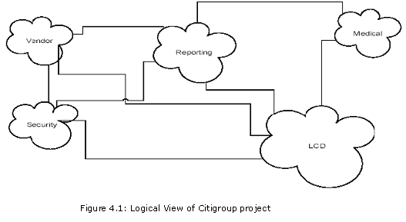

ACS
The objective of the project is to create a web-based tool, which will allow doctors electronically to administer medically approved surveys, and pharmaceutical firms to conduct research for their own medical products. The product will consist of a user interface that will allow an individual to answer the questionnaire and formulate a medical diagnosis based upon the individual's responses. Project database design has the ability to handle three major properties, sequencing, branching and scoring. Technologies that were used - ASP.NET, C#, SQL Server. Briefly, some of the features the application will handle are as follows:
Percentage decrease in turnaround time: 75% decrease from around 1 month down to 1 week for processing of data. Currently it takes approximately 6 weeks to process surveys from the time they are printed and mailed to the time they are entered into a database and the information compiled into reports.
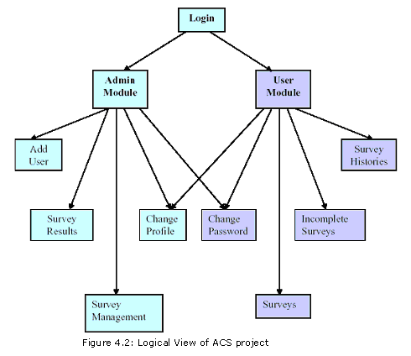

Gameboy
The game currently in development is classified as an arcade style shooter (in the vein of Galaga, Gradius, and R-Type), and will feature a damage system, complex collision detection, multiple levels of different design, more complex ‘boss’ style battles. Additionally, a weapons upgrade system, cut scenes, equipment, and a simulated acceleration/ deceleration speed system will be added piecemeal and when time permits.
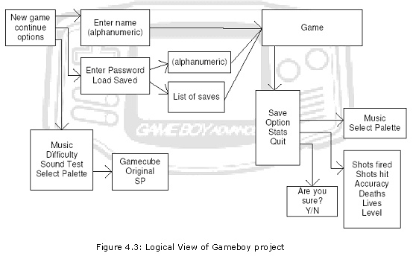
Following technologies are utilized to communicate within the structure:
(1) CVS – Concurrent Version System (for source control). (2) Web Wiki – Living Documentation. (3) Mailman – Simple mailing list communication

Here in Gameboy project, there are three modules: (1) New Game, (2) Continue and (3) Options

Experiments
To check trustworthiness of student projects Citigroup, ACS and Gameboy, We will examine reliability, security and safety for each project. These experiments allow explanation of the problems listed in chapter 1.

Experiment one: Citigroup Project

Reliability Analysis
Reliability is the probability that a system or a capability of a system functions without failure for a specified period in a specified environment. The period may be specified in natural or time units.
This experiment was designed to study the effect of missing requirements, design and other faults, which leads to failures of the system. The system has less probability of reliability if probability of failures is more. We will examine this effect by graph.
In order to define Necessary Reliability for this website, let’s examine the Normal and Critical operation for Citigroup website.
Operational Modes of Citigroup project
Normal Operations: • Data viewing by Users (Vendors, Medical, Security) • User logins/Account Creation • Entering Consultant’s information or Consultant’s result. •Scheduling drug test
Critical Operations: • Get result from Medical • Enter background check result • Enter fingerprint result • Approve or reject consultant • Failure Severity Objective
Cost Impact: • Severity 1: Website down, Interface with Medical or security site down • Severity 2: Slow processing of requests • Severity 3: Application is not compatible with other application like mozila browser, MAC O.S.
Service Impact: Service impact measures the activity, which impact the end user
• Severity 1: Website Down/Slow, Interface with /Medical /Security • Severity 2: None • Severity 3: Schedule Downtime
Use Impact: User Impact measures how well is the service getting through to the individual market. • Severity 1: Website down • Severity 2: User Login service down/ Sending survey result to Admin not working/slow, Design error which lead user logged out in between process • Severity 3: Broken links, Inconsistent Survey information

By reviewing Documentation and code of this project, following are the some of the faults responsible for failures. In Citigroup project, only one version of software is used, so, redundancy should apply to single version to detect and recover from faults.
Missing requirements: Not killing session after logout
Code not implemented to design: No option to view newly created user and his/ her information in admin mode.
Missing Code: Application is not handling any exception through out the code.
Function is not working as expected: Function to Edit NHP information, function to store date in specified format and retrieved stored date
In the presence of above faults, we used eValid tool [48] to measure the number of failures in certain duration. Following table shows some set of transactions in Normal operation. Here we assume that all transactions are equal probable.

FirstName | LastName | mid_name | maiden_name | d_o_b | Address1 | Address2 | City | State | Country | Zip | Vendor | ssn | start date | end date | daily rate | smt | proj_manager | proj_name | p_and_l | Location | rits_id | skill_set | invoice_name | is_fixedprice | status | transfer_from | transfer_to varchar | replace_name
Test | Test1 | T | k | 12-10-78 | Test St. Test, |  | Hoboken | NJ | US | 07035 | Data Inc | 123-456-7890 | 12-05-2005 | 05-05-05 | 30 |  | Bakhru | Fix Deposit |  | NJ |  | C, C++
Steve | Hauck | N | Scoble | 06-15-70 | Garde st | Rock Ave | Short Hills | CT | US | 05612 | RCM | 145-783-1564 | 02-02-2000 | 10-10-2010 | 50 |  | Mike | Fund Raise |  | CL |  | Java
Ekta | Parikh | A | Shah | 02-10-65 | Ange ave |  | Dover | NJ | US | 07039 | pfizer | 154-789-6523 | 10-30-2002 | 12-30-2002 | 100 |  | Tom | Services |  | NJ |  | Testing
Bob | Panchal |  | O’hara | 04-25-1999 | JFK Blv |  | Littlewood | CL | US | 06524 | Temp | 456-782-1245 | 06-06-2001 | 05-29-2002 | 20 |  | Jan | Web
David | Washington |  |  | 05-05-1960 | Temp |  | Test st | AZ | US | 05623 | Link | 561-458-7825 | 05-07-2000 | 05-07-2002 | 37 |  | Tina | SMS |  | AZ |  | Install | sfdsaf
Jessica | Simpson | h | chadda | 10-25-1955 | No add | hgjh | saragam | CO | US | 06542 | Bytes | 154-789-4521 | 06-08-1998 | 03-04-2009 | 8 |  | Boss | Admin |  | CL |  | Type
derrick | ellerbie | h |  | 06-29-1987 | Orange St | Test | Edison | NJ | US | 04563 | Megha | 452-896-1450 | 02-27-1985 | 05-27-1995 | 22 |  | Greg | Help Desk |  | CO |  | Comm.
rickey | smiley |  | Mickey | 10-15-2000 | New Rd | Brunswick bl. | Beville | UT | US | 048123 | Kimo | 125-451-2310 | 06-15-1999 | 12-31-1999 | 10 |  | Jason | Support |  | NV |  | Lang
Prachi | Chokshi | i | Pandit | 09-01-1965 | Old Blvd |  | Long Brach | TX | US | 07632 | FastTrack | 036-124-4578 | 11-25-2004 | 05-31-2005 | 60 |  | Lisa | IT |  | TX |  | Database
Jason | Ryan | s | Dong | 07-25-1999 | Lake st. |  | Las Vegas | NV | US | 05148 | Ring | 361-452-1245 | 01-01-2000 | 07-01-2004 | 45 |  | Linda | Networking |  | NJ |  | TCP – IP
Deep | Gandhi | l | Shah | 05-06-2004 | Temp St. |  | Piscataway | NJ | US | 02756 | Pioneer | 562-150-7812 | 03-15-2002 | 09-31-2008 | 8 |  | Bob | Marketing |  | NY |  | Marketing

Note: To view all the data of above table, please see in Normal View.

Failure Rate for each Module is determined by equation
λ = where n is the number of failure occurring and T is the period of observation (calendar time) in sec.
Module i | Start time(sec) | End time(sec) | Failure rate
1 (Admin) | 0 | 476.062 | 2 x 10^{-3 (1 fails)}
2 (Vendor) | 0 | 328.172 | 6 x 10^{-3 (2 fail)}
3 (Medical) | 0 | 49.062 | 0
4 (Security) | 0 | 55.016 | 0

Admin Module Failure Rate Calculations:

Calculation of End Time (Using e-Valid tool)

Purpose: To find how much time Admin Module takes, if we browse all the functions of Admin Module.
- In e-Valid browser enter Citigroup project URL
- Begin recording by selecting start ->recording menu from browser
- Browse all functions of Admin Module and enter the data as shown in above table wherever required. At the end click on exit
- From e-Valid browser, select Record -> Stop recording
- From e-valid browser, select site analysis ->start analysis
- At the end, e-valid will give below report.

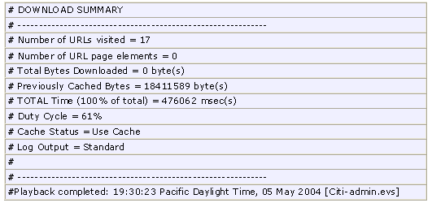
Below are the Manual test cases in which system failure or undesirable output occurs.
 | Description |  | Input/Process | Expected Results | Results |  | Type of Fault |  | Description
1 |  | Verification of NHP Edit function | Login as Admin user. Select ‘Consultant Pending for final approval’ from Administrator drop down menu. Select any consultant. Click on ‘submit’ button. Enter ‘RITS ID’ – 11. Click on ‘Submit’ button. | ‘submit’ confirmation message should display. |  | “Warning: mail(): SMTP server response: 503 No recipient(s). in D:\hims\citilcd\adminRitsIDIssue.php on line 69” will display. |  | Design Error (Permanent Fault) |  | Email server could not find recipient

Failure Rate (λ) = = 1/ 476.062(sec) = 2 x 10⁻³ failures/second

Vendor Module Failure Rate Calculations:

Calculation of End Time (Using e-Valid tool)

Purpose: To find how much time Vendor Module takes, if we browse all the functions of Admin Module.
- In eValid browser enter Citigroup project URL
- Begin recording by selecting start ->recording menu from browser
- Browse all functions of Vendor Module and enter the data as shown in above table wherever required. At the end click on exit
- From e-Valid browser, select Record -> Stop recording
- From e-valid browser, select site analysis ->start analysis
- At the end, e-valid will give below report 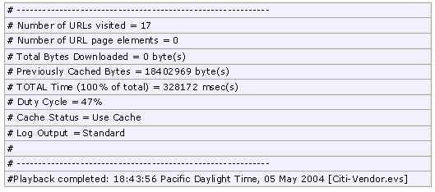
Below are the Manual test cases in which system failure or undesirable output occurs.

 |  | Description |  | Input/Process |  | Expected Results |  | Results |  | Type of Fault |  | Description
1 | Verification of ‘Previously saved NHP Form’ function not working as expected. |  | Login as ‘Vendor’. Click on ‘Add Consultant NHP Information’. Fill all required information. Click on ‘Save button’. Now select ‘work on Previously saved NHP Form’ from Vendor drop down menu. Click on submit button. |  | Consultant should be added and confirmation message should display. |  | ‘Consultant was not added’ message will display. |  | Design Error (Permanent fault) |  | Incorrect logic
2 |  | Verification of date field is not working as expected |  | Login as ‘Vendor’. Click on ‘Add Consultant NHP Information’. Fill all required information. Enter 1111-11-11 in date of birth field. Click on ‘Submit’ button. Select “Search for consultant” from vendor drop down menu. Enter Last Name of previously added consultant. Hit Search button. Click on view/Edit information button. |  | All the information along with date should be the same as it was entered. |  | The entered date will be changed to default 0000-00-00. |  | Design Error |  | Data inconsistency

Failure Rate (λ) = = 2/ 328.172(sec) = 6 x 10⁻³ failures/second

Security Module Failure Rate Calculations:

Calculation of End Time (Using e-Valid tool)

Purpose: To find how much time Security Module takes, if we browse all the functions of Admin Module.
- In eValid browser enter Citigroup project URL
- Begin recording by selecting start ->recording menu from browser
- Browse all functions of Security Module and enter the data as shown in above table wherever required. At the end click on exit
- From e-Valid browser, select Record -> Stop recording
- From e-valid browser, select site analysis ->start analysis
- At the end, e-valid will give below report.
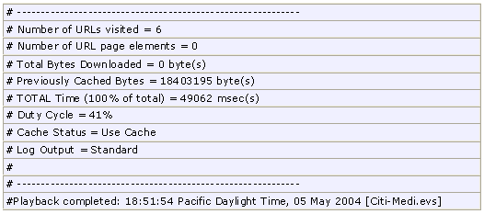

Failure Rate (λ) = = 0/ 490.62(sec) = 0 failures/second

Medical Module Failure Rate Calculations:

Calculation of End Time (Using e-Valid tool)

Purpose: To find how much time Medical Module takes, if we browse all the functions of Admin Module.
- In eValid browser enter Citigroup project URL
- Begin recording by selecting start ->recording menu from browser
- Browse all functions of Medical Module and enter the data as shown in above table wherever required. At the end click on exit
- From e-Valid browser, select Record -> Stop recording
- From e-valid browser, select site analysis ->start analysis
- At the end, e-valid will give below report.
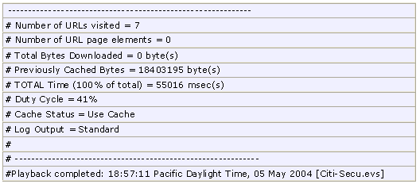

Failure Rate (λ) = = 0/ 550.16 (sec) = 0 failures/second

To calculate reliability and analysis of the application, we used above data in BlocksIM 6 tool [50]. Below is the results we get from BlocksIM 6.

Reliability Block Diagram for Citigroup
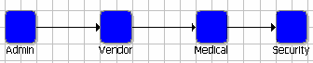
System Reliability Equation
RSystem=+RVendor.RVendor.RMeidcal.RSecurity
Aggregate Failure Rate (ג) : Here we assumed that a software system is operating in an environment with an unchanging operational profile. In other words, the distribution of the types of user demands or requests for system capabilities do not vary with time. We also assume here that no changes are made to the software during operations. Then the software might be modeled with a constant failure rate .Failure rate at t = 100 sec is constant for the system and it is 0.0082 and Mean Time to Failure (MTTF) is 122.0416 sec

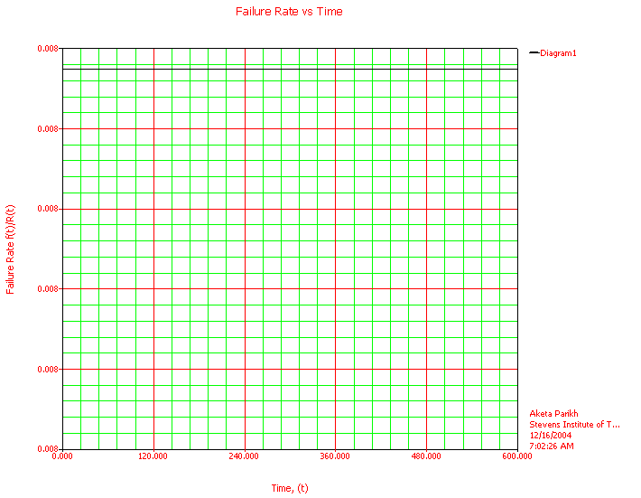

Standard Probability Calculation
Mission End Time (sec) | Reliability | Probability of Failure
50 | 0.6640 | 0.3360
100 | 0.4409 | 0.5591
150 | 0.2927 | 0.7073
200 | 0.1944 | 0.8056
300 | 0.0857 | 0.9143
400 | 0.0378 | 0.9622
500 | 0.0167 | 0.9833

Unreliability vs. Time (sec) for Citigroup
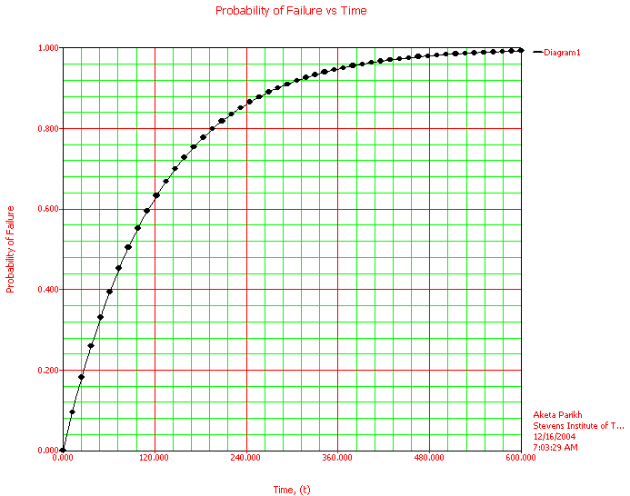

Using the above Unreliability vs. Time graph, one can determine how long system test must proceed until any reliability goal is met. Confidence bounds should be used for a reliability stopping rule instead of point estimates. For example, testing might stop when a 90% upper confidence bound on the number of remaining failures is below a required target bound. From above graph, we can see that for Citigroup project, failure rate increases very rapidly 240 sec and between 280 sec and 700 sec, intensity of failure is very high but failure rate increases slowly compared to initial time and at t = 600 sec, system will fail completely.

Reliability vs. Time for Citigroup
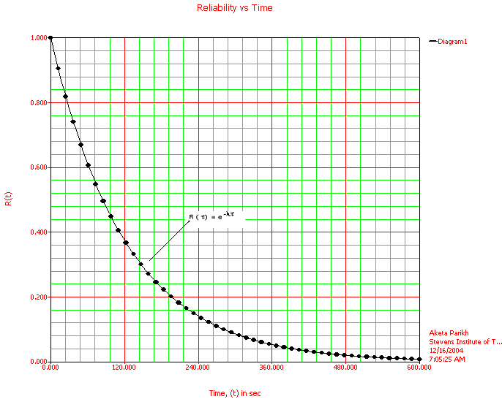

The probability that the software will operate without failure, the reliability R( ), becomes smaller the longer the time period under consideration. above graph shows this relationship in which reliability decreases exponentially with execution time . Also from the above graph we can see that at t = 600 sec when failure rate is maximum, reliability is minimum, in fact almost zero. Below table shows warranty of reliability at different time.
Warranty Time
Required Reliability | Time (sec)
0.99999 | 0.0012
0.99 | 1.2271
0.90 | 12.8645
0.80 | 27.2459
0.70 | 43.5501
0.60 | 62.3719
0.40 | 111.8792
0.1 | 281.1459
0.001 | 843.4378

Point Availability Plot (Simulation Plot) for Citigroup
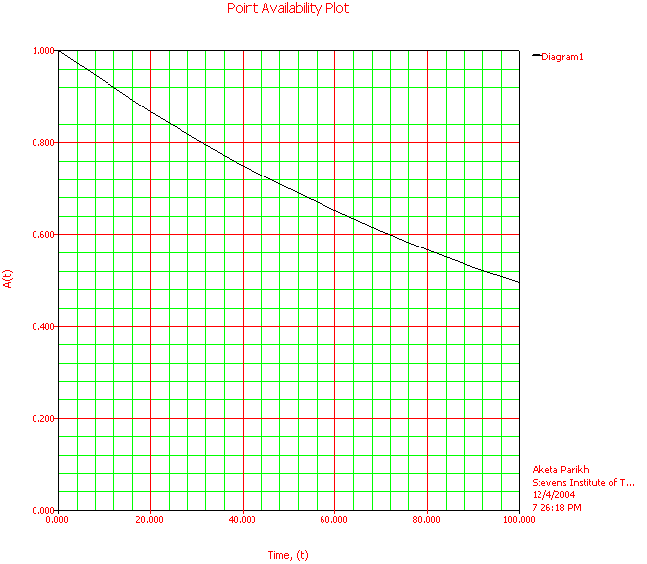
From the above graph, we can see that at t = 0, system is fully available and as time goes, availability decreases. For example at t = 100, availability of the reliable system will be only 50%.
From above analysis, we can see that design faults damage the system most. Whenever failure occurs because of design errors, it always damages the system. To get rid of failures because of design error, software should be capable to tolerate those faults and prevent application to fail. As we know from above analysis the goal of software fault tolerant can be achieved by making λ very small, thus reducing any failures of an application by handling failures inside the application. Citigroup project is single – version project and here faults because of incorrect logic is less compare to ACS application (see below analysis for ACS project), so by following approach mention in section 4.1.2.3.1, if we implement code with recovery blocks, defensive programming and exception handling, we can make application to handle failures because of faults in the application and prevent application to terminate abnormally. Like in above analysis if we use recovery blocks, we can rollback the data when failure because of data inconsistency occurs. Application should also include fault tolerant code to handle failure because of improper logic.

Security Analysis
The below Security Analysis table provides a detail analysis of each vulnerabilities, whether that vulnerability is available in the application or not, if available then what are the causes for that vulnerabilities, possible threat because of that and Countermeasures to prevent vulnerabilities and thus possible threat.
√ = Attack is possible
X = Attack is not possible

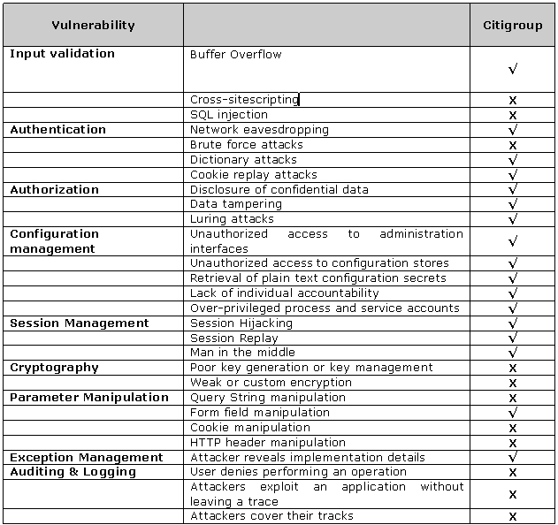

Below is the explanation for each attack whether is it possible or not and if possible what are the countermeasures.

Attack: Buffer Overflow
Possibility: √
Cause: Buffer Overflow vulnerability in mail ( ) function which affects admincheckUser.php,adminFpCheck.php, adminRitsIDIssue.php,forgotPassword.php,medicalEnterResults.php and vendorMakeAppts.php Modules
Possible Threats: - denial of service attacks eventually leads to process crash
- code injection which eventually alters the program execution address to run an attacker’s injected code
Countermeasures: Perform thorough input validation

To detect buffer overflow Vulnerabilities, we used RATS tool [49]. Below is the output generated by RATS tool.
C:\Ekta\Stevens-Sub\Thesis\Tools\RATE\rats-2.1\CitiLcd>rats --html adminAddUser0 .php adminAddUser1.php adminCheckUser.php adminFpCheck.php adminIndex.php adminP endingCompletion.php adminRitsIDIssue.php adminSubmitCompletion.php adminViewPen dingCompletion.php backgroundEnterResults.php backgroundViewPending.php changePa ss.php contact.php forgotPassword.php idxnoscript.php index.php lcd.php logout.p hp medicalEnterResults.php medicalIndex.php medicalViewSched.php medicalViewSche d0.php monthlyReport.php passChange.php securityIndex.php user_manual.php vendor App2.php vendorApproveNHP.php vendorConEditInfo.php vendorConEditInfoAux.php ven dorEditConInfoAux.php vendorIndex.php vendorMakeAppts.php vendorSearchConsultant .php vendorViewDTPending.php vendorViewPending.php Entries in perl database: 33
Entries in python database: 62
Entries in c database: 334
Entries in php database: 55
Analyzing adminAddUser0.php
Analyzing adminAddUser1.php
Analyzing adminCheckUser.php
Analyzing adminFpCheck.php
Analyzing adminIndex.php
Analyzing adminPendingCompletion.php
Analyzing adminRitsIDIssue.php
Analyzing adminSubmitCompletion.php
Analyzing adminViewPendingCompletion.php
Analyzing backgroundEnterResults.php
Analyzing backgroundViewPending.php
Analyzing changePass.php
Analyzing contact.php
Analyzing forgotPassword.php
Analyzing idxnoscript.php
Analyzing index.php
Analyzing lcd.php
Analyzing logout.php
Analyzing medicalEnterResults.php
Analyzing medicalIndex.php
Analyzing medicalViewSched.php
Analyzing medicalViewSched0.php
Analyzing monthlyReport.php
Analyzing passChange.php
Analyzing securityIndex.php
Analyzing vendorApp2.php
Analyzing vendorApproveNHP.php
Analyzing vendorConEditInfo.php
Analyzing vendorConEditInfoAux.php
Analyzing vendorEditConInfoAux.php
Analyzing vendorIndex.php
Analyzing vendorMakeAppts.php
Analyzing vendorSearchConsultant.php
Analyzing vendorViewDTPending.php
Analyzing vendorViewPending.php

RATS results.
Severity: High
Issue: mail
Arguments 1, 2, 4 and 5 of this function may be passed to an external progra m. (Usually sendmail). Under Windows, they will be passed to a remote email serv er. If these values are derived from user input, make sure they are properly for matted and contain no unexpected characters or extra data.
File: adminCheckUser.php
Lines: 150
File: adminFpCheck.php
Lines: 41
File: adminRitsIDIssue.php
Lines: 69
File: forgotPassword.php
Lines: 58
File: medicalEnterResults.php
Lines: 68 72 77
File: vendorMakeAppts.php
Lines: 121 122 158

Inputs detected at the following points
Total lines analyzed: 6853
Total time 0.000000 seconds
0 lines per second
C:\Ekta\Stevens-Sub\Thesis\Tools\RATE\rats-2.1\CitiLcd>
Below is the part of code where bold text shows the vulnerable in the code.
Location adminCheckUser.php
Description Arguments 1, 2, 4 and 5 of this function may be passed to an external progra m. (Usually sendmail). Under Windows, they will be passed to a remote email server. If these values are derived from user input, make sure they are properly for matted and contain no unexpected characters or extra data on line 150.
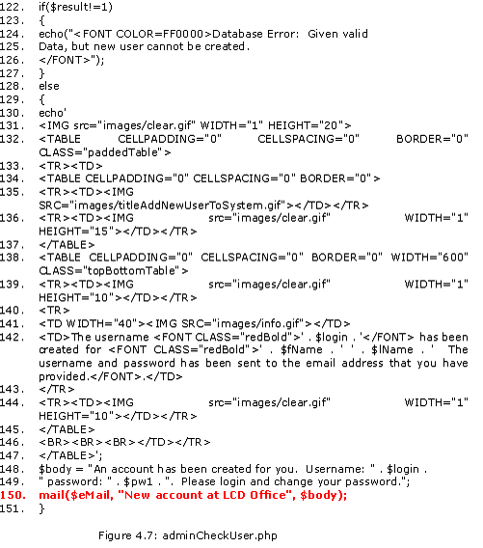
- Location adminFpCheck.php
Description Arguments 1, 2, 4 and 5 of this function may be passed to an external program. (Usually sendmail). Under Windows, they will be passed to a remote email server. If these values are derived from user input, make sure they are properly for matted and contain no unexpected characters or extra data on line 41.
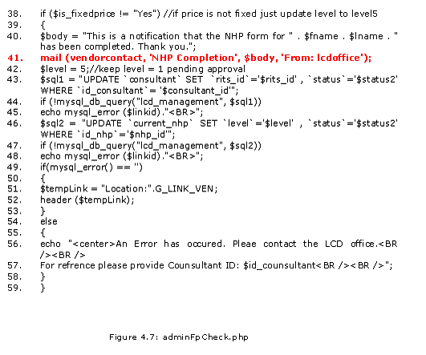

  - Location: adminRitsIDIssue.php
Description Arguments 1, 2, 4 and 5 of this function may be passed to an external program. (Usually sendmail). Under Windows, they will be passed to a remote email server. If these values are derived from user input, make sure they are properly for matted and contain no unexpected characters or extra data on line 69.
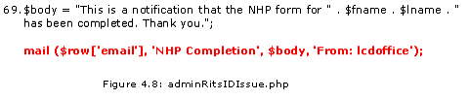
  - Location: forgotPassword.php
Description Arguments 1, 2, 4 and 5 of this function may be passed to an external program. (Usually sendmail). Under Windows, they will be passed to a remote email server. If these values are derived from user input, make sure they are properly for matted and contain no unexpected characters or extra data on line 58.
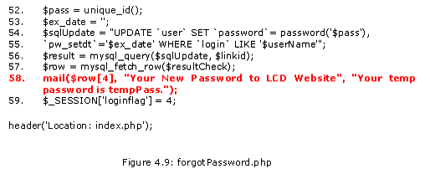
  - Location: medicalEnterResults.php
Description Arguments 1, 2, 4 and 5 of this function may be passed to an external program. (Usually sendmail). Under Windows, they will be passed to a remote email server. If these values are derived from user input, make sure they are properly for matted and contain no unexpected characters or extra data on line 68, 72, 77.
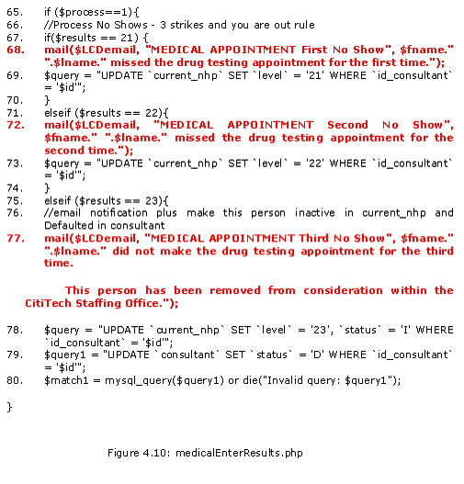
- Location: vendorMakeAppts.php
Description Arguments 1, 2, 4 and 5 of this function may be passed to an external program. (Usually sendmail). Under Windows, they will be passed to a remote email server. If these values are derived from user input, make sure they are properly for matted and contain no unexpected characters or extra data on line 121, 122, 158.
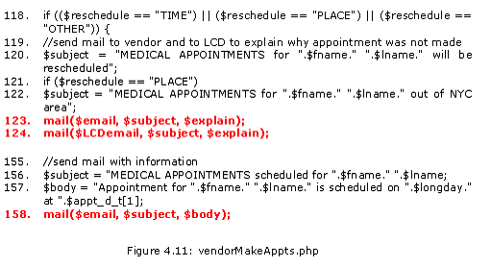

Attack: Cross-site scripting
Possibility: X
Cause: Application uses POST method to submit information, so attacker can not inject JavaScript, VBScript, ActiveX, HTML, or Flash into application.

Attack: SQL injection
Possibility: X
Cause: Application validate all the input received from the user.

Attack: Network eavesdropping
Possibility: √
Cause: Passwords are passed in plain text format from client to server.
Possible Threats: Using network monitoring software that can capture traffic leading to host which is on the same network, Attacker can get password and thus gain the access of the system

Countermeasures: - Use Kerberos authentication or Windows authentication which doesn’t transmit the password over the network
- When there is a necessity for transmitting password through network, use an encryption communication channel like SSL which will encrypt the contents passed through network channel

Attack: Brute force attacks
Possibility: X
Cause: No hash key is used to encrypt data. (Application is not implemented to do any encryption)

Attack: Dictionary attacks
Possibility: √
Cause: Sensitive information like password are stored in plain text format.
Possible Threats: Attacker can gain the access of the system
Counter –measures: - Use strong passwords with that are complex. Use mixture of uppercase, lowercase, numerals, special characters in the password that makes difficult to crack.
- Store non-reversible password hashes in the user store. Also combine a salt value (a cryptographically strong random number) with the password hash.

Attack: Cookie replay attacks
Possibility: √
Cause: Application uses cookie technology to store authentication information.
Possible Threats: The attacker can read authentication information that is submitted for the application to gain access. The attacker can then replay the same information to the application causing cookie replay attacks
Counter –measures: - Use SSL that encrypts al the information including cookie information passed through the channel
- Always use timeout property for the cookie information. This will reduce the probability of attack.

Attack: Disclosure of confidential data
Possibility: √
Cause: Passwords and other sensitive information are passed in plain text format from client to server.
Possible Threats: Unauthorized users can gain access to sensitive data
Counter –measures: - Before providing access to sensitive data perform a role check
- Always secure windows resources using strong Access Control Lists (ACL)
- Persistent stores like database and configuration files should store the sensitive information in the encrypted form

Attack: Data tampering
Possibility: √
Cause: Passwords and other sensitive information are passed in plain text format from client to server.
Possible Threats: An attacker, who gains access to the information transmitted through the network, can modify the information and the application while receiving will get the tampered data.
Counter –measures: - Always secure windows resources using strong Access Control Lists (ACL)
- Use role-based security to differentiate between users who can view data and users who can modify data.

Attack: Luring attacks
Possibility: X
Cause: entity with few privileges is able to have an entity with more privileges perform an action on its behalf

Attack: Unauthorized access to administration interfaces
Possibility: √
Cause: Application allows administrators and vendors to manage site contents and configuration.
Possible Threats: An attacker who gains access to the configuration management data can bring down the system by altering the configuration data.
Counter –measures: - Minimize the number of administration interfaces
- Use strong authentication like using digital certificates or multiple gatekeepers
- Avoid remote administration interfaces. If it is a must, provide access through VPN or through SSL.

Attack: Unauthorized access to configuration stores
Possibility: √
Cause: Sensitive data maintained in configuration stores.
Possible Threats: An attacker who gains access to the configuration stores can bring down the system by altering the configuration data.
Counter –measures: - Configure restricted ACLs on text based configuration files. For e.g. Machine.config and web.config should be configured for restricted access
- Keep custom configuration files outside the directory that doesn’t have web access

Attack: Retrieval of plain text configuration secrets
Possibility: √
Cause: Configuration files web.config stores password and connection string store the details in plain text format.
Possible Threats: External attackers who gains access can then see the sensitive information as it is stored in plain text format. Similarly, disgusted employees and administrators can misuse this sensitive information.
Counter –measures: Rather than storing the data in plain text format, store the sensitive information n encrypted formats.

Attack: Lack of individual accountability
Possibility: √
Cause: When the changes are made and who made those changes, these information are not being logged by application.
Possible Threats: Lead us to a threat of not being able to track the changes made by whom and when.
Counter –measures: - Administrative accounts must not be shared
- While using user/ application/service accounts, ensure that any damage to the privileges using this account can be identified
- Apply preventive measures for all the possible violation that you foresee

Attack: Over-privileged process and service accounts
Possibility: √
Cause: Application provide rights to change the configuration information
Possible Threats: An attacker can take advantage of the same to modify configuration information.
Counter –measures: - Avoid providing rights to change the configuration information unless it is mandatory. In that case, enable auditing and logging to track each and every change made by the account.

Attack: Session Hijacking
Possibility: √
Cause: Authentication is stored in a session for a particular user’s session. An attacker can use a network monitoring tool to capture this information.
Possible Threats: Having captured the authentication token, an attacker can spoof the user’s session and gain access to the system. An attacker can perform all the operations as that of legitimate user.
Counter –measures: - Avoid storing anything in the session objects. However, if the application demands that then use the following prevention technique
- Implement SSL as it will encrypt all the information that is transmitted via the network. In that case, the authentication token stored in the cookie too will be encrypted and sent via the communication channel.
- Allow only one session per user at a time. If a new session is started for the same user, implement logout functionality.
- Incase if SSL is not implemented and still there is a need to store information in the session object, ensure you set a time period for expiry. Though it doesn’t prevent the user from session hijacking, it reduces the risk of attack when the user is attempting for stealing cookie information.

Attack: Session Replay
Possibility: √
Cause: If an attacker gains access to the authentication token stored in a cookie, then the attacker can then frame a requests with the authentication cookie received from another user to the application from which the authentication cookie is sent
Possible Threats: An attacker gets access to the system as that of legitimate user.
Counter –measures: - Do not store authentication information on the client
- Whenever a critical function is being called or an operation is performed, re-authenticate the user
- Set expiry date for all cookies

Attack: Man in the middle Attack
Possibility: √
Cause: When communication happens between sender and receiver, an attacker can come in the middle and intercept all the messages transmitted between the sender and receiver, as password and all other information passed in plain text.
Possible Threats: An attacker can then change the information and send it to receiver. Both sender and receiver will be communicating with each other without the knowledge of a man in the middle who intercepts and modifies the information.
Counter –measures: - Use strong encryption. When the data is sent in a encrypted format, even though the man in the middle gains access to the information, s/he will not be able to intercept the original message as it is encrypted
- Use Hashing. When attacker tries to modify the hashed information, recalculation of hash will not be successful and hence it can be discovered that the information is modified in the middle

Attack: Poor key generation or key management
Possibility: X
Cause: Application is not using cryptography to encrypt information.

Attack: Weak or custom encryption
Possibility: X
Cause: Application is not using cryptography to encrypt information.

Attack: Query String manipulation
Possibility: X
Cause: Application uses POST method to submit information, so attacker can not inject JavaScript, VBScript, ActiveX, HTML, or Flash into application.

Attack: Form field manipulation
Possibility: √
Cause: As the HTTP Protocol transmits the information in plain text, it is still possible for the attackers to modify any form fields and their values that are sent to the server.
Possible Threats: Security credentials can be modified bypassing the client script validations.
Counter –measures: Use session identifiers to reference state maintained in the state store on the server.

Attack: Cookie manipulation
Possibility: X
Cause: Application is not using cookies to store sensitive information

Attack: HTTP header manipulation
Possibility: X
Cause: Application is not make any security decisions based on request and response headers. If so, the application is vulnerable to attack

Attack: Attacker reveals implementation details
Possibility: √
Cause: Application is not handling any exception through out the code.
Possible Threats: SQL information like tables, connection strings, column names, etc… may return when exception raise, that will become a open door for an attacker to take the entry into the application.
Countermeasures: - Handle all types of exception in your application through out the code base.
- Log all the exceptions that rose in the application for internal use. However, show appropriate information in the front end to the user who received this exception

Attack: User denies performing an operation
Possibility: X
Cause: Application is not creating any log file for user activity.

Attack: Attackers exploit an application without leaving a trace
Possibility: X
Cause: Application is not creating any log file for user activity

Attack: Attackers cover their tracks
Possibility: X
Cause: Application is not creating any log file for user activity

Safety Analysis
To determine whether the system could present a hazard to safety, we will do preliminary hazard analys (PHA) and subsequent system and software safety analyses to identify when software is a potential cause of a hazard or will be used to support the control of a hazard. Here we will use Hzard identification form, FMEA (Failure Mode and Effect Analysis) and FTA (Fault Tree Analysis) to identify potential safety problems.
Hazard Level Matrix: A Hazard level was determined by using a standard matrix (Described in book Safeware by Nancy Leveson, pp 264-265 [40]) to combine hazard severity and hazard probability. As described in Safeware book [40] “Here the hazard level was used to allocate resources for hazard control by establishing priorities for identified hazard”
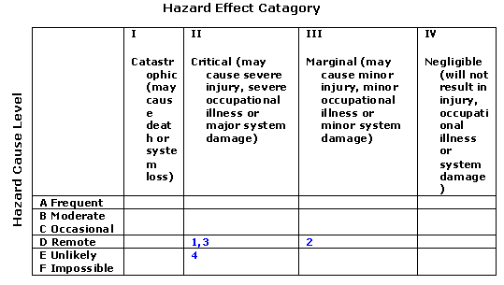
Here the number in the boxes are related to hazard condition as shown below in Hazard Identification Form
Hazard Identification Form for Citigroup Project
No | Hazard | Cause | Level | Effect | Category
1 | Faulty Admin Module | - Faulty Admin module approves vendor without /rejected medical or security check report  - Faulty Admin module approves vendor without /rejected medical report  -Faulty Admin module approves vendor without/ rejected security report. | D | Wrong person with criminal history / physically unfit get selected | II
2 | Faulty drug test report which shows mentally disable or unfit person as healthy person | - Fault in drug testing machine  - Fault in report generating system  - Fault in Citigroup system either in database or in module | D | Wrong person with criminal history / physically unfit get selected | III
3 | Faulty background check result which shows criminal as a good person. | - Fault in background check database  - Fault in report generating system  - Fault in Citigroup system either in database or in module | D | Wrong person with criminal history / physically unfit get selected | II
4 | Faulty Fingerprint result which shows criminal as a good person. | - Fault in Fingerprint checking mechanism  - Fault in report generating system  - Fault in Citigroup system either in database or in module | E | Wrong person with criminal history / physically unfit get selected | II

FAILURE MODE AND EFFECTS ANALYSIS (FMEA)
Below table shows FMEA for Citigroup Project to identify and list all components and their failure Modes. As described in Safeware book pp. 341-342[40], for each failure mode, the effect on all other system components are determined along with the effect on overall system.
Item / function |  | Potential Failure Mode | Effect of Failure | Potential Causes of Failure
Admin Module | - Faulty Admin module approves vendor without /rejected medical or security check report  - Faulty Admin module approves vendor without /rejected medical report  -Faulty Admin module approves vendor without/ rejected security report. |  | - Wrong person with criminal history / physically unfit get selected | - company data loss or damage to company property or loss of output work.
Vendor Module | - Faulty Vendor Module alter the SSN, DOB or other important vendor data. |  | - Wrong person get selected or good person get rejected | company data loss or damage to company property or loss of output work.
Medical Module | Faulty Medical Module passes wrong data to Admin Module |  | Wrong person get selected or good person get rejected | company data loss or damage to company property or loss of output work.
Security Module | Faulty Security Module passes wrong data to Admin Module |  | Wrong person get selected or good person get rejected | company data loss or damage to company property or loss of output work.
FTA for Citigroup Project:
For the FTA for Citigroup Project, from the knowledge of application and User Manual, The purpose of Citigroup Application is to automate vendor selection process. So for the FTA, we assume that top event will be “Wrong Person Selected”. To construct fault tree, we consider all the casual events related to top event [40].
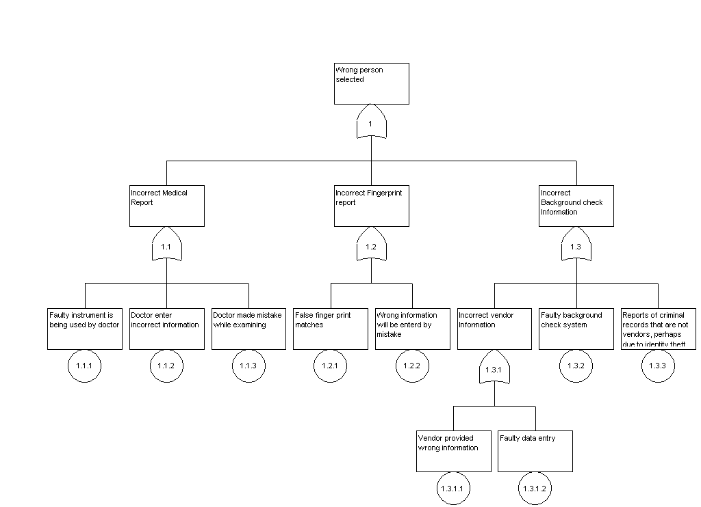
Figure 4.13: FTA for Citigroup project
From above analysis of Safety for Citigroup, we can see that this application is not Mission critical application but if wrong vendor selected then he/she can damage the system. Citigroup software cannot prevent wrong information provided by medical person as well as security person in our software, but check should done about information provided by Medical person and Fingerprint person. Our software should be able to prevent by accepting invalid data such as data 00/00/000. Also from Hazard level matrix, there are no any catastrophic or frequent critical hazards in this application.

Experiment two: ACS Project

Reliability Analysis
Reliability is the probability that a system or a capability of a system functions without failure for a specified period in a specified environment. The period may be specified in natural or time units.
This experiment was designed to study the effect of missing requirements, design and other faults, which leads to failures of the system. The system has less probability of reliability if probability of failures is more. We will examine this effect by graph.
In order to define Necessary Reliability for this website, let’s examine the Normal and Critical operation for ACS website.
Operational Modes for ACS project
Normal Operations: • Data viewing by Survey Users • User logins/Account Creation • Changing user profile/ password
Critical Operations: • Survey Management (activate/ deactivate survey) • Taking available or uncompleted survey • Compute a score based on user response
Cost Impact: • Severity 1: Website down, Interface with Money Broker site down • Severity 2: Slow processing of requests • Severity 3: Application is not compatible with other application like mozila browser, MAC O.S.
Service Impact: Service impact measures the activity, which impact the end user
• Severity 1: Website Down/Slow, Interface with /Medical /Security • Severity 2: None • Severity 3: Schedule Downtime
Use Impact: User Impact measures how well is the service getting through to the individual market. • Severity 1: Website down • Severity 2: User Login service down/ Sending survey result to Admin not working/slow, Design error which lead user logged out in between process • Severity 3: Broken links, Inconsistent Survey information
By reviewing Documentation and code of this project, following are the some of the faults responsible for failures. In ACS project, only one version of software is used, so, redundancy should applied to single version to detect and recover from faults.
Missing requirements: Not killing session after logout
Code not implemented to design: No option to view newly created user and his/ her information in admin mode.
Missing Code: Application is not handling any exception through out the code.
Function is not working as expected: Function to Edit NHP information, function to store date in specified format and retrieved stored date
Following are couple of scenarios when application is not working as expected because of presence of faults. Here we assume that all transactions are equal probable.

UserType | FirstName | LastName | Password | Email | Address1 | Address2 | City | State | Country | Zip | Telephone
doctor | David | Washington | DWashington | dwashington@stevens.edu | 289 Stevens institute of technology | 1 castle point on hudson | Hoboken | NJ | USA | 07030 | 2012163333
admin | debraj | ghosh | dghosh | dghosh@stevens.edu | Castle Point on Hudson |  | Hoboken | NJ | USA | 07030 | 2012165555
doctor | Jessica | Simpson | JSimpson | jessica@simpson.com |  |  |  |  |  | 12334 | 1738008900
admin | roger | lim | Rlim | rlim@stevens.edu |  |  | Old Bridge | NJ | USA | 07894 | 1111111111
admin | ankita | parikh | Aparikh | aparikh1@stevens.edu | 122 Madison Ave |  | Clifton | NJ | USA | 07011 | 9739430102
default | Srujal | Shah | SShah | sshah2@stevens.edu | 1 default st. | 1 default | default | aa | default | 00000 | 7325868888
doctor | hiral | shah | Hshah | hshah@stevens.edu | 701 lincoln street |  | Jersey City | NJ | USA | 07408 | 2012169874
doctor | derrick | ellerbie | Dellerbie | dellerbi@stevens.edu | 144 harbor side |  | Jersey City | NJ |  | 07305 | 2012163578
user | Arpan | Parikh | aparikh | arpan@aol.com | 1 Lake street |  | Jerssey | nj | us | 07306 | 2016537004
doctor | test | test | Ttest | dde@mailbox.com | 121 clinton street |  | hoboken | nj | us | 08201 | 2012198989
admin | rickey | smiley | Rsmiley | rick@jahav.com | 78 river road |  | edgewater | nj | usa | 90909 | 9999999999
user | yin | lee | Ylee | hohi@hohi.net | 4234 dsfsdf |  | brooklyn | ny | usa | 11204 | 7183313651
admin | hi | hi | Hhi | ylee3@stevens.edu | 233 sdfnsdf |  | brooklyn | ny | usa | 11204 | 7183313651
user | Larry | Bernstein | Lbernstein | lbernste@stevens.edu | 1 castle Point |  | Hoboken | NJ | USA | 07030 | 2018765432
admin | Aketa | Parikh | Aparikh | aparikh@stevens.edu | 1 ThisWay |  | Hoboken | NJ | USA | 07030 | 7321234567
user | Arpan | Parikh | aparikh | arpan@aol.com | 1 Lake street |  | Jerssey | nj | us | 07306 | 2016537004
admin | deez | smooth | dsmooth | deez@stevens.edu | l;kjalao |  | hoboken | nj | us | 07030 | 2012163600

Below is the Failure Rate for each Module
The failure rate of any Module is determined by equation
λ =
where n is the number of failure occurring and T is the period of observation (calendar time) in sec.

Module i | Start time | End time (sec) | Failure rate (per/sec)
1 (Admin) | 0 | 587.094 | 8 x 10⁻³
2 (User) | 0 | 90.718 | 11 x 10⁻³ (1 fail)
3 (Survey) | 0 | 263.265 | 3 x 10⁻³ (1 fail)

Admin Module Failure Rate Calculations:

Calculation of End Time (Using e-Valid tool)

Purpose: To find how much time Admin Module takes, if we browse all the functions of Admin Module.
- In eValid browser enter ACS project URL
- Begin recording by selecting start ->recording menu from browser
- Browse all functions in Admin Module and enter the data as shown in above table wherever required. At the end click on exit
- From e-Valid browser, select Record -> Stop recording
- From e-valid browser, select site analysis ->start analysis
- At the end, e-valid will give below report.
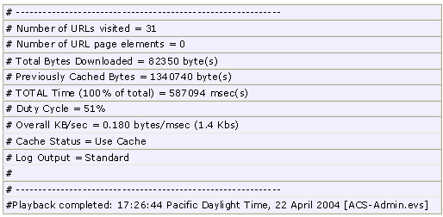

Below are the Manual test cases in which system failure or undesirable output occurs.

 | Description | Input/Process | Expected Results | Results | Type of Fault | Description
1 | Change Profile function not working as expected. | Login as admin. Select Admin Home. Click Change Profile from left navigation. Without searching any user, just Hit Update Profile button. | Application should ask user to enter search criteria. | The profile of current user (admin) who log in will be changed. | Design Error (Permanent Fault) | Incorrect logic
2 | User will be logged out without hitting logout option. | Select view/change user profile from Admin module. In search criteria select Email option and enter email address. Now Hit enter key from keyboard (don't click 'search button). | All the matching record for entered search criteria should display. | User will be logged out. | Design Error (Permanent fault) | Incorrect logic
3 | Duplicate Record for user allowed. | Select Admin Home. Click Add user. Enter all required field and click on ‘submit’. Now again click on Add user. Enter the same information for this user as previous user. Click on ‘submit’. | Should display error message, showing record already exist. | Duplicate record are accepted | Design Error | Incorrect logic
4 | Telephone number field changed when select change profile function. | Select Admin Home. Click Change Profile from left navigation. Enter email address of previously created user. Click on ‘Search’ button. | Profile of requested user should display with all the information as it was entered. | Profile of requested user would display where telephone number will be changed to 0. | Design Error (Permanent fault) | Incorrect logic
5 | Admin Module, Survey ‘Activate /Deactivate’ function not working | Select ‘Survey Management’ from left navigation in Admin Module. Click on Deactivate link for any survey. Click on user home. | Deactivate survey should become active. | Still Deactivated survey is active. | Design Error (Permanent Fault) | code is missing

Failure Rate (λ) = = 5/ 587.094(sec) = 8 x 10⁻³ failures/second

User Module Failure Rate Calculations:

Calculation of End Time (Using e-Valid tool)

Purpose: To find how much time User Module takes, if we browse all the functions of Admin Module.
- In eValid browser enter ACS project URL
- Begin recording by selecting start ->recording menu from browser
- Browse all functions in User Module and enter the data as shown in above table wherever required. At the end click on exit
- From e-Valid browser, select Record -> Stop recording
- From e-valid browser, select site analysis ->start analysis
- At the end, e-valid will give below report.
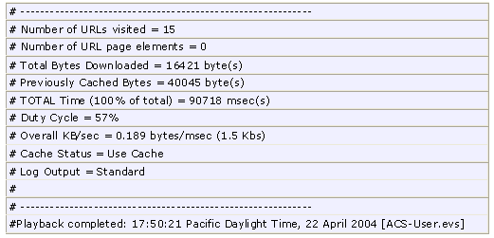

 | Description |  | Input/Process | Expected Results |  | Results |  | Type of Fault |  | Description
1 | Change password function not working as expected. | When we add user, we can add minimum 2 characters for password. Now select ‘change password’ in user module from left navigation. Enter current password. |  |  | Application should allow to ‘Change password’ by entering current password. |  | Message will be displayed that ‘password must be six character long’ while at the time of adding user we can keep 2 character password. So unable to change password now. |  | Design Error (Permanent fault) |  | Incorrect logic

Failure Rate (λ) = = 1/ 90.718(sec) = 11 x 10⁻³ failures/second

Survey Module Failure Rate Calculations:

Calculation of End Time (Using e-Valid tool)

Purpose: To find how much time Survey Module takes, if we browse all the functions of Admin Module.
- In eValid browser enter ACS project URL
- Begin recording by selecting start ->recording menu from browser
- Browse all functions in Survey Module and enter the data as shown in above table wherever required. At the end click on exit
- From e-Valid browser, select Record -> Stop recording
- From e-valid browser, select site analysis ->start analysis
- At the end, e-valid will give below report.

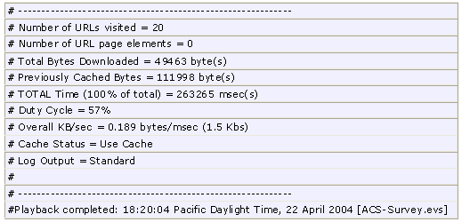

 | Description | Input/Process | Expected Results | Results | Type of Fault | Description
1 | Survey function in user Module is not working as expected | Finish first page, hit submit button, you will come to second page, hit back from browser, hit submit button, again hit back from browser, hit submit. | Page 2 of survey should display. | You will reach to end of survey without filling other pages. | Design Error in scoring, branching and piping survey features | Incorrect logic

Failure Rate (λ) = = 1/263.265(sec) = 3 x 10⁻³ failures/second

To calculate reliability and analysis of the application, we used above data in BlocksIM 6 tool [50]. Below is the results we get from BlocksIM 6.

Reliability Block Diagram ACS
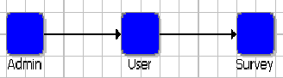

System Reliability Equation
RSystem=+RAdmin.RUser.RSurvey

Aggregate Failure Rate (ג) : Here we assumed that a software system is operating in an environment with an unchanging operational profile. In other words, the distribution of the types of user demands or requests for system capabilities do not vary with time. We also assume here that no changes are made to the software during operations. Then the software might be modeled with a constant failure rate .Failure rate is constant for the system and it is 0.0220
and Mean Time to Failure (MTTF) is 45.4328 sec.
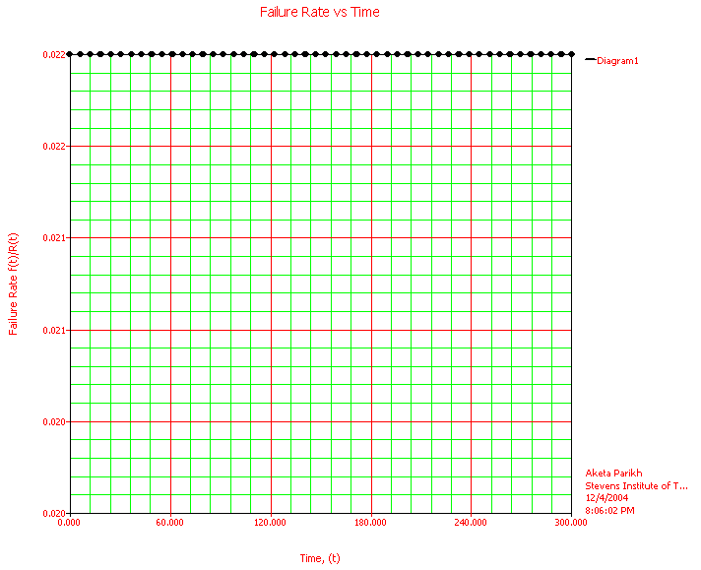

Standard Probability Calculation
Mission End Time | Reliability | Probability of Failure
50 | 0.3329 | 0.6671
100 | 0.1108 | 0.8892
150 | 0.0369 | 0.9631
200 | 0.0123 | 0.9877
300 | 0.0014 | 0.9986
400 | 0.0002 | 0.9998
500 | 16.7017E-6 | 1.0000

Unreliability vs. Time (sec) for ACS
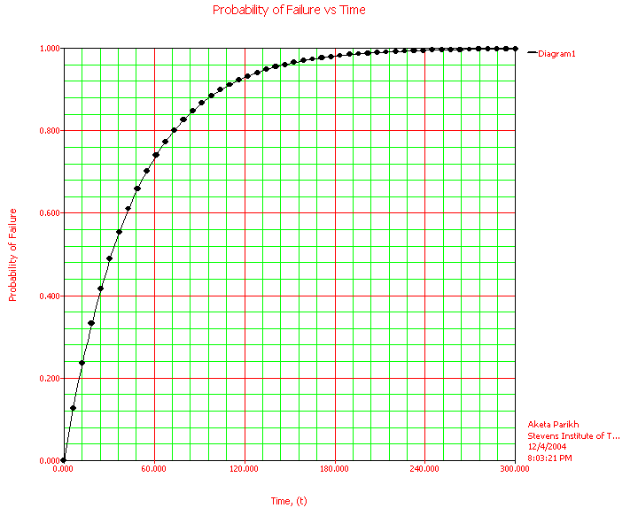
Using the above Unreliability vs. Time graph, one can determine how long system test must proceed until any reliability goal is met. Confidence bounds should be used for a reliability stopping rule instead of point estimates. For example, testing might stop when a 90% upper confidence bound on the number of remaining failures is below a required target bound. From above graph, we can see that for ACS project, failure rate increases very rapidly 120 sec and between 280 sec and 300 sec, intensity of failure is very high but failure rate increases slowly compared to initial time and at t = 300 sec, system will fail completely.

Reliability vs. Time for ACS
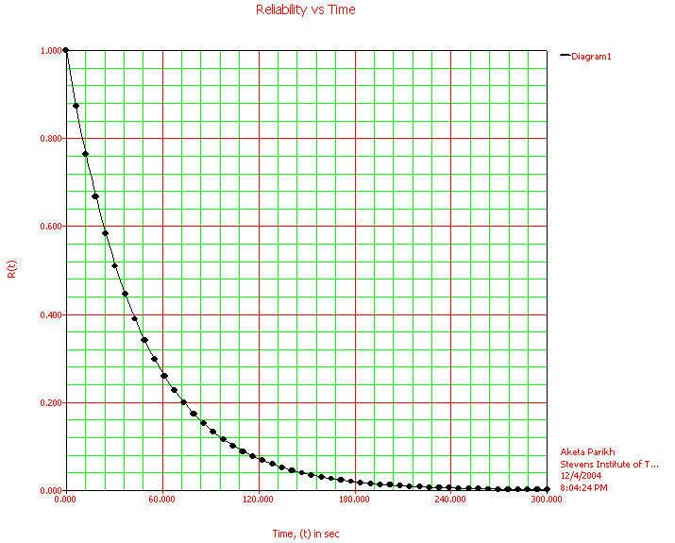
The probability that the software will operate without failure, the reliability R( ), becomes smaller the longer the time period under consideration. above graph shows this relationship in which reliability decreases exponentially with execution time . Also from the above graph we can see that at t = 300 sec when failure rate is maximum, reliability is minimum, in fact almost zero. Below table shows warranty of reliability at different time.
Warranty Time
Required Reliability | Time (sec)
0.99999 | 0.0005
0.99 | 0.4568
0.90 | 4.7891
0.80 | 10.1429
0.70 | 16.2125
0.60 | 23.2193
0.40 | 41.6496
0.1 | 104.6630
0.001 | 313.9889

Point Availability Plot (Simulation Plot) for ACS
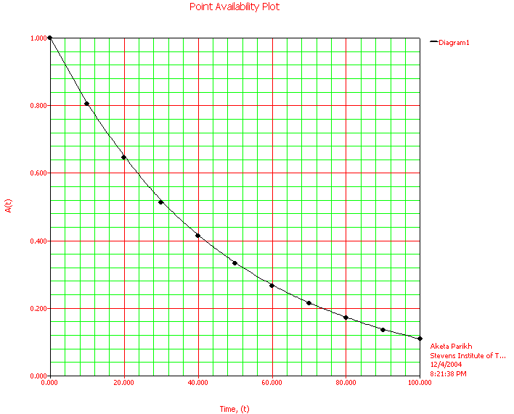
From the above graph, we can see that at t = 0, system is fully available and as time goes, availability decreases. For example at t = 100, availability of the reliable system will be only 10%.
From above analysis, we can see that in ACS Project failure rate is much higher than ACS project and so reliability is very low for ACS project copare to ACS project. Here Failures occur because of improper logic (design faults) or code is missing as shown in above table. ACS project is single – version project but as most of the failures are because of logic error, so here N-Version programming is the best solution to make application fault tolerant. But even do not offer (sufficient) protection against design faults because human designs are correlated. So, best approach in for this application to make it fault tolerant is to use N-version programming and implementing each version by following approach mention in section 4.1.2.3.1 to implement code with recovery blocks and exception handling, we can make application to handle failures because of faults in the application. Still application cannot be 100% fault tolerant even though by applying combination of single version and multiple version approach. If we use fault tolerant library (includes code for self checking) implemented for this application, so that it prevent application to any abnormal action and terminate the application in safe state. And thus the goal of software fault tolerant can be achieved by making λ very small, thus reducing any failures of an application by handling all the failures using fault tolerant library. For example in the above analysis if we use fault tolerant library, we can remove failure because of above test cases because fault tolerant library will contain self-checking code that can prevent all the improper actions taken by function responsible for change profile, change password, duplicate record, activate/ deactivate survey and other functions of the application.

Security Analysis
The below Security Analysis table provides a detail analysis of each vulnerabilities, whether that vulnerability is available in the application or not, if available then what are the causes for that vulnerabilities, possible threat because of that and Countermeasures to prevent vulnerabilities and thus possible threat.
√ = Attack is possible
X = Attack is not possible

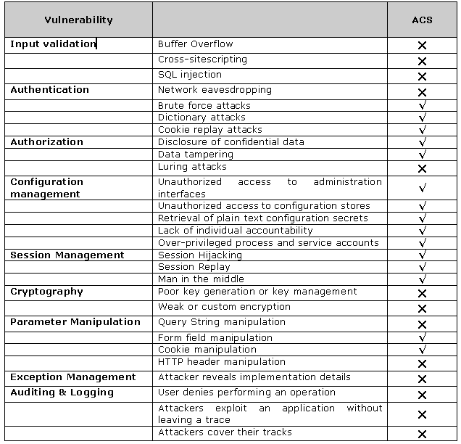

Below is the explanation for each attack whether is it possible or not and if possible what are the countermeasures.

Attack: Buffer Overflow
Possibility: X
Cause: ACS Application uses manage code using C# and asp.net programming language. String and array copying have tight bounds checking in the .NET Framework class libraries.

Attack: Cross-site scripting
Possibility: X
Cause: Application uses POST method to submit information, so attacker can not inject JavaScript, VBScript, ActiveX, HTML, or Flash into application.

Attack: SQL injection
Possibility: X
Cause: Application validates all the input received by the user.

Attack: Network eavesdropping
Possibility: X
Cause: Passwords are not passed in plain text format from client to server instead uses hash key encryption,

Attack: Brute force attacks
Possibility: √
Cause: Hacking the sensitive data like password or other such secrets by relying upon the computational power to identify the hash string and encryption technique used for securing the sensitive information.
Possible Threats: Attacker can gain the access of the system
Counter –measures: Use a very strong hash key strings

Attack: Dictionary attacks
Possibility: √
Cause: Sensitive information like password will not be stored in plain text format or encrypted form in the application. Rather the application normally uses a hashing technique and stores the hashed strings.
Possible Threats: Attacker can gain the access of the system
Counter –measures: - Use strong passwords with that are complex. Use mixture of uppercase, lowercase, numerals, special characters in the password that makes difficult to crack.
- Store non-reversible password hashes in the user store. Also combine a salt value (a cryptographically strong random number) with the password hash.

Attack: Cookie replay attacks
Possibility: √
Cause: Application uses cookie technology to store authentication information.
Possible Threats: The attacker can read authentication information that is submitted for the application to gain access. The attacker can then replay the same information to the application causing cookie replay attacks
Counter –measures: - Use SSL that encrypts al the information including cookie information passed through the channel
- Always use timeout property for the cookie information. This will reduce the probability of attack.

Attack: Disclosure of confidential data
Possibility: √
Cause: Passwords and other sensitive information are passed using hashing from client to server. Using brute force attack information can be leak.
Possible Threats: Unauthorized users can gain access to sensitive data
Counter –measures: - Before providing access to sensitive data perform a role check
- Always secure windows resources using strong Access Control Lists (ACL)
- Persistent stores like database and configuration files should store the sensitive information in the encrypted form

Attack: Data tampering
Possibility: √
Cause: Passwords and other sensitive information are passed using hashing from client to server. Using brute force attack information can be leak.
Possible Threats: An attacker, who gains access to the information transmitted through the network, can modify the information and the application while receiving will get the tampered data.
Counter –measures: - Always secure windows resources using strong Access Control Lists (ACL)
- Use role-based security to differentiate between users who can view data and users who can modify data.

Attack: Luring attacks
Possibility: X
Cause: entity with few privileges is able to have an entity with more privileges perform an action on its behalf

Attack: Unauthorized access to administration interfaces
Possibility: √
Cause: Application allows administrators and vendors to manage site contents and configuration.
Possible Threats: An attacker who gains access to the configuration management data can bring down the system by altering the configuration data.
Counter –measures: - Minimize the number of administration interfaces
- Use strong authentication like using digital certificates or multiple gatekeepers
- Avoid remote administration interfaces. If it is a must, provide access through VPN or through SSL.

Attack: Unauthorized access to configuration stores
Possibility: √
Cause: Sensitive data maintained in configuration stores.
Possible Threats: An attacker who gains access to the configuration stores can bring down the system by altering the configuration data.
Countermeasures: - Configure restricted ACLs on text based configuration files. For e.g. Machine.config and web.config should be configured for restricted access
- Keep custom configuration files outside the directory that doesn’t have web access

Attack: Retrieval of plain text configuration secrets
Possibility: √
Cause: Configuration files web.config stores password and connection string store the details in plain text format.
Possible Threats: External attackers who gains access can then see the sensitive information as it is stored in plain text format. Similarly, disgusted employees and administrators can misuse this sensitive information.
Countermeasures: Rather than storing the data in plain text format, store the sensitive information n encrypted formats.

Attack: Lack of individual accountability
Possibility: √
Cause: When the changes are made and who made those changes, these information are not being logged by application.
Possible Threats: Lead us to a threat of not being able to track the changes made by whom and when.
Countermeasures: - Administrative accounts must not be shared
- While using user/ application/service accounts, ensure that any damage to the privileges using this account can be identified
- Apply preventive measures for all the possible violation that you foresee

Attack: Over-privileged process and service accounts
Possibility: √
Cause: Application provide rights to change the configuration information
Possible Threats: An attacker can take advantage of the same to modify configuration information.
Counter –measures: - Avoid providing rights to change the configuration information unless it is mandatory. In that case, enable auditing and logging to track each and every change made by the account.

Attack: Session Hijacking
Possibility: √
Cause: Authentication is stored in a session for a particular user’s session. An attacker can use a network monitoring tool to capture this information.
Possible Threats: Having captured the authentication token, an attacker can spoof the user’s session and gain access to the system. An attacker can perform all the operations as that of legitimate user.
Counter –measures: - Avoid storing anything in the session objects. However, if the application demands that then use the following prevention technique
- Implement SSL as it will encrypt all the information that is transmitted via the network. In that case, the authentication token stored in the cookie too will be encrypted and sent via the communication channel.
- Allow only one session per user at a time. If a new session is started for the same user, implement logout functionality.
- Incase if SSL is not implemented and still there is a need to store information in the session object, ensure you set a time period for expiry. Though it doesn’t prevent the user from session hijacking, it reduces the risk of attack when the user is attempting for stealing cookie information.

Attack: Session Replay
Possibility: √
Cause: If an attacker gains access to the authentication token stored in a cookie, then the attacker can then frame a requests with the authentication cookie received from another user to the application from which the authentication cookie is sent
Possible Threats: An attacker gets access to the system as that of legitimate user.
Counter –measures: - Do not store authentication information on the client
- Whenever a critical function is being called or an operation is performed, re-authenticate the user
- Set expiry date for all cookies

Attack: Man in the middle Attack
Possibility: √
Cause: When communication happens between sender and receiver, an attacker can come in the middle and intercept all the messages transmitted between the sender and receiver, as password and all other information passed in plain text.
Possible Threats: An attacker can then change the information and send it to receiver. Both sender and receiver will be communicating with each other without the knowledge of a man in the middle who intercepts and modifies the information.
Countermeasures: - Use strong encryption. When the data is sent in a encrypted format, even though the man in the middle gains access to the information, s/he will not be able to intercept the original message as it is encrypted
- Use Hashing. When attacker tries to modify the hashed information, recalculation of hash will not be successful and hence it can be discovered that the information is modified in the middle

Attack: Poor key generation or key management
Possibility: X
Cause: Application is not using cryptography to encrypt information.

Attack: Weak or custom encryption
Possibility: X
Cause: Application is not using cryptography to encrypt information.

Attack: Query String manipulation
Possibility: X
Cause: Application uses POST method to submit information, so attacker can not inject JavaScript, VBScript, ActiveX, HTML, or Flash into application.

Attack: Form field manipulation
Possibility: √
Cause: Application uses HTTP Protocol and as the HTTP Protocol transmits the information in plain text, it is still possible for the attackers to modify any form fields and their values that are sent to the server.
Possible Threats: Security credentials can be modified bypassing the client script validations.
Countermeasures: Use session identifiers to reference state maintained in the state store on the server.

Attack: Cookie manipulation
Possibility: √
Cause: cookie value stores information used for security mechanism of the application
Possible Threats: The application is vulnerable to attack. Attacker can get access of important information about user, stored in cookies.
Countermeasures: - Use SSL which encrypts the information that are transmitted via the communication channel
- Incase of persistent cookies stored in the client computer, use encryption or hashing to protect the information

Attack: HTTP header manipulation
Possibility: X
Cause: Application is not make any security decisions based on request and response headers. If so, the application is vulnerable to attack

Attack: Attacker reveals implementation details
Possibility: X
Cause: Application handles all exceptions.

Attack: User denies performing an operation
Possibility: X
Cause: Application is not creating any log file for user activity.

Attack: Attackers exploit an application without leaving a trace
Possibility: X
Cause: Application is not creating any log file for user activity

Attack: Attackers cover their tracks
Possibility: X
Cause: Application is not creating any log file for user activity

Safety Analysis
To determine whether the system could present a hazard to safety, we will do preliminary hazard analys (PHA) and subsequent system and software safety analyses to identify when software is a potential cause of a hazard or will be used to support the control of a hazard. Here we will use Hzard identification form, FMEA (Failure Mode and Effect Analysis) and FTA (Fault Tree Analysis) to identify potential safety problems.
Hazard Level Matrix: A Hazard level was determined by using a standard matrix (Described in book Safeware by Nancy Leveson, pp 264-265 [40]) to combine hazard severity and hazard probability. As described in Safeware book [40] “Here the hazard level was used to allocate resources for hazard control by establishing priorities for identified hazard”
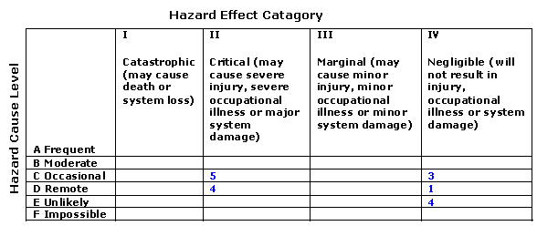

Here the number in the boxes are related to hazard condition as shown below in Hazard Identification Form.
Hazard Identification Form for ACS
No | Hazard | Cause | Level | Effect | Category
1 | Faulty Admin Module | - Faulty Admin Module Activate /deactivate wrong survey | D | Wrong survey will be posted | IV
2 | Faulty Admin Module | - Faulty Admin Module shows wrong result (score) for survey | D | Wrong data for research for medical product will be gathered | II
3 | Faulty User Module | - Faulty user module change user profile of other user instead of current user | C | Wrong user’s profile will be changed | IV
4 | Faulty User Module | - Faulty user module shows incorrect list of completed / uncompleted or available survey | E | Wrong survey selection possible | IV
5 | Faulty suvey Module | - Faulty dynamic branching feature in Survey module skip questions which are not answers.  - Faulty scoring feature in survey module calculate wrong scores of survey questions.  - Faulty survey module shows female survey for male or male survey for female. | C | Wrong data for research for medical product will be gathered | II

FAILURE MODE AND EFFECTS ANALYSIS (FMEA)
Below table shows FMEA for ACS Project to identify and list all components and their failure Modes. As described in Safeware book pp. 341-342[40], for each failure mode, the effect on all other system components are determined along with the effect on overall system.
Item / function |  | Potential Failure Mode | Effect of Failure | Potential Causes of Failure
Admin Module | - Faulty Admin module approves vendor without /rejected medical or security check report  - Faulty Admin module approves vendor without /rejected medical report  -Faulty Admin module approves vendor without/ rejected security report. |  | - Wrong person with criminal history / physically unfit get selected | - company data loss or damage to company property or loss of output work.
Vendor Module | - Faulty Vendor Module alter the SSN, DOB or other important vendor data. |  | - Wrong person get selected or good person get rejected | company data loss or damage to company property or loss of output work.
Medical Module | Faulty Medical Module passes wrong data to Admin Module |  | Wrong person get selected or good person get rejected | company data loss or damage to company property or loss of output work.
Security Module | Faulty Security Module passes wrong data to Admin Module |  | Wrong person get selected or good person get rejected | company data loss or damage to company property or loss of output work.

FTA for ACS
For the FTA for ACS Project, from the knowledge of application and User Manual, The purpose of ACS Application is to automate vendor selection process. So for the FTA, we assume that top event will be “Wrong Person Selected”. To construct fault tree, we consider all the casual events related to top event [40].
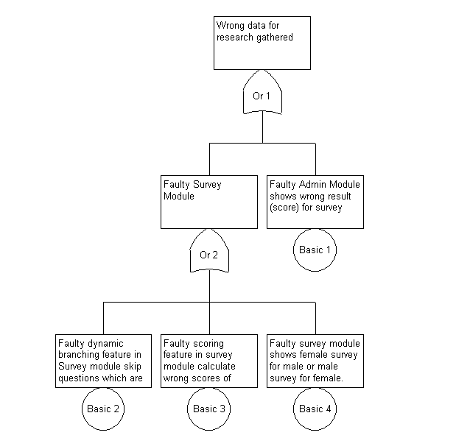
Figure 4.14: FTA for ACS project
From above analysis of Safety for ACS, we can see that this application is not Mission critical application but if wrong survey result sent then wrong data for research will collected. Our application cannot prevent wrong information provided by doctor about patient, but survey module in ACS application must be reliable and should always generate correct report. Currently branching module cause some failures, which should be prevented or should avoided to prevent hazards condition. Also from Hazard level matrix, there are no any catastrophic or frequent critical hazards in this application.

Experiment two: Gameboy Project

Reliability Analysis
In order to define Necessary Reliability for this application, let’s examine the Normal and Critical operation for Citigroup website.
Operational Modes for Gameboy project
Normal Operations: • User starts new game • User ‘save’ the current game and options • User select/ change options • User check his states for selected game
Critical Operations: •None
Cost Impact: • Severity 1: Game should fun people by providing challenging situation • Severity 2: Game should allow user to change options • Severity 3: None
Service Impact: Service impact measures the activity, which impact the end user
• Severity 1: Game damage other application on device. Game is very slow • Severity 2: Application is crashing while playing Game is very slow  Severity 3: Game is very slow
Use Impact: User Impact measures how well is the service getting through to the individual market. • Severity 1: Game should fun people by providing challenging situation • Severity 2: Game should allow user to change options, Application is crashing while playing Game is very slow • Severity 3: Game is very slow

By reviewing Documentation and code of this project, following are the some of the faults responsible for failures. In Citigroup project, only one version of software is used, so, redundancy should applied to single version to detect and recover from faults.
Missing requirements: Game is very simple, no requirement for making it challenging, fun part is missing.
Missing Code: Functions ‘Save’, ‘Options’ and ‘Status’ not implemented.
Function is not working as expected: Functions ‘Save’, ‘Options’ and ‘Status’ is not working because they are not implemented.
Following are couple of scenarios when application is not working as expected because of presence of faults.
 | Description | Input/Process | Expected Results | Results | Type of Fault | Description
1 | ‘Save’ function is not working | Start New Game in Gameboy application and select ‘Save‘ | Current game should either should ask confirmation or location to save game. | User remains on the same page and game is not saved. | Design Error (Permanent Fault) | Function not implemented
2 | ‘Option’ function is not working | Start Gameboy application and select ‘Option’ | Application should display all available ‘Option’ | User remains on the same page and game is not displaying any available Options. | Design Error (Permanent Fault) | Function not implemented
3 | ‘States’ function is not working | Start New Game in Gameboy application and select ‘Status’. | Current game should display user status. | User remains on the same page and game is not displaying user status. | Design Error (Permanent Fault) | Function not implemented
Here failures because of design faults are independent failure. Failures occur only when user select any of the options out of “save”, “options” and “states”. So, failures are apt to occur randomly over time. These options are additional features for the application, so probability of user select this function is very low compare to option “New game”. If we assume that probability of each function get selected (failure) is 10%, then
Module i | Probability of function selection | Probability of failure rate | Ave. Duration (sec) | Failure Rate
1 (Welcome Module) | 1 | 0 | 3 | 0
2 (Continue) | 0.1 | 1 | 2 | 0.2/100 = 0.002
3 (New Game) | 90% | 0 | 2 | 0
4 (Game) | 100% | 0 | 90 | 0
5 (Options) | 0.1 | 1 | 3 | 0.3/100 = 0.003

To calculate reliability and analysis of the application, we used above data in BlocksIM 6 tool. Below is the results we get from BlocksIM 6.
Reliability Block Diagram Gameboy
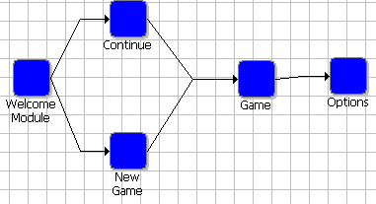
System Reliability Equation
IGame=-RContinue.RNew Game+RContinue+RNew Game
D1=+RWelcome Module.RGame.IGame

RSystem=+ROptions.D1

Aggregate Failure Rate (ג) : Here we assumed that a software system is operating in an environment with an unchanging operational profile. In other words, the distribution of the types of user demands or requests for system capabilities do not vary with time. We also assume here that no changes are made to the software during operations. Then the software might be modeled with a constant failure rate .Failure rate is constant for the system and it is 0.0030
and Mean Time to Failure (MTTF) is 333.1736 sec
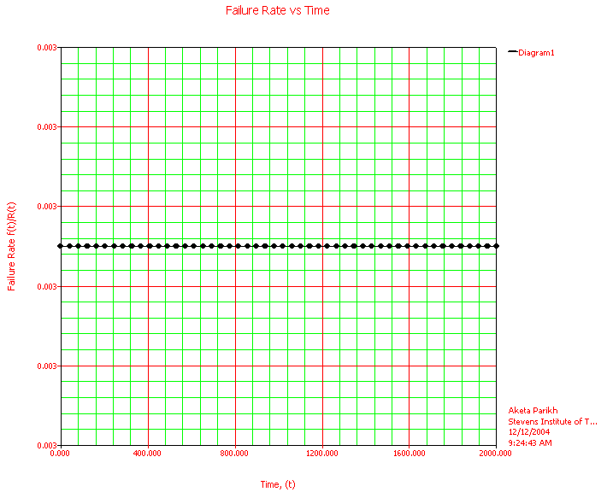

Standard Probability Calculation
Mission End Time | Reliability | Probability of Failure
50 | 0.8607 | 0.1393
100 | 0.7408 | 0.2592
150 | 0.6376 | 0.3624
200 | 0.5488 | 0.4512
300 | 0.4066 | 0.5934
400 | 0.3012 | 0.6988
500 | 0.2231 | 0.7769

Unreliability vs. Time (sec) for Gameboy
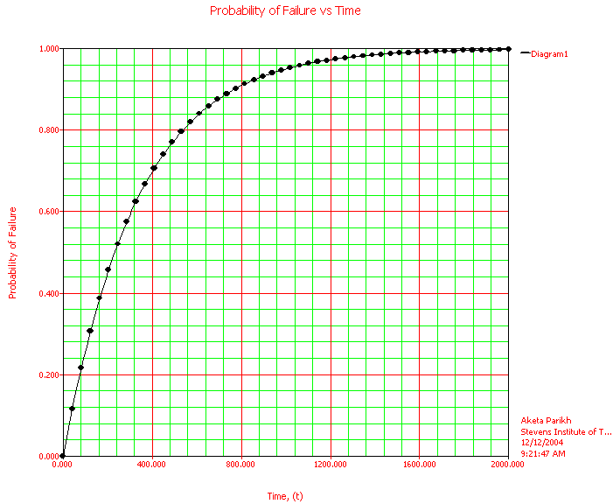

Using the above Unreliability vs. Time graph, one can determine how long system test must proceed until any reliability goal is met. Confidence bounds should be From above graph, we can see that for Gameboy project, failure rate increases very rapidly up to 800 sec and between 800 sec and 2000 sec, intensity of failure is very high but failure rate increases slowly compared to initial time and at t = 2000 sec, system will fail completely.

Reliability vs. Time for Gameboy

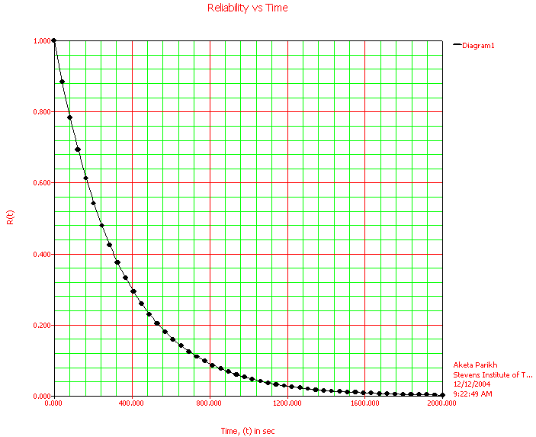
The probability that the software will operate without failure, the reliability R( ), becomes smaller the longer the time period under consideration. above graph shows this relationship in which reliability decreases exponentially with execution time . Also from the above graph we can see that at t = 2000 sec when failure rate is maximum, reliability is minimum, in fact almost zero. Below table shows warranty of reliability at different time.
Warranty Time
Required Reliability | Time (sec)
0.99999 | 0.0033
0.99 | 3.3501
0.90 | 35.1202
0.80 | 74.3812
0.70 | 118.8916
0.60 | 170.2752
0.40 | 305.4302
0.1 | 767.5284
0.001 | 2302.5851

Gameboy project is very simple project. In this project complexity is almost zero. But there are three functions called “save”, “options” and “states” are not implemented. So these are permanent design fault. When user clicks on any of these options, instead of redirecting user to respective page, user remains on the same page. There is no failure for the period of one game due to Bohrbugs. After completing each game new game starts in clean environment. So the failure because of transient fault is also not present. Failure rate of Gameboy project (0.0030) is very low compare to Citigroup and ACS . ACS project has highest design faults compare to Citigroup and Gameboy and all modules are series connected, thus the reliability is very less compare to other two project. While in Gameboy project, three functions are not implemented but design faults for the implemented functions are least and also two modules are parallel connected (one module is implemented while other is not), thus reliability is nore compare to Citigroup and ACS project.

Security Analysis
Gameboy application is used with Gameboy device, so hackers cannot attack on the application. Even no important data are used such as user personal information. So, there is no need of any security in this application.
To detect buffer overflow Vulnerabilities, we used RATS tool [49]. Below is the output generated by RATS tool.
C:\Ekta\Stevens-Sub\cs800\Student-Project\Tools\RATE\rats-2.1>rats --html main.c Entries in perl database: 33
Entries in python database: 62
Entries in c database: 334
Entries in php database: 55
Analyzing main.c

RATS results.
Severity: High
Issue: fixed size global buffer
Extra care should be taken to ensure that character arrays that are allocated on the stack are used safely. They are prime targets for buffer overflow attacks.
File: main.c
Lines: 236

Inputs detected at the following points
Total lines analyzed: 609
Total time 0.000000 seconds
0 lines per second
C:\Ekta\Stevens-Sub\cs800\Student-Project\Tools\RATE\rats-2.1>
For the Buffer overflow Vulnerabilities, below is the part of code where bold text show the vulnerable code.
Location: main.c
Description Extra care should be taken to ensure that character arrays that are allocated on the stack are used safely. They are prime targets for buffer overflow attacks.
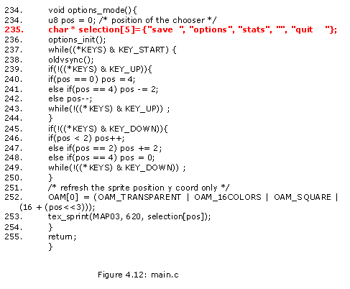

Safety Analysis
Gameboy application is being used by children of age 6 and more. This Gameboy application is very simple and basic application. It doesn’t have any sex or violence part in application. As this application is only used with its PDA and only used for fun and gaming, it doesn’t have any kind of hazard which may cause injury, occupational illness or system damage. So, at a safety point of view Gameboy application is SAFE.

Conclusion and Future work
The Trustworthiness of a system reflects the user’s degree of trust in that system. It reflects the extent of the user’s confidence that it will operate as users expect and that it will not ‘fail’ in any condition, data used by applications are secure from hackers, application is not vulnerable of external attack and application is not causing human/ system damage. To increase Reliability, design an application to avoid crashes and hangs using software fault tolerant so that everybody can put trust in software based system. To increase security, application should not vulnerable to any external attack. By using safe programming language, secure programming practice and securing data pass through network; we can prevent software application from hacker’s hand. In each application software safety activities needed to ensure that software does not cause or contribute to a system reaching a hazardous state; that it does not fail to detect or take corrective action if the system reaches a hazardous state; and that it does not fail to mitigate damage if an accident occurs.
As by increasing reliability, safety and security, we can make software trustworthy but how should “Software Trustworthiness” be measured? Because of complexity, difficulty and chaotic nature, software can never 100% fault free. When can we say that software products are ready to ship with known latent defects acceptable?

References

[1] Software QA and Testing Resource Center
by Rick Hower, What are some recent major computer system failures caused by software bugs?
http://softwareqatest.com/qatfaq1.html#FAQ1_3

[2] "The Hacker Crackdown - Law and Disorder on the Electronic Frontier"
by Sterling, B, ISBN 0-553-56370-x, Bantam Books, U.S. (1992), Part I pp. 1-2.
http://www.farcaster.com/sterling/contents.htm

[3] “Notorious Bugs", BYTE, 20 Years Special Issue
Needleman, R., (Ed.), pp. 125-128 (Sept. 1995).
http://www.byte.com/art/9509/sec7/art20.htm

[4] "The Debugging Scandal and What to Do About It"
Lieberman, H., Communications of the ACM, Vol. 40, No. 4, pp. 27-29 (April 1997), Media Laboratory, Massachusetts Institute of Technology
http://agents.www.media.mit.edu/people/lieber/Lieberary/Softviz/CACM-Debugging/CACM-Debugging-Intro.html

[5] Event Graph Analysis for Debugging Massively Parallel Programs
PhD thesis, GUP Linz, Joh. Kepler University Linz, Austria, section 3.3.1 History of debugging, http://www.gup.uni-linz.ac.at/~dk/thesis (September 2000)

[6] Microsoft Progress Report
by Bill Gates, Published on March 31, 2004
http://www.microsoft.com/mscorp/execmail/2004/03-31security.asp

[7] Aspects of Practical Software and System Availability and reliability Estimation
by John Gaffney, Lockheed Martin Corporation 2000, Software Tech News, pp. 3
http://www.stc-online.org/cd-rom/cdrom2000/webpages/jongafny/sld001.htm

[8] Computer Related Risks
Peter Neumann, ISBN 0-201-55805-x, Published by ACM Press / Addison Wesley, pp. 231-235
http://www.rothstein.com/drjbooks/drj453.htm

[9] Software Reliability Engineering
Lecture by prof. Linda M. Laird
guinness.cs.stevens-tech.edu/ ~lbernste/cs689/First%20Lecture.ppt

[10] IEEE Standard Computer Dictionary
A Compilation of IEEE Standard Computer Glossaries, ISBN 1-559-37079-3, Publisher by Inst of Elect & Electronic (January 1, 1991)

[11] Institute of Electrical and Electronic Engineers,
ANSI/IEEE Std 729-1983, Glossary of Software Engineering Terminology, IEEE, NY
http://www.computer.org/certification/csdpprep/Glossary.htm

[12] Encyclopedia of Software Engineering VOL. 1
by John J. Marciniak, ISBN 0-471-21008-0, published by John Wiley & sons.
topic: Software Reliability Theory by Michael Rung-Tsong Lyu, pp.1611-1630

[13] An Introduction to Safety Critical Systems
Testing papers developed by Information Processing Ltd. (IPL), UK, pp 2
www.iplbath.com/pdf/p0826.pdf

[14] Security And Software engineering of Distributed Systems
by Burak DAYIOĞLU – Mustafa YAVAŞ, Survey for distributed systems security from an attackers viewpoint. pp. 5-7
www.dayioglu.net/publications/software-eng-security.doc

[15] Securing your ASP.NET web application
by Krishnan V R
http://www.c-sharpcorner.com/Code/2004/Sept/securewebappl.asp

[16] Software Fault Tolerance : A Tutorial
by Wilfredo Torres-Pomales, Langley Research Center, Hampton, Virginia, NASA/TM-2000-210615, pp 4-17
http://techreports.larc.nasa.gov/ltrs/PDF/2000/tm/NASA-2000-tm210616.pdf

[17] Why software Quality Matters
Code of Honor by John McCormick March 5, 2004, Originally appearing in Baseline.
www.baselinemag.com/article2/0,1397,1543588,00.asp

[18] Software Reliability and Dependability: a Roadmap
by Bev Littlewood and Lorenzo Strigini, ISBN 1-581—113253-0, Published by ACM Press, New York, NY, USA pp 2-3
http://portal.acm.org/citation.cfm?id=336512.336551

[19] Standish group Survey
CHAOS Research, The chaos Report (1994) and extreme Chaos (2001)
http://www.standishgroup.com/sample_research/

[20] Evil Software
by Dr. Steve G. Belovich, BV Technologies, Inc. Published on February 2, 1999, smart data: white paper, pp. 1
http://www.smart-data.com/evil-software.htm

[21] Why Software Quality Matters
by Debbie Gage and John McCormick, Baseline magazine, March 4, 2004, http://www.baselinemag.com/article2/0,1397,1543564,00.asp

[22] Building secure software: How to avoid security problems the right way
by Gary McGraw and John Viega, ISBN 0- 201-72152-x, Published by Addison Wesley, Chapter: Introduction to Software Security, section 1
http://www.awprofessional.com/articles/article.asp?p=23950&seqNum=1

[23] ARP protocol weakness leading to "man in the middle" and DoS attacks on WLAN & LAN
Security Alerts by Datavatic, release date 18th February, 2004
http://www.datavatic.com/alerts/dv0401.htm

[24] Buffer Overflow
by Russell Kay, Security Computerword Magazine, Knowledge center, Security Special Report, Published on July 14, 2003
http://www.computerworld.com/securitytopics/security/story/0,10801,82920,00.html

[25] Changes to Functionality in Microsoft Windows XP Service Pack 2
by Starr Andersen, Technical Writer; Vincent Abella, Technical Editor, Published on August 9, 2004
http://www.microsoft.com/technet/prodtechnol/winxppro/maintain/sp2chngs.mspx

[26] The Day the Phones Stopped: How people Get Hurt When Computers Go Wrong
by Leonard Lee, ISBN 1-556-11286-6, Published byDonald I. Fine, Inc., New York.

[27] Toward a Reusable and Generic Security Aspect Library
by Minhuan Huang, Chunlei Wang, Lufeng Zhang, Beijing Institute of System Engineering, pp. 1
http://www.cs.kuleuven.ac.be/~distrinet/events/aosdsec/AOSDSEC04_Minwell_Huang.pdf

[28] High-Availability Computer Systems,
by J. Gray and D. P. Siewiorek, ISSN:0018-9162 ," IEEE Computer, September 1991, pp.:39-48.
http://www.research.microsoft.com/~gray/

[29] Why do Computers Stop and What Can be Done About it?
In Proc. of 5th Symposium on Reliability in Distributed Software and Database Systems, Tandem TR 85.7, pages 3-12, January 1986.
http://www.cs.berkeley.edu/~yelick/294-f00/papers/Gray85.txt

[30] Dependability Properties of P2P Architectures
by James Walkerdine Lee Melville, Ian Sommerville, Computing Department, Lancaster University, Lancaster, UK (2002), ISBN:0-7695-1810-9, Published by IEEE Computer Society
www.comp.lancs.ac.uk/computing/users/walkerdi/Papers/DependabilityPosterPaper.pdf

[31] Minimizing Completion Time of a Program by Checkpointing and Rejuvenation. By S. Garg, Y. Huang, C. Kintala and K. S. Trivedi, ISBN:0-89791-793-6, In Proc. 1996 ACM SIGMETRICS Conference, May 1996, pp. 252-261

[32] Software Dependability in the Tandem GUARDIAN System
by I. Lee and R. K. Iyer, ISSN 0098-5589, IEEE Trans. on Software Engineering, Vol. 21, No. 5, May 1995, pp 455-467
http://ieeexplore.ieee.org/xpl/abs_free.jsp?arNumber=387474

[33] Advance in Computers, volume 58
by, ISBN 0-12-012158-1, published by Academic Press
Chapter: Software Fault Tolerance Forestalls Crashes by Lawrence Bernstein, , pp.244-245

[34] Software Engineering
by Sommerville I., ISBN 0-201-39815-X Published by Addison Wesley,6th edition, 1996

[35] Software Fault Tolerance
by Prof. Kishor Trivedi, Duke University
http://srel.ee.duke.edu/

[36] Software Rejuvenation: Analysis, Module and Applications
by Yennum Huang, Chandra Kintala, Nick Kolettis and Dudley Fulton, ISSN:0731-3071, Proc. of 25th Symposium on Fault Tolerant Computing FTCS-25, Pasadena, CA, June 1995: 381-390
www.ece.stevens-tech.edu/~ckintala/Papers/RejuvFTCS25.pdf

[37] Software Rejuvenation
by Lawrence Bernstein and Dr. Chandra M. R. Kintala, CrossTalk – The Journal of Defense Software Engineering, August 2004 Issue
http://www.stsc.hill.af.mil/crosstalk/2004/08/0408Bernstein.html

[38] Somersault Software Fault-Tolerance
by P. Murray, R. Fleming, P. Harry, and P. Vickers, Hewlett Packard Technical Reports, 1997 www.hpl.hp.com/techreports/98/HPL-98-06.pdf

[39] SOFTWARE SAFETY NASA TECHNICAL STANDARD
NASA-STD-8719.13A, SEPTEMBER 15, 1997
satc.gsfc.nasa.gov/assure/nss8719_13.html

[40] Safeware –System Safety and Computers
by Leveson, Nancy, ISBN 0-201-11972-2, Published by Addison Wesley, Chapter 2, 12, 14, pp 33 –35, 263-267, 317-325

[41] Software Safety
by Michael Scheinholtz, 18-849b Dependable Embedded Systems, Spring 1998
[Carnegie Mellon University] www.ece.cmu.edu/~koopman/des_s99/software_safety/

[42] Software and System Safety
Software Assurance Technology Center, SOFTWARE ASSURANCE GUIDEBOOK, NASA-GB-A201, section VII
http://satc.gsfc.nasa.gov/assure/agbsec7.txt

[43] Safety Validation of Complex Components – Validation by Analysis
by Timo Malm and Maarit Kivipuro, European Project STSARCES, Annex 8 WP 3.1, Contract SMT 4CT97-2191, pp. 31
www.safetynet.de/EC-Projects/stsarces/WP31_Annex8_validation_by_analysis.PDF

[44] RSA Crypto Challenge Sets New Security Benchmark
Press Release, RSA Crypto Challenge Sets New Security -Benchmark512-Bit Public Key Factored by International Team of Researchers, Published on August 26, 1999
http://www.rsasecurity.com/press_release.asp?doc_id=509&id=1034

[45] Linux Advisory Watch: Information Security News
by Benjamin D. Thomas, Security Failure, Published on May 21, 2004
http://security.linux.com/article.pl?sid=04/05/21/1316245

[46] Software Reliability
by Jiantao Pan Carnegie Mellon University 18-849b Dependable Embedded Systems Spring 1999
http://www.ece.cmu.edu/~koopman/des_s99/sw_reliability/index.html

[47] Introduction to High Level Programming
by I. M. Barlow, University of Playmouth, why software is unreliable, pp 80-85
http://pdowland.see.plymouth.ac.uk/modules/COMP223/COMP223_Handbook.pdf

[48] eValid
Website Analysis and Testing Suite from e-Valid, eValid Ver. 4 -- User Manual
http://www.soft.com/eValid/Products/Documentation.40/

[49] RATS
Rough Auditing Tool for Security from Secure Software, licensed under the GPL
http://www.dwheeler.com/secure-programs/Secure-Programs-HOWTO/tools.html

[50] BlocksIM 6
System Visualization Tool from Reliasoft for system reliability, availability, Life Cycle cost and related analysis
http://www.reliasoft.com/BlockSim/

