Overhead – Bane of Layered Network Design?

Jabu Woodard
Research Project
Steven Institute of Technology
Hoboken, NJ
Abstract:

Protocol layering has been advocated as a way of dealing with the complexity of computer communication. It has also been criticized for its performance overhead. In this paper some insights into the design of protocols are presented, while comparing the overhead of a Point-to-Point link, ATM, Frame Relay and Ethernet protocols for transmission data of 1500, 800 and 80 bytes.
The paper also looks at what happens when OSI Layer overhead is added to each protocol. The paper examines two new tools for viewing web site traffic called eValid and Visual Route. These tools provide the measurement for comparing the OSI Layer overhead. The paper concludes with a model called the “ICE T” model that breaks down the overall subjective measure of the website's quality into five separate groups of related measures. These groups are Intuitive, Consistent, Efficient, Durable, and Thoughtful. After collecting the data we demonstrate the effects that overhead and latency has on the Efficiency of a network and how the user’s perception play a vital role in response time of a website.

Introduction

The most common use of PPP is to allow network data to be communicated over a telephone connection using modems. PPP is the modern replacement for SLIP; unlike SLIP, PPP provides support for carrying protocols other than IP, and has a built-in authentication system. Point-to-Point Protocol (PPP) is an example of a common protocol. PPP is used over a full-duplex link between two points. A router supporting PPP over a data link will let the user configure the maximum payload bytes. Often it is set to the same value as the Ethernet maximum payload bytes (1500 bytes) if the router connects to an Ethernet and will forward packets to and from the Ethernet. This information is exchanged between the two ends of a PPP link with link control protocol packets that are used for hand shaking between the two ends. Each PPP frame has a frame header and a frame trailer. The total size of them is ten bytes. Thus for PPP, the overhead bytes is set to 10. PPP can be configured to support data compression. If you are using this feature, then the effect of data compression can be taken into account in the model by increasing the bandwidth by a factor equivalent to the extent of data compression. In this paper certain terms that will be used to measure network performance are defined there.

Throughput -The amount of data that can be sent from one location to another in a specific amount of time, usually measured in Kbps, Mbps, or Gbps. Throughput refers to the performance of data transmission, and is measured by characters actually transmitted or received during a certain period of time. The throughput of a connection depends on CPU, memory, and performance between the two devices, pattern of measurement, as well as the performance of the operating system.

Goodput - Generally referring to the measurement of actual data successfully transmitted from the sender(s) to receiver(s). This is often a more useful measurement than the number of ATM cells per second throughput of an ATM switch if that switch is experiencing cell loss that results in many incomplete, and therefore unusable, frames arriving at the recipient.

Goodput = (max no of pkts recvd by the rx in sequence) / (total number of pkts sent by the sender including
retransmissions)

Efficiency - the ratio of the output to the input of any system. Efficiency = (Pout/Pin) x 100

Point-to-Point Protocol

PPP was originally designed for dial-up lines, and is now used by DSL providers to solve the problems of managing an open DSL network, such as IP address shortages and broadcasts not meant for you appearing on your local IP address. PPP acts like a generic modem connection, and the connection is secure, preventing other DSL clients from eavesdropping on the line, and relatively uncongested. There is a slight bit of overhead in that there's an extra step of authentication with the ISP before the Internet connection is established. Security is built into PPP with the Challenge Handshake Authentication Protocol (CHAP) and the Password Authentication Protocol (PAP). CHAP offers a high degree of security because the password is never transmitted over the link and the server is in control of the authentication process. Passing clear text passwords over the link, PAP offers a lower level of security. Developed by the Internet Engineering Task Force (IETF) over the past 6 years, PPP has gained widespread acceptance in the UNIX, PC, and Macintosh markets.

PPP Encapsulation

The PPP encapsulation is used to distinguish between multiprotocol datagrams. This encapsulation requires framing to indicate the beginning and end of the encapsulation. Methods of providing framing are specified in companion documents. It is important at this point to define what datagrams, packets, and cells means.

A datagram is an independent, self-contained message sent over the network whose arrival, arrival time, and content are not guaranteed. Clients and servers that communicate via a reliable channel, such as a URL or a socket, have a dedicated point-to-point channel between themselves, or at least the illusion of one. To communicate, they establish a connection, transmit the data, and then close the connection. All data sent over the channel is received in the same order in which it was sent. The channel guarantees this.

In contrast, applications that communicate via datagrams send and receive completely independent packets of information. These clients and servers do not have and do not need a dedicated point-to-point channel. The delivery of datagrams to their destinations is not guaranteed. Nor is the order of their arrival.

IP packet is the basic data chunk that can be sent over the Internet. All the data is partitioned into IP packets on the sending computer and reassembled on the receiving computer. Like datagrams the delivery of packets to their destinations is not guaranteed. Nor is the order of their arrival.

The ATM cell, on the other hand, is the fixed length data unit used to transmit data. The data is encapsulated into a 48-byte payload and is preceded by a 5-byte header. In an ATM network, all data is switched and multiplexed in these cells. The header includes information about the contents of the payload and about the method of transmission. The sections in the header are a series of bits that are recognized and processed by the ATM layer. The 48-byte payload size allows ATM to carry multiple forms of traffic. Both time-sensitive traffic (voice) and time-insensitive traffic can be carried with the best possible balance between efficiency and packetization delay.

A summary of the PPP encapsulation is shown below. The fields are transmitted from left to right.

+----------+--------------+-----------+
| Protocol | Information | Padding |
| 8/16 bits | * | * |
+----------+---------------+----------+

Protocol Field

The Protocol field is one or two octets, and its value identifies the datagram encapsulated in the information field of the packet. The field is transmitted and received most significant octet first. The structure of this field is consistent with the ISO 3309 extension mechanism for address fields. All Protocols must be odd; the least significant bit of the least significant octet must equal "1". Also, all Protocols must be assigned such that the least significant bit of the most significant octet equals "0". Frames received, which don’t comply with these rules, must be treated as having an unrecognized Protocol.

Protocol field values in the "0***" to "3***" range identify the network-layer protocol of specific packets, and values in the "8***" to "b***" range identify packets belonging to the associated Network Control Protocols (NCPs), if any. Protocol field values in the "4***" to "7***" range are used for protocols with low volume traffic which have no associated NCP. Protocol field values in the "c***" to "f***" range identify packets as link-layer Control Protocols (such as LCP).

PPP Link Operation

In order to establish communications over a point-to-point link, each end of the PPP link must first send LCP packets to configure and test the data link. After the link has been established, the peer may be authenticated. Then, PPP must send NCP packets to choose and configure one or more network-layer protocols. Once each of the chosen network-layer protocols has been configured, datagrams from each network-layer protocol can be sent over the link. The link will remain configured for communications until explicit LCP or NCP packets close the link down, or until some external event occurs (an inactivity timer expires or network administrator intervention).

PPP Overhead Graph:
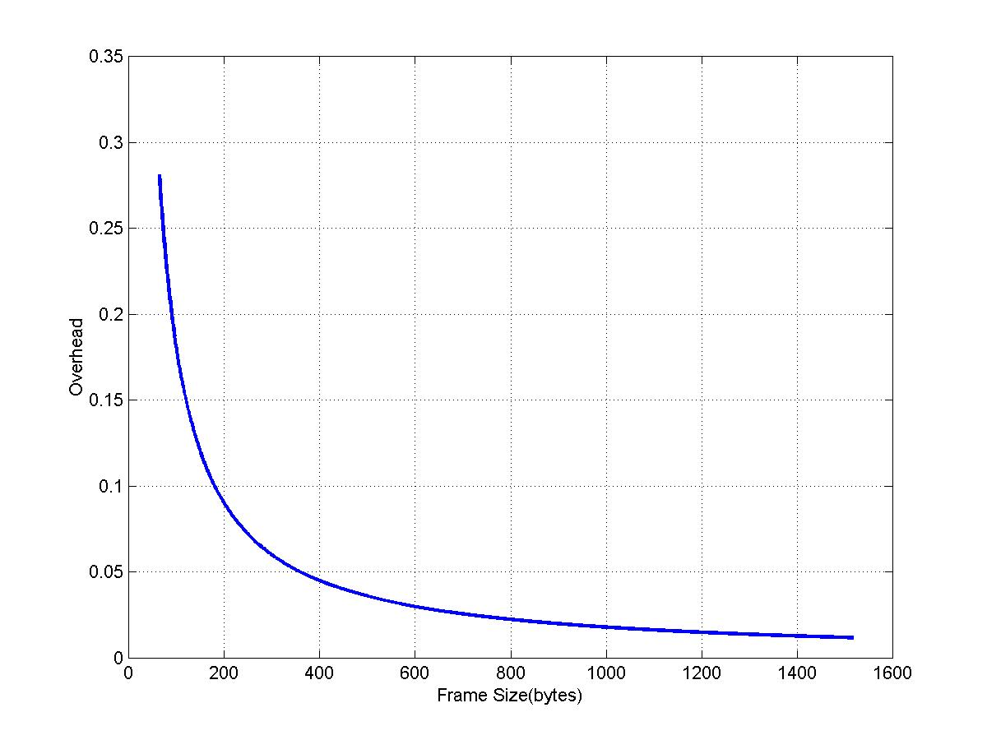

ATM
ATM (asynchronous transfer mode) cell relay is a set of specifications for data transmission at very high speed using virtual circuit packet switching technology. It is often referred to simply as ‘ATM.’ ATM does not specify the properties of the physical network on which it operates, but assumes that an optical fiber system called SONET (synchronous optical network) is used. ATM can be considered a specification of level 2 of the OSI 7-layer model, but many specialists think that ATM does not fit properly into the OSI model. Basic speeds are about 155 and 622 Mbits/sec. Apart from the increase in speed, the most obvious difference from frame relay is the small fixed packet size. ATM uses a packet that contains a 5-byte header and 48 bytes of data. This data size is a bad compromise between the needs of audio telecommunications users, who wanted two bytes, and computer users, who wanted 128 bytes. The design of ATM switches presents interesting challenges to the engineer. Each switch can handle up to 1024 virtual circuit connections, at a proposed data rate of 622 Mbits/sec. X.25 and frame relay switches are based on computers that can store and route incoming packets, but no existing computer is fast enough to operate that way with ATM. As a consequence, ATM switches use a store and forward method for cells; custom hardware is also use to switch incoming cells onto outgoing channels. A simple system for this type of routing is a crossbar switch, used during the early telephone era but implemented electronically.

Understanding ATM Overhead

ATM is both a layer-2 protocol and a protocol stack, in a similar way that IP is a layer-3 protocol and a protocol stack. The following diagram illustrates the ATM protocol stack.
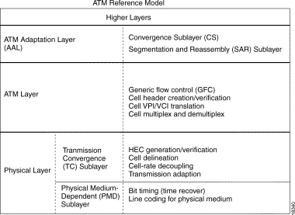
All three layers introduce overhead. The next two sections discuss overhead added by the ATM layer and by the ATM adaptation layer. The four ATM adaptation layers (AAL) that have been defined are as follows:
- AAL1—Designed to support connection-oriented services that require constant bit rates and are sensitive to timing, delay, and error detection. Sequence numbers are associated with each cell, similar to TCP/IP. Because cells always arrive in order, this allows for easy determination of lost cells and a request for retransmission. One octet of the payload is used for the sequence number, which leaves 47 octets for data payload. Sample candidates for AAL1 are constant bit-rate services such as DS1 or DS3 transport.
- AAL2—Designed to carry voice and video over ATM. AAL2 consists of variable-size packets encapsulated within the ATM payload, but it does not require the constant bit rate. AAL2 is otherwise similar to AAL1. Because of the variable-length data stream, three octets of the payload were used: 1 bit for sequence, 6 bits for length, and 10 bits for CRC-10. This leaves only 45 octets for actual data payload.
- AAL3/4—Intended for both connection-oriented and connectionless (AAL3, AAL4 respectively) variable bit-rate services. AAL3/4 was designed for computer data that is sensitive to loss but not necessarily timing or delay. AAL3/4 does not support real-time or timed connections. The final nail in the coffin for this specification is that it takes 4 octets of overhead, leaving only 44 octets for data payload.
- AAL5—Designed to support variable bit-rate data services. AAL5 is essentially a raw cell, 48 octets of pure payload. Compared with AAL3/4, you lose error recovery and built-in retransmission, but this can be handled at upper protocol layers, such as TCP/IP. Because sequence numbers and CRCs did not need to be calculated, this simplified processing and implementation.

ATM Layer Overhead
ATM overhead is called ATM cell tax or five-byte cell header. The format of this header is illustrated below.
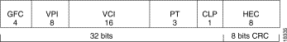

AAL Layer Overhead
The ATM adaptation layer adds overhead that supports the quality of service needs of an ATM service category like CBR or nrt-VBR. AAL5 is the most commonly used AAL type. Therefore, in this paper we will focus on the AAL5 layer. A look at the other layer will be mention only. An AAL5 service data unit (SDU) is defined as the layer-three datagram plus the optional Logical Link Control/Sub network Access Protocol (LLC/SNAP) header. An AAL5 PDU is defined as the AAL5 SDU plus variable-length padding and the eight-byte AAL5 trailer. There are three pieces of overhead here:
- 8-byte LLC/SNAP header (RFC 1483) in the format illustrated below. Note that a protocol ID value of 0800 indicates that AAL5 PDU is encapsulating an IP packet. Specify use of the LLC/SNAP header on ATM PVCs with the encapsulation AAL5 SNAP command, which is enabled by default.
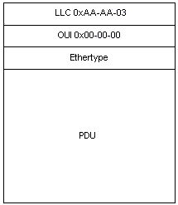
- Up to 47 octets of variable-length padding is used to make the AAL5 PDU an even multiple of 48 bytes. The feature module for Low Latency Queuing provides an interesting discussion of ATM overhead in the context of voice over IP over ATM. It considers the example of a voice stream of 60-byte packets emitted at 50 packets per second. Before such packets are transmitted, the router adds an eight-byte LLC/SNAP header and then divides the now 68-byte packet into two 53-byte ATM cells. Thus, the bandwidth consumed by this flow is 106 bytes per packet.
- 8-byte AAL5 trailer. RFC 1483 defines the format of an AAL5 trailer, as illustrated below.
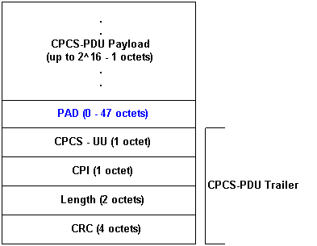

Similar to a packet network technology such as Fast Ethernet, Packet Over SONET is a transport technology that encapsulates packet data such as an IP datagram directly into SONET, eliminating ATM's cell overhead. As the argument goes, smaller size packets suffer a large amount of ATM overhead. A 64-byte IP packet will not fit into the 48-byte payload of one ATM cell, so two are needed, with the remainder of the payload of the second cell consisting of padding-bytes that don't contain any data to simply fill out the cell. These two cells will consume 106-bytes, approximately 60% efficiency (64-bytes divided by 106-bytes) and with Packet Over SONET, the overhead is small with only a few addressing bytes per packet, so efficiency is nearly 100%. Things do get slightly better with larger frame sizes. For a 1,500-byte IP packet, efficiency is about 88%. Padding has much less of an effect on large packets than small packets, since the most a cell would need to be padded is 47 bytes, and 47 compared to 1,500 is small. Cell overhead, having the same amount of impact regardless of frame size, takes up about 10% of bandwidth. Actually, ATM overhead turns out to be much more competitive with other schemes than most people seem to appreciate. But yes, there is more overhead than just the 5-byte cell header. ATM over SONET, let's say using SONET STS-3c (155.52 Mb/s) provides a raw 135.63 Mb/s of ATM cell payload. So that's 14 percent overhead. However, in terms of baud rate, since both SONET and ATM use bit scrambling instead of wasteful schemes like 4B/5B or, worse, Manchester, 14 percent overhead isn't at all bad. FDDI is 20 percent overhead at the physical layer alone. If you use AAL1, your actual ATM payload becomes 132.81 Mb/s, since AAL1 introduces six bytes of overhead that includes the standard five-byte ATM cell header plus a one-byte AAL1 header and one payload byte is used for a sequence number. So with AAL1 overhead is 14.6 percent. If you use AAL5, you add 8 bytes of overhead for each AAL5 frame so I'd say that overhead is negligible. But use of AAL5 implies some other overhead as well, typically LLC/SNAP and then IP overhead.
Below we examine how fast we can really go using a given media and protocol stack and setting the MTU to 80 bytes, 800 bytes and 1500 bytes. We examine how much bandwidth is left for applications when using ATM.
-------------------------- DS3 ------------------------------
Line Rate 44.736 Mbps
PLCP Payload 40.704 (avail to ATM)
ATM Payload 36.864 (avail to AAL)

MTU=80 MTU=800 MTU=1500
AAL5 Payload 34.501 36.752 36.845 (avail to LLC/SNAP)
LLC/SNAP Payload 34.028 36.720 36.841 (avail to IP)
IP Payload 32.847 36.640 36.830 (avail to transport)
UDP Payload 32.374 36.608 36.825 (avail to application)
TCP Payload 31.665 36.560 36.818 (avail to application)

-------------------------- OC-3c ------------------------------
Line Rate 155.520 Mbps
SONET Payload 149.760 (avail to ATM)
ATM Payload 135.632 (avail to AAL)

MTU=80 MTU=800 MTU=1500
AAL5 Payload 126.937 135.220 135.563 (avail to LLC/SNAP)
LLC/SNAP Payload 125.198 135.102 135.547 (avail to IP)
IP Payload 120.851 134.808 135.506 (avail to transport)
UDP Payload 119.112 134.690 135.489 (avail to application)
TCP Payload 116.504 134.513 135.464 (avail to application)

-------------------------- OC-12c -----------------------------
Line Rate 622.080 Mbps
SONET Payload 600.768 (avail to ATM)
ATM Payload 544.092 (avail to AAL)

MTU=80 MTU=800 MTU=1500
AAL5 Payload 509.214 542.439 543.818 (avail to LLC/SNAP)
LLC/SNAP Payload 502.239 541.966 543.752 (avail to IP)
IP Payload 484.800 540.786 543.586 (avail to transport)
UDP Payload 477.824 540.313 543.519 (avail to application)
TCP Payload 467.361 539.605 543.420 (avail to application)

Calculating ATM Overhead
In calculating ATM overhead, one should consider that ATM overhead can consume a significant part of a VC's bandwidth. The following show how to estimate this value. First, consider that IP packets on the Internet typically are one of three sizes:
- 64 bytes (for example, control messages)
- 1500 bytes (for example, file transfers)
- 256 bytes (all other traffic).
These values produce a typical overall Internet packet size of 250 bytes. Next, consider that some overhead is predictable and some is variable.
Overhead Field | Predictable | Variable
five-byte cell header (cell tax) | X | -
eight-byte AAL5 trailer | X | -
eight-byte LLC/SNAP header | X | -
Up to 47 bytes of AAL5 padding | - | X
Now, use the above values to estimate the percentage of overhead on an ATM link based on the encapsulation type. In the following calculations, we assume packet sizes of 1500, 800, and 80 bytes with 1500 bytes requiring a total of 36 bytes of padding and 800 and 80 bytes requiring a total of 16 bytes of padding after we include the eight-byte LLC/SNAP header and eight-byte AAL5 trailer.
- AAL5SNAP encapsulation:
8+8+22=38 or 15 percent "AAL5" overhead + 10 percent cell tax = >25 percent overall overhead per cell. So sending 1500 bytes with overhead added means it will take a minimum of 40 cells. With 800 bytes it will take a minimum of 31 cells to get the message across with overhead added and with an 80 bytes message with take a minimum of 4 cells with overhead added. Because overhead is added per cell the number of cell that will be send goes up to account for the overhead.
In other words, the overhead factor will vary with packet size. Small packets result in higher padding, which results in increased overhead. The diagrams below show the efficiency of ATM when SNAP is used and without it for illusions.

IP payload over ATM with SNAP

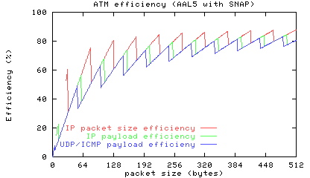

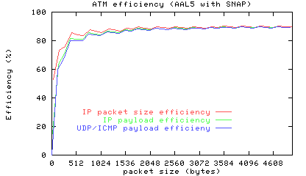

IP payload over ATM without SNAP

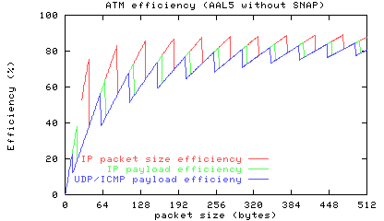

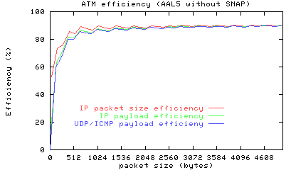
ATM Adaptation Layer 2

AAL2 is an adaptation layer that is used to multiplex more than one constant low bit rate user information stream on a single ATM virtual connection. This AAL provides for bandwidth efficient transmission of low-rate, short, and variable length packets in delay sensitive applications. In situations where multiple low Constant Bit Rate data streams need to be connected on end systems, a lot of precious bandwidth is wasted in setting up conventional VCs for each of the connections. Moreover, most network carriers charge on the basis of number of open Virtual Connections, hence it is efficient both in terms of bandwidth and cost to multiplex as many of these as possible on a single connection. When looking at the ATM AAL2 rather than AAL5 as the transport for PPP it becomes apparent that there is a different in overhead. SSSAR along with the AAL2 CPS generates less ATM encapsulation overhead per PPP payload. The payload encapsulation consists of a 2 byte CRC. The AAL2 CPS header consists of 3 bytes, and the AAL2 Start Field (STF) is 1 byte. This is a total encapsulation overhead of 6 bytes. This compares to 8 bytes of overhead for the AAL5 trailer used for PPP over AAL5. The multiplexing function of the AAL2 CPS layer allows more bandwidth efficient transport of PPP frames by multiplexing multiple PPP frames into one or more ATM cells using the AAL2 CPS function. This removes the pad overhead of AAL5 when used to transport short frames.

General Framework of AAL2

The AAL type 2 is subdivided into the Common Part Sublayer (CPS) and Service Specific Convergence Sublayer (SSCS) as shown in Fig 4.1 (a). Different SSCS protocols may be defined to support specific AAL2 user services or groups of services. The SSCS may also be null, providing merely for the required mapping between the CPS and higher layers. AAL2 provides the capabilities to transfer AAL-SDUs from one AAL-SAP to another through the ATM network (Fig 4.1 (b)). Multiple AAL2 connections may utilize a single underlying ATM connection. The multiplexing and de-multiplexing of connections occurs at the CPS.

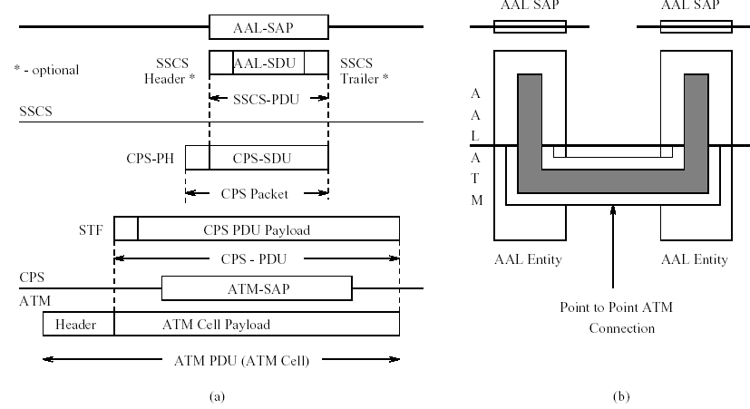
Figure 4.1: AAL2 Structure (a) Sections and Data Interfaces (b) Connection

CPS to ATM data interface

The CPS hands a 48 byte ATM payload to the ATM layer below it, a 1 bit ATM User to ATM User (AUU) indication, and a loss priority (called the Submitted Loss Priority). SLP is used by the ATM layer to set it’s own CLP bit. CPS also receives from the ATM layer a 48 byte SDU, and a loss priority bit (called the Received Loss Priority). The RLP may differ from SLP in case the network changed CLP along the way.

CPS to SSCS data interface

The CPS hands CPS-Interface data packets to the SSCS (1 to 64 bytes). The format and actual length of the data are determined at setup time. The CPS also hands a 5-bit User-to-User Indication to the SSCS. This is data used optionally by the SSCS entity to decide the destination of the PDU. The CPS also receives the same two units from the SSCS entity.

AAL2 Part Sublayer

AAL2 CPS offers the following peer-to-peer operation:

- Data transfer of CPS-SDUs of up to 45 (default) or 64 bytes.
- Multiplexing and de-multiplexing of multiple AAL2 channels.
- Maintains the CPS-SDU sequence integrity on each AAL2 channel
- Unassured operation, i.e. lost CPS-SDUs are not retransmitted
- Bi-directional virtual channel connection, using the same VC number in either direction.

The VC can be permanent or switched. The CPS interacts with both the management layer and the control layer. The control layer establishes the VC as required. Switching at the channel level has not yet been defined.

Format and Encoding of CPS Packet

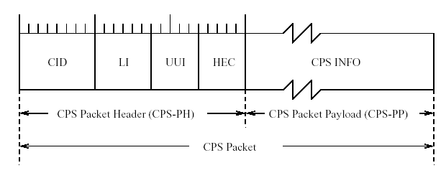Figure 4.2: AAL2 CPS Packet Format
A CPS Packet consists of a 3 byte Packet Header (CPS-PH), followed by up to 64 bytes of Packet Payload (CPS-PP). CPS Packets are the data exchange mechanism between CPS and SSCS. Fig 4.2 shows the field lengths and format.

- Channel Identifier (CID) value identifies the AAL2 channel user. The AAL2 channel is a bi-directional-medium, and both directions use the same value of CID.

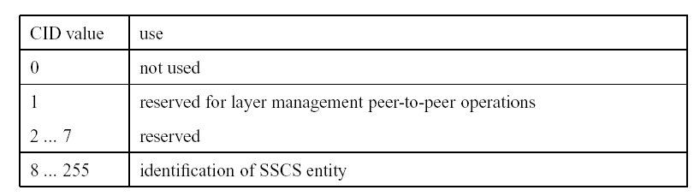
- Length Indicator (LI) is a binary encoded value that corresponds to the length of the payload of the CPS-Packet. The default maximum length is 45 bytes. It can be set to a maximum of 64 bytes. The maximum channel length needs to be negotiated at setup time. LI cannot exceed the maximum negotiated value. Each channel can individually negotiate its maximum value. Maximum lengths between 45 and 64 are not allowed.

- User-to-User Indication (UUI) serves two specific purposes: 1) to convey specific information to SSCS entities transparently through the CPS and 2) to distinguish between the SSCS entities and Layer Management users of the CPS

CPS hands the 5-bit UUI field without change to the SSCS entity. It’s usage by the SSCS entity is optional.

- Header Error Control (HEC) is the reminder (modulo 2) of the division, by generator polynomial X5 +X2 +1, of the product of X5 and the contents of the first 19 bits of the CPS-PH. The receiver uses the HEC field to detect errors in the CPS-PH.

Format and Encoding of CPS-PDU

The CPS-PDU consists of a one byte start field (STF), and 47-byte payload. The 48 byte CPSPDU is the ATM cell SDU (Fig 4.4). A CPS-PDU may carry 0, one or more full or partial CPS-Packets. The packets may overlap over more than one PDUs. Any unused space in the PDU is padded with 0s. The CPS-Packet may be partitioned anywhere along it’s length (Fig 4.3).

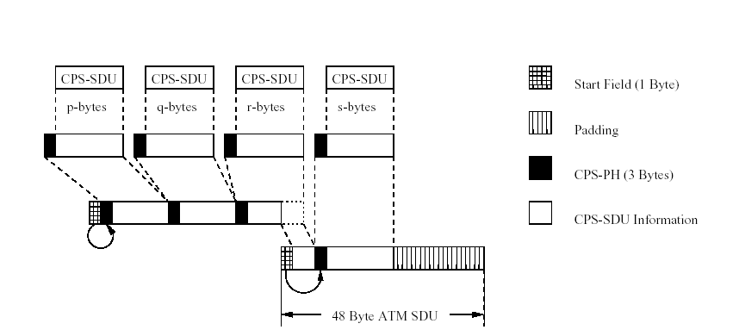
Figure 4.3: Translating CPS-SDUs to ATM SDUs

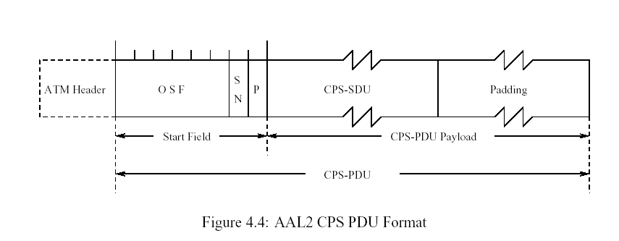

AAL2 Transmitter

The multiplexing function in the CPS to merge several different sized streams into a single ATM SDU requires a method for scheduling these streams so that none of the streams suffer any more than acceptable delays. The nature of traffic on AAL2 channels require a CPS SDU to be transmitted within a certain time frame after it is generated. In flow diagram form shown below, the CPS transmitter has the following procedure (Figs 4.5, 4.6).
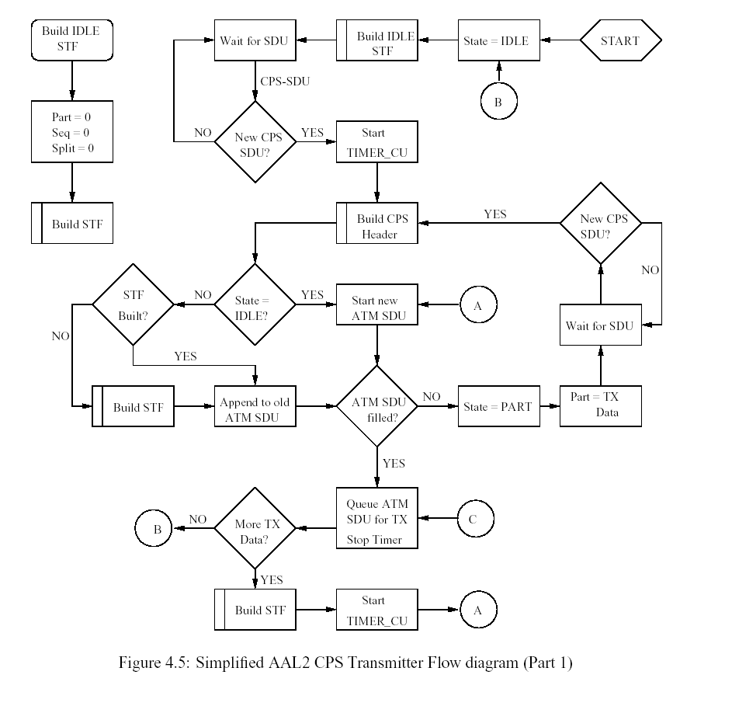

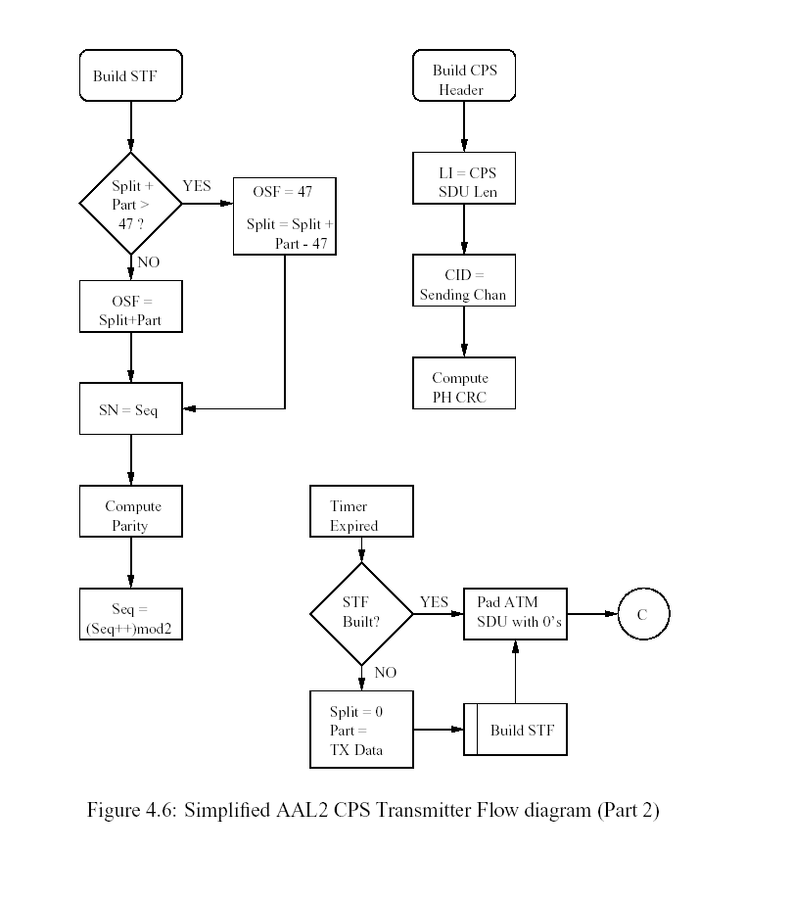Frame Relay
What is Frame Relay? Frame Relay was developed to solve communication problems that other protocols could not: the increased need for higher speeds, an increased need for large bandwidth efficiency, particularly for clumping ("bursty" traffic), an increase in intelligent network devices that lower protocol processing, and the need to connect LANs and WANs. Frame Relay connections provide rock solid reliability, high-bandwidth, and low latency. All of this is very important for companies that rely on the Internet for mission critical tasks. Frame Relay is a commercial-grade, high-speed, dedicated connection that is based on packet technology. It provides guaranteed throughput of data, with the ability to "burst" to higher speeds for short periods of time. Frame Relay is also a high performance wide area networking protocol that enjoys many of the advantages of T1. Using Frame Relay protocol allows one to choose the level of bandwidth that is needed, ranging from 384kbps to a full 1.544 Mbps. A Frame Relay network doesn't perform error detection, which results in a considerably smaller amount of overhead and faster processing than other protocols. For Frame-Relay alone, there are 16 bits for start and end of frame flags, 16 bit for address and another 16 bits for Frame Check Sequence. Plus the overhead of TCP/IP packets.

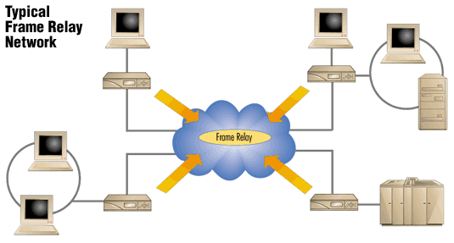

Invention of Ethernet
“In late 1972, Metcalfe and his Xerox PARC colleagues developed the first experimental Ethernet system to interconnect the Xerox Alto, a personal workstation with a graphical user interface. The experimental Ethernet was used to link Altos to one another, and to servers and laser printers. The signal clock for the experimental Ethernet interface was derived from the Alto's system clock, which resulted in a data transmission rate on the experimental Ethernet of 2.94 Mbps.
Metcalfe's first experimental network was called the Alto Aloha Network. In 1973 Metcalfe changed the name to "Ethernet," to make it clear that the system could support any computer--not just Altos--and to point out that his new network mechanisms had evolved well beyond the Aloha system. He chose to base the name on the word "ether" as a way of describing an essential feature of the system: the physical medium (i.e., a cable) carries bits to all stations, much the same way that the old "aluminiferous ether" was once thought to propagate electromagnetic waves through space. Thus, Ethernet was born.”

Protocol Overhead

How fast can you really go using a given media and protocol stack? We examine how much bandwidth is left for applications using Ethernet.

Ethernet
Ethernet frame format:
- 6 byte destination address
- 6 byte source address
- [4 byte optional 802.1q VLAN Tag]
- 2 byte length/type
- 46-1500 byte data (payload)
- 4 byte CRC
Ethernet overhead bytes:
12 gap + 8 preamble + 14 header + 4 trailer = 38 bytes/packet w/o 802.1q
12 gap + 8 preamble + 18 header + 4 trailer = 42 bytes/packet with 802.1q

Ethernet Payload data rates are thus:
1500/(38+1500) = 97.5293 % w/o 802.1q tags
1500/(42+1500) = 97.2763 % with 802.1q tags

TCP over Ethernet:
Assuming no header compression (e.g. not PPP)
Add 20 IPv4 headers or 40 IPv6 header (no options)
Add 20 TCP headers
Add 12 bytes optional TCP timestamps
Max TCP Payload data rates over Ethernet are thus:
(1500-40)/(38+1500) = 94.9285 % IPv4, minimal headers
(1500-52)/(38+1500) = 94.1482 % IPv4, TCP timestamps
(1500-52)/(42+1500) = 93.9040 % 802.1q, IPv4, TCP timestamps
(1500-60)/(38+1500) = 93.6281 % IPv6, minimal headers
(1500-72)/(38+1500) = 92.8479 % IPv6, TCP timestamps
(1500-72)/(42+1500) = 92.6070 % 802.1q, IPv6, ICP timestamps

UDP over Ethernet:
Add 20 IPv4 headers or 40 IPv6 header (no options)
Add 8 UDP headers
Max UDP Payload data rates over Ethernet are thus:
(1500-28)/(38+1500) = 95.7087 % IPv4
(1500-28)/(42+1500) = 95.4604 % 802.1q, IPv4
(1500-48)/(38+1500) = 94.4083 % IPv6
(1500-48)/(42+1500) = 94.1634 % 802.1q, IPv6

Layer Overhead

Now let’s look at the different layer and the overhead that each layer products. The main focus here is to investigate the Network layer, Data link layer and Physical layer, although a look at each layer’s overhead will be mention. After looking at this a comparison can then be made of each protocol by adding that protocol’s overhead to the layer’s overhead to find the total bytes each message take to cross the network. But first a brief look at each layer.

Network Layer

In the Open Systems Interconnection (OSI) communications model, the Network layer knows the address of the neighboring nodes in the network, packages output with the correct network address information, selects routes and Quality of Service, and recognizes and forwards to the Transport layer incoming messages for local host domains. Among existing protocol that generally map to the OSI network layer are the Internet Protocol (IP) part of TCP/IP and NetWare IPX/SPX. Both IP Version 4 and IP Version 6 (Ipv6) map to the OSI network layer.

The network layer is the third lowest layer in the OSI seven-layer model. The network layer determines routing of packets of data from sender to receiver via the data link layer and is used by the transport layer. The most common network layer protocol is IP.

Data link layer
The data link layer is level two of the seven-level OSI seven-layer model. It responds to service requests from the network layer and issues service requests to the physical layer. The data link layer is the layer of the model which ensures that data is transferred correctly between adjacent network nodes in a wide area network. The data link layer provides the functional and procedural means to transfer data between network entities and to detect and possibly correct errors that may occur in the Physical layer. Examples of data link protocols are HDLC and ADCCP for point-to-point
The data link is all about getting information from one place to a selection of other places. At this layer one does not need to be able to go everywhere, just able to go somewhere else. So in social contact, one needs to know at least one other person, but not necessarily know Prof. Bernstein.
This layer is made up of two components. The first component is Logical Link Control. This component determines where one frame of data ends and the next one starts. In a snail-mail network, each letter is one frame of data, and you can tell where it begins and ends because it is inside an envelope. You might also specify that a letter will begin with a phrase like "Dear Sir", and ends with a phrase like "yours Sincerely".
The second component is Media Access Control. This component determines who is allowed to access the media at any one time. There are generally two forms of media access control: distributed and centralized. Both of these have real-world examples that we see each day.

Physical layer
The physical layer is level one in the seven level OSI model. It performs services requested by the data link layer. This level is referring to network hardware, physical cabling or a wireless electronmagnetic connection. It also deals with electrical specifications, collision control and other low-level functions.
The physical layer is the very simplest, defining only exactly what a bit is: in other words how to transmit a one or a zero. For example, you would specify at this layer things like what shapes the electrical connectors are, what frequencies to broadcast at, and what frequencies are allowed and will not blow up the network cards. In a snail-mail network, that is a network made up of people posting letters to one another, the physical layer is all about how you write and read individual letters of the alphabet.
The major functions and services performed by the physical layer are the establishment and termination of a connection to a communications medium; to participation in the process whereby the communication resources are effectively shared among multiple users, e.g., contention resolution and flow control; and to conversion between the representation of digital data in user equipment and the corresponding signals transmitted over a communications channels.
With this said, lets now look at the overhead of each layer and compare the total overhead to send messages of size 1500, 800 and 80 using ATM, Ethernet, Point-to-Point and a Frame Relay Protocol.

Layer Protocol Overhead .
Application HTTP 100 bytes of overhead
Transport TCP 24 bytes of overhead
Network IP 24 bytes of overhead
Data Link Ethernet 26 bytes of overhead
Physical Ethernet 26 bytes of overhead

Now that we have the layer overhead, the table below shows the actual overhead to send a message.

Layer | Protocol Use for message | Layer Overhead | Protocol Overhead | Total Overhead
Network | Frame Relay | 24 bytes | 24 bytes | 48 bytes
Network | PPP | 24 bytes | 18 bytes | 42 bytes
Network | ATM | 0 | 0 | 0
Network | Ethernet | 24 bytes | 42 bytes | 66 bytes
Data Link | Frame Relay | 26 bytes | 24 bytes | 50 bytes
Data Link | PPP | 26 byes | 18 bytes | 44 bytes
Data Link | ATM | 26 bytes | 38 bytes | 64 bytes
Data Link | Ethernet | 26 bytes | 42 bytes | 68 bytes
Physical Link | Frame Relay | 26 bytes | 24 bytes | 50 bytes
Physical Link | PPP | 26 byes | 18 bytes | 44 bytes
Physical Link | ATM | 0 | 0 | 0
Physical Link | Ethernet | 26 bytes | 42 bytes | 68 bytes
*Note that the Physical and Data Link layer have the same overhead.

If we send 1500, 800 and 80 bytes over ATM, Ethernet, PPP and Frame Relay, the tables below show the total size of transmitted data and the Transmission Efficiency.

ATM Cells

Layer | 1500 bytes payload | Protocol Overhead per cell | Layer Overhead per cell | Total bytes sent
Application | 0 | 0 | 0 | 0
Transport | 0 | 0 | 0 | 0
Network | 0 | 0 | 0 | 0
Data Link | 32 cells (48 bytes) | 26 bytes | 38 bytes | 3548 bytes or  74 cells
Physical Link | 0 | 0 | 0 | 0
User Data = 48 bytes per cell
Total Size of Transmitted Data = 3548
Transmission Efficiency = User Data/Total Transmitted Data = 1500/3548 = 42.28%

Layer | 800 bytes payload | Protocol Overhead per cell | Layer Overhead per cell | Total bytes sent per cell
Application | 0 | 0 | 0 | 0
Transport | 0 | 0 | 0 | 0
Network | 0 | 0 | 0 | 0
Data Link | 17 cells (48 bytes) | 26 bytes | 38 bytes | 1888 bytes or  40 cells
Physical Link | 0 | 0 | 0 | 0
User Data = 48 bytes per cell
Total Size of Transmitted Data = 1888
Transmission Efficiency = User Data/Total Transmitted Data = 800/1888 = 42.37%

Layer | 80 bytes payload | Protocol Overhead per cell | Layer Overhead per cell | Total bytes sent
Application | 0 | 0 | 0 | 0
Transport | 0 | 0 | 0 | 0
Network | 0 | 0 | 0 | 0
Data Link | 2 cells (48 bytes) | 26 bytes | 38 bytes | 208 bytes or  5 cells
Physical Link | 0 | 0 | 0 | 0
User Data = 48 bytes per cell
Total Size of Transmitted Data = 208
Transmission Efficiency = User Data/Total Transmitted Data = 80/208 = 38.46%

Frame Relay Frames

Layer | 1500 bytes payload | Protocol Overhead per packet | Layer Overhead per packet | Total bytes sent  To next layer
Application | 1500 bytes or 2 packets | 24 bytes | 100 bytes | 1788 bytes
Transport | 1500 bytes or 2 packets | 0 | 24 bytes | 1812 bytes
Network | 1500 bytes or 2 packets | 0 | 24 bytes | 1836 bytes
Data Link | 1500 bytes or 2 packets | 0 | 26 bytes | 1862 bytes
Physical Link | 1500 bytes or 2 packets | 0 | 26 bytes | 1888 bytes
User Data = 1500 bytes or 2 packets with padding
Total Size of Transmitted Data = 1888 bytes
Transmission Efficiency = User Data/Total Transmitted Data = 1500/1888 = 79.45%

Layer | 800 bytes payload | Protocol Overhead packet | Layer Overhead per packet | Total bytes sent  To next layer
Application | 800 bytes | 24 bytes | 100 bytes | 924 bytes
Transport | 800 bytes | 0 | 24 bytes | 948 bytes
Network | 800 bytes | 0 | 24 bytes | 972 bytes
Data Link | 800 bytes | 0 | 26 bytes | 998 bytes
Physical Link | 800 bytes | 0 | 26 bytes | 1024 bytes
User Data = 800 bytes
Total Size of Transmitted Data = 1024 bytes
Transmission Efficiency = User Data/Total Transmitted Data = 800/1024 = 78.13%

Layer | 80 bytes payload | Protocol Overhead packet | Layer Overhead per packet | Total bytes sent  To next layer
Application | 80 bytes | 24 bytes | 100 bytes | 204 bytes
Transport | 80 bytes | 0 | 24 bytes | 228 bytes
Network | 80 bytes | 0 | 24 bytes | 252 bytes
Data Link | 80 bytes | 0 | 26 bytes | 278 bytes
Physical Link | 80 bytes | 0 | 26 bytes | 304 bytes
User Data = 80 bytes
Total Size of Transmitted Data = 304 bytes
Transmission Efficiency = User Data/Total Transmitted Data = 80/304 = 26.32%

Ethernet Packets

Layer | 1500 bytes payload | Protocol Overhead per packet | Layer Overhead per packet | Total bytes sent  To next layer
Application | 1500 bytes or 2 packets | 42 bytes | 100 bytes | 1806 bytes
Transport | 1500 bytes or 2 packets | 0 | 24 bytes | 1854 bytes
Network | 1500 bytes or 2 packets | 0 | 24 bytes | 1902 bytes
Data Link | 1500 bytes or 2 packets | 0 | 26 bytes | 1950 bytes
Physical Link | 1500 bytes or 2 packets | 0 | 26 bytes | 1998 bytes
User Data = 1500 bytes or 2 packets with padding
Total Size of Transmitted Data = 1998 bytes
Transmission Efficiency = User Data/Total Transmitted Data = 1500/1998 = 75.07%

Layer | 800 bytes payload | Protocol Overhead packet | Layer Overhead per packet | Total bytes sent  To next layer
Application | 800 bytes | 42 bytes | 100 bytes | 942 bytes
Transport | 800 bytes | 0 | 24 bytes | 966 bytes
Network | 800 bytes | 0 | 24 bytes | 990 bytes
Data Link | 800 bytes | 0 | 26 bytes | 1016 bytes
Physical Link | 800 bytes | 0 | 26 bytes | 1042 bytes
User Data = 800 bytes
Total Size of Transmitted Data = 1042 bytes
Transmission Efficiency = User Data/Total Transmitted Data = 800/1042 = 76.78%

Layer | 80 bytes payload | Protocol Overhead packet | Layer Overhead per packet | Total bytes sent  To next layer
Application | 80 bytes | 42 bytes | 100 bytes | 222 bytes
Transport | 80 bytes | 0 | 24 bytes | 246 bytes
Network | 80 bytes | 0 | 24 bytes | 270 bytes
Data Link | 80 bytes | 0 | 26 bytes | 296 bytes
Physical Link | 80 bytes | 0 | 26 bytes | 322 bytes
User Data = 80 bytes
Total Size of Transmitted Data = 322 bytes
Transmission Efficiency = User Data/Total Transmitted Data = 80/322 = 24.84%

Point-to-Point Frames

Layer | 1500 bytes payload | Protocol Overhead packet | Layer Overhead per packet | Total bytes sent  To next layer
Application | 1500 bytes | 18 bytes | 100 bytes | 1758 bytes
Transport | 1500 bytes | 0 | 24 bytes | 1782 bytes
Network | 1500 bytes | 0 | 24 bytes | 1806 bytes
Data Link | 1500 bytes | 0 | 26 bytes | 1832 bytes
Physical Link | 1500 bytes | 0 | 26 bytes | 1858 bytes
User Data = 1500 bytes or 2 frames with padding
Total Size of Transmitted Data = 1858 bytes
Transmission Efficiency = User Data/Total Transmitted Data = 1500/1858 = 80.73%

Layer | 800 bytes payload | Protocol Overhead packet | Layer Overhead per packet | Total bytes sent  To next layer
Application | 800 bytes | 18 bytes | 100 bytes | 918 bytes
Transport | 800 bytes | 0 | 24 bytes | 942 bytes
Network | 800 bytes | 0 | 24 bytes | 966 bytes
Data Link | 800 bytes | 0 | 26 bytes | 992 bytes
Physical Link | 800 bytes | 0 | 26 bytes | 1018 bytes
User Data = 800 bytes
Total Size of Transmitted Data = 1018 bytes
Transmission Efficiency = User Data/Total Transmitted Data = 800/1018 = 78.58%

Layer | 80 bytes payload | Protocol Overhead packet | Layer Overhead per packet | Total bytes sent  To next layer
Application | 80 bytes | 18 bytes | 100 bytes | 198 bytes
Transport | 80 bytes | 0 | 24 bytes | 222 bytes
Network | 80 bytes | 0 | 24 bytes | 246 bytes
Data Link | 80 bytes | 0 | 26 bytes | 272 bytes
Physical Link | 80 bytes | 0 | 26 bytes | 298 bytes
User Data = 80 bytes
Total Size of Transmitted Data = 298 bytes
Transmission Efficiency = User Data/Total Transmitted Data = 80/298 = 26.84%

ATM Comparison

Lets first compare the results of sending 1500, 800 and 80 bytes over ATM to see if there are any differences in Efficiency and overhead. As seen above, when using an ATM protocol the only layer overhead is at the Data Link Layer. This might seem great, but because of the cell size restriction of 48 bytes plus overhead we find that sending larger amounts of data results in poor efficiency (this is truly when sending very small packets) when overhead is taken into account. So when sending 1500 bytes (each cell has overhead) we get an efficiency rate of 42.28%. As table 4 below shows the total overhead to send the message will be 2048 bytes, which is greater than the message itself. As the size of packets decreases to 800 bytes, the efficiency rate increases but only slightly to 42.37% while the total overhead also decreases to 1088 bytes. There is no real change in the efficiency or overhead until the packet decrease to 80 bytes. At this point the efficiency rate jumps to 38.46%, while the total overhead decreases to 128 bytes. Thus, one can clearly see that the larger the message, the more overhead comes into play in lowering the efficiency rate due to high overhead. Each cell sent has overhead, which in turn increases the amount of bytes that will need to be sent, thus increasing the number of cells.

Frame Relay Comparison

When looking at sending the same messages of 1500, 800, and 80 bytes over a Frame Relay network what we look is that efficiency is higher with larger messages. When sending a 1500 byte message the efficiency rate of 79.5%. The rate is better than ATM on the surface. Unlike ATM, a connection into Frame Relay network must be ordered at a particular port speed, which is the maximum bandwidth rate that the provider accepts from your connection. This number must be less than or equal to the line speed. This speed is the maximum rate at which you can transmit data to any of your PVCs under any circumstances. As table 4 below shows the total overhead to send the message will be 448 bytes, which is somewhat better than ATM. As the size of packets decreases to 800 bytes, again unlike ATM the efficiency rate decreases but only slightly to 78.1% while the total overhead also decreases to 224 bytes. The real change in the efficiency can be seen one the packet decrease to 80 bytes. At this point the efficiency rate jumps to a low 26.3%, while the total overhead remains the same. Thus, one can clearly see that in the case of Frame Relay, the smaller the message, the more overhead comes into play in lowering the efficiency rate. While larger messages have a higher efficiency rate, the total overhead is twice the size of smaller messages.

Ethernet Comparison
When comparing Ethernet using the same message sizes we see again that sending messages great than 1500 bytes cause the efficiency rate to decrease slightly. This is due to having to fragment the message into packets. Thus, each packet sent has overhead added which results in a lower but still good efficiency rate. With Ethernet, unlike ATM each layer adds its’ own overhead, as mention above, for each packet sent. When sending 800 bytes the efficiency rate increases slightly because only one packet is sent. At 80 bytes we find that the efficiency rate drops greatly to 24.84%. Of this rate, over 70% is overhead both from the protocol and each layer. Thus, again we see sending smaller packets results in lower efficiency. When encapsulating a 1500 byte IP packet to be sent, the encapsulated packet becomes 1540 bytes (1500 + 40 bytes of IP, UDP and Layer 2 Tunneling Protocol headers) and needs to be fragmented if it is to be transmitted over a standard Ethernet-type interface (which has an MTU of 1500 bytes). The encapsulated packet will be fragmented in two: the first fragment will consist of 1500 bytes (1460 bytes of the original IP packet + 40 bytes of Layer 2 Tunneling Protocol encapsulation) and the second fragment will consist of 60 bytes (last 40 bytes of the original IP packet + 20 bytes of IP overhead). Only the first fragment contains the L2TP header; the second fragment only contains an IP header. This allows the L2TP peer, be it a LAC or LNS, to reassemble the two fragments into the original 1540 byte tunnel-encapsulated packet.

Point-to-Point Comparison

As with ATM and Ethernet we see decrease in efficiency when message are great than 1500, but with PPP using the same message sizes we see that sending messages great than 1500 bytes results in an efficiency rate of 80.73% which is slightly higher. This is due to having a smaller protocol overhead in the beginning. Even with fragmentation the messages will have a higher efficiency. When sending 800 bytes the efficiency rate, unlike ATM and Ethernet that increased slightly, in PPP there is a slight decrease. At 80 bytes we find that the efficiency rate drops greatly to 26.84%. Of this rate, over 70% is overhead both from the protocol and each layer. Thus, again we see from the chart below that sending smaller packets results in lower efficiency.

Protocol | Overhead for 1500 byte message | Overhead for 800 byte message | Overhead for 80 byte message
ATM | 2048 bytes | 1088 byte | 128 byte
Ethernet | 484 bytes | 242 bytes | 242 bytes
Frame Relay | 448 bytes | 224 bytes | 224 bytes
Point-to-Point | 236 bytes | 218 bytes | 218 bytes
Table 4: Total Overhead for sending messages

Protocol | Overhead Efficiency for 1500 bytes message | Overhead Efficiency for 800 byte message | Overhead Efficiency for 80 byte message
ATM | 73% | 74% | 63%
Ethernet | 310% | 331% | 33%
Frame Relay | 335% | 357% | 36%
Point-to-Point | 636% | 367% | 37%
Table 5: Overhead Efficiency for sending messages

Data Sent in Bytes
Frame Relay
Ethernet
PPP

When comparing each protocol for efficiency one sees that overhead play a very important part in bandwidth usage. A Point-to-Point Protocol has a slightly better efficiency rate than ATM and Ethernet when sending data that is less than 1800 bytes due to layer overhead. But what becomes evidence is that as the number of bytes sent becomes smaller, the efficiency rate becomes the same as shown in the graph above. Which means that it will not matter which protocol is use when the frame size is small. The efficiency rate will be the same. Even with ATM only having one layer’s overhead, when sending large packets overhead cost.

Now lets turn our attention to looking at the utilization of the bandwidth when sending the above data size across these mediums. To accomplish this we will examine an encoding scheme called Manchester Encoding. Using this scheme we will look at overhead per cycle if any, along with bits per cycle when sending data of sizes 1500, 800, and 80 bytes.

Manchester Encoding

Manchester encoding is a synchronous clock encoding technique used by the OSI physical layer to encode the clock and data of a synchronous bit stream. In this technique, the actual binary data to be transmitted over the cable are not sent as a sequence of logic 1's and 0's (known technically as Non Return to Zero (NRZ)). Instead, the bits are translated into a slightly different format that has a number of advantages over using straight binary encoding.

Manchester encoding follows the rules shown below:

Original Data | Value Sent
Logic 0 | 0 to 1 (upward transition at bit center)
Logic 1 | 1 to 0 (downward transition at bit center)

Note that in some cases you will see the encoding reversed, with 0 being represented as a 0 to 1 transition. This occurs because when an inverting line driver is used to convert the binary digits into an electrical signal, the signal on the wire is the exact opposite of that output by the encoder. Differential physical layer transmission, does not suffer this inversion. The following diagram shows a typical Manchester encoded signal with the corresponding binary representation of the data (0,1,1,1,1,1,1,0) being sent.

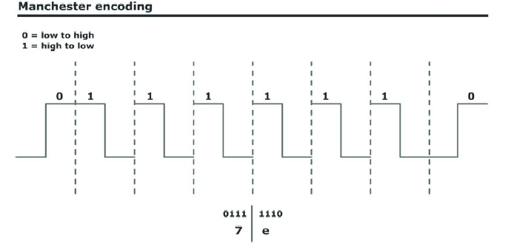
The waveform for a Manchester encoded bit stream carrying the sequence of bits 01111110.

In the Manchester encoding shown a logic 0 is indicated by a 0 to 1 transition at the center of the bit and a logic 1 is indicated by a 1 to 0 transition at the center of the bit. Note that signal transitions do not always occur at the 'bit boundaries' (the division between one bit and another), but that there is always a transition at the center of each bit. The encoding may be alternatively viewed as a phase encoding where each bit is encoded by a positive 90-degree phase transition, or a negative 90-degree phase transition. The Manchester code is therefore sometimes known as a Biphase Code. A Manchester encoded signal contains frequent level transitions that allow the receiver to extract the clock signal using a Digital Phase Locked Loop (DPLL) and correctly decode the value and timing of each bit. To allow reliable operation using a DPLL, the transmitted bit stream must contain a high density of bit transitions. Manchester encoding ensures this, allowing the receiving DPLL to correctly extract the clock signal.

The penalty for introducing frequent transitions is that the Manchester coded signal consumes more bandwidth than the original signal. For a 10 Mbps LAN, the signal spectrum lies between the 5 and 10 MHz. Manchester encoding has up to two transitions per bit-time, it therefore needs twice as much bandwidth as a signal, which has only one transition per bit-time. Ethernet uses a transmission frequency of approximately 20 MHz, as it uses the Manchester encoding scheme it utilizes only half the bandwidth, 10 Mbit/s. Because Manchester encoding is used at the physical layer of an Ethernet LAN, the additional bandwidth is not a significant issue.

Ethernet can send up to 1,500 octets of data (12,000 bits) in what are known as frames, but no more. Each Ethernet frame must start with a 64-bit preamble. Thus the overhead here can be as low as 0.5%, which is a lot better than the RS-232 overhead. Manchester encoding is very inefficient as far as bandwidth requirements. To transmit 10 Mbps you need at least a 10MHz bandwidth for the signal on the cable. The same can be said for Point-to-Point and ATM protocols. The table below shows the bits per cycle using Manchester Encoding and latency to send the above mention frame sizes.
The information carrying capacity of a communications channel is very important, but it is an average figure; it tells us nothing about how quickly a given bit of data will move from one point to another. The time taken for this to happen is called the latency of the system. The theoretical limit to latency is the speed of light; as far as we know, information cannot be transmitted faster than this. An electrical signal propagates along a wire at about 70% of the speed of light. Over a wide-area network the latency is much longer, because the message has to be processed at a number of intermediate stations between the sender and the recipient. For this examine we will use a 10Mbps line or 20MHz with an MTU of 1500 bytes. We are assuming that the distance between the two networks is 4000 km and there is no other traffic on the network, therefore queuing time is zero.

Frame Size in bits | Symbols per cycle | Total # cycles | Efficiency Rate | Latency
12000 | 1 | 6000 | 0.12% | 3.6 sec
6400 | 1 | 3200 | 0.064% | 2.4 sec
640 | 1 | 320 | 0.0064% | 2.4 sec
Latency = propagation time for all links + Data Transmission Time for first hop + Data transmission time
for next hop + queuing time at each hop.

From the results above, we see that latency stays somewhat constant for 800 and 80 bytes transmitted, but increases when 1500 bytes are transmitted while the uses of bandwidth increase and its efficiency rate drop fast.

The eValid Software evaluation

What is eValid? eValid is a Browser-Based Client-Side Website Mapping & Analysis, Functional Testing and Validation, Server Loading, Page Timing/Tuning, and Quality Monitoring tool for today’s e-commerce companies to compare there site for capacity, speed, etc.

We all have had the exasperating experience of waiting too long for a page to arrive at our Web browser. Ultimately, if the response time is too long, we "click away" and do something else. Even when the Web is heavily saturated with requests, if you are patient enough every page you request will -- ultimately -- be delivered to your browser. But that's not good enough. Too slow response times turn users away, or, worse yet, because the user has moved on to another page or context, important session data could be lost.

How slow is "too slow"? From my personal experience I tend to “click away” after about 7 seconds. The real answer to "too slow" probably is more subjective, but at the same time probably not too terribly different. In other words, the Website sever is configured properly and effectively when it has "enough capacity to meet the customer demands."
Another way to look at this is to look for the reverse information: when is the server delivering a request too slowly? While you may never really know what the peak deliverable capacity of the server is, you might be able to tell fairly accurately when the imposed server load (i.e. the queue of incomings requests) is not being served within a specified time limit, say 10 seconds. Then you surely will know when there is NOT enough capacity -- when this limit is exceeded.
Can You Measure Response Time From a Typical Users' Perspective? It may be simpler to measure response time at the client side of the picture, i.e. from the browser. If you can pre-establish a multi-case scenario that is typical of what users do, then it is possible to engineer series of experiments that measure Website performance against that specific scenario. Even though it is relatively easy to measure if such tests run slower than a threshold -- for example, the 10 second overall response time limit -- this approach has a fundamental limit: it is only as good as the set of scenarios that you develop to emulate actual Website use.
Many factors affect how fast a Website appears to a user. There are many stages between a RETURN typed on a browser and a completed page being rendered on the client.
- Client Machine Speed and LAN Factors. Before the request is delivered to the Web by the client machine it may have to work its way through the local LAN and enter the Web, where the connect speed and local saturation affects performance.
- The Outbound Request to the Server. Before the request gets to the server the Web routing and other technical overhead produces delays.
- The Server Response Time. After the request gets to the server the response speed is affected by the current request backlog, where the request is in a multi-layer queue, and how long running the last-tier request takes.
- The Inbound Delivery to the Client. After the response is delivered by the server the reverse of the above sequence takes over: the delivered pages have to wend their way through the Web back to the client.
- The Client Response Time. After the data arrives at the client access point client machine speed and local LAN factors come into play again.
- The Client Rendering. The browser now has all the parts it needs; it is a matter of how long it takes the browser to render the page/image.
Armed with this information a basic analysis of each website can and will be made. The test bed is design to first duplicate the eValid tests that were done in August 2003; the top 25 companies are shown in our test bed and the test were ran in December 2003. To assure as close of comparability of the technical analysis data, all the eValid site analysis runs were made serially during normal working hours on the same Windows XP Professional machine using a T1 line. Although the eValid test were ran using Windows 2000/Professional machine on a dedicated 386 Kbps DSL the line speed should not cause any major different due to the number of servers that the T1 line connects. The 150+ eValid runs were all limited (using eValid's site analysis setup and control menus) to analyze only the first 1000 pages out to depth 3 from the top page on the site. After running these test, we then evaluated the tool by running test of 26 web sites listed below to compare each website in terms of Best Online Experience, data rate, overhead, and efficiency. The web sites used are listed below.
- University of Oxford
- Stanford University
- The University of Hong Kong
- Massachusetts Institute of Technology
- General Motors
- General Electric
- America International Group
- State Farm Insurance
- Wal-Mart Stores
- Federal Aviation Administration
- Exxon Mobil
- Ford Motor Company
- Citigroup
- IBM
- Verizon
- Home Depot
- Boeing
- Fannie Mae
- Merck
- Kroger
- Cardinal Health
- AT&T
- Bank of America
- Target
- NIST
Goals
For this comparative analysis of Websites we use two important dimensions to rank order each Website in terms of Best Online Experience:
- Ease of Navigation [Qn]. This factor is a combination of the average rate of download of pages and the number of successful page retrievals. A high score for ease of navigation means that users will have quick responses as they work on the Website, and that they will find very few broken or unavailable pages.
- Quality of Maintenance [Qm]. This factor is based on the relative age of pages found on the Website. A well-maintained Website has very-current information, and indicates that great care has been taken to assure the quality of the information.
We used the eValid Website analysis engine, programmed to collect specific metrics that contribute to these factors. To assure accuracy the measurements were done over a 3-day time frame and using similar access capabilities.

Crunching The Numbers
We used the eValid Website analysis engine, programmed as described below, to collect specific metrics that contribute to these factors. We put the data into a spreadsheet and massaged the data in a number of ways. For simplicity all the data values were converted to normalized relative values. After computing the scores for the two dimensions [0%-100%, with 100% being the best possible score for that factor] we multiplied the two values Quality of Maintenance [Qm] and Ease of Navigation [Qn] to arrive at the Total Quality Score = Qn * Qm, and from this we get the Quality Rankings.

Results
The measurements we made of the Websites of the selected produced the relative Quality of Online Experience comparison chart shown. The data shown are all normalized relative values. The table below shows all of the results used to construct the comparative chart and the Quality rank of each company’s website. First, we computed the Quality Rank using the formula from the crunching the number section above for all 25 of our candidate Websites and showed these values in the table along with the measured percentage of broken/unavailable links (page return code 400 or greater), percentage of old pages (dated more than 2 days ago), and percentage of slow-loading pages (more than 2,000 msecs download time on a fast DSL).
Quality Ranking | Company Name | Percent Broken Links | Percent Old Pages | Percent Slow Pages
1 | FEDERAL AVIATION ADMINISTRATION | 1.00% | 5.61% | 0.14%
2 | CARDINAL HEALTH | 2.00% | 1.65% | 1.00%
3 | CITIGROUP | 0.00% | 5.60% | 0.19%
4 | FANNIE MAE | 1.00% | 4.20% | 2.90%
5 | STANFORD | 2.00% | 3.00% | 2.89%
6 | UNIVERSITY OF HONG KONG | 3.00% | 1.00% | 4.00%
7 | MIT | 2.00% | 24.00% | 0.14%
8 | EXXON MOBIL | 10.00% | 0.06% | 1.38%
9 | NIST | 12.00% | 2.00% | 3.00%
10 | AMERICAN INTERNATIONAL | 1.00% | 10.84% | 0.19%
11 | UNIVERSITY OF OXFORD | 11.00% | 3.00% | 15.00%
12 | WAL-MART STORES | 0.00% | 13.79% | 0.10%
13 | HOME DEPOT | 1.00% | 11.40% | 2.69%
14 | STATE FARM INSURANCE | 1.00% | 15.80% | 0.00%
15 | TARGET | 12.00% | 0.00% | 18.10%
16 | IBM | 23.00% | 5.66% | 0.28%
17 | KROGER | 0.00% | 29.00% | 2.47%
18 | GENERAL ELECTRIC | 2.70% | 36.22% | 1.00%
19 | BOEING | 2.00% | 37.40% | 0.00%
20 | BANK OF AMERICA | 28.00% | 10.10% | 1.60%
21 | GENERAL MOTORS | 43.00% | 0.06% | 0.10%
22 | MERCK | 50.00% | 7.60% | 1.30%
23 | FORD MOTOR | 75.00% | 3.99% | 0.40%
24 | VERIZON | 47.00% | 23.78% | 0.12%
25 | AT&T | 79.00% | 2.70% | 1.70%

Methodology
To collect the data used in the chart we used the eValid Website analysis engine with parameter settings as follows:
- Search Mode. We used the HTTP Normal mode, which scans pages in the background without using the cache (all pages are freshly downloaded).
- Depth of Search. All of these tests were done with a maximum tree depth of 3. Most of these Websites are many layers deeper.
- Large Page Threshold. We chose a relatively small 10 Kbytes limit for this factor because user response is usually best when the total page size is small. 10 Kbytes @ 5 KBytes/second = 2.0 secs.
- Slow Page Threshold. We chose a 2.0 sec threshold to decide if a page was slow loading.
- Old Page Threshold. Here we chose a threshold of 1 day (24 hrs) to emphasize the stability of the site.
- Broken/Unavailable Link Counts. This factor is expressed as a percentage of the total number of URLs visited.
- Excluded URLs. To make sure that the report was not biased by the existence of long and very-long files -- PDF format files, for example -- these suffixes and a similar set were blocked from consideration.
- Mapped Links Limit. Because these corporate Websites tend to be very large we imposed a 5000-link limit in each run. This limit means that eValid maps only the URLs that give rise to the first 5000 links. After the limit is reached eValid continues to search out properties of the already-enumerated URLs that gave rise to those links.
All tests were done on a 1.544 Mbps (peak performance value) T1 connection over a WAN. To test the speed of the WAN and eValid browser while connecting to a website, a file download time calculator that was programmed in C++ was written for the purpose of these test. What we found was that using a T1 connection, the web browser downloaded 1,071,147 bytes in 3.08 seconds. Which means that our download rate should be about 1,007.87 kilobits per second. At this rate, we could download a 10-megabyte file in 29.43 seconds. These calculations assume a perfect connection at the stated speed. Actual performance varies due to retries, latency, transmission protocol requirement and other concurrent traffic. The data for our analysis was collected with successive eValid runs during normal business hours. The summaries below gives information about each run. The total bytes download were very large. By comparing our finding and using the Efficiency Rate to rank each website, the results above closely matched the finding of eValid test with small changes on some sites.

Manchester Encoding

Manchester Encoding was used to look at bits per cycle and symbols per cycle in our evaluation. Our findings support what we found when using the eValid software. When taking into account the Efficiency Rate, and Total Wait time for all the pages to download, our findings hold true. From the chart above we see that broken links and pages that were not available had an effect on the overall rating of the websites. Overall, the eValid tool evaluation of web sites matched my expectation of how websites should respond at different times of the day or week and is a good tool for evaluating website performance. Taking these results of the websites performance gives us a good starting point, but to fully evaluate the sites two additional models were needed to evaluation our data.

First, we wanted to determine the precise where and how this traffic would flow on the routes between the desired destinations. To determine this, we used a tool called Visual Route that collects data on network routing.

Visual Route

What is Visual Route and what data will be collected? Visual Route is an award winning traceroute application that provides an easy to use, graphical tool for determining precisely where and how traffic is flowing on the route between the desired destination and the user trying to access it. Visual Route enables network administrators and system managers to quickly pinpoint where connectivity bottlenecks occur, so that service to end-users and customers can be quickly restored.

- Provides quick analysis and identification of the source of Internet connectivity problems
- Identifies the geographical location of an IP address or Web site
- Provides domain and network contact information for quick problem reporting
- Provides students with a visual tool to help demonstrate how the Internet works

Visual Route is utilized by information security specialists and police organizations worldwide to help identify and track suspects. For network security specialists, the unique IP geo-tracking ability helps ascertain where a threat is coming from. For Internet crime investigations, the easy-to-use graphical interface provides an instant picture of an IP address location, down to the city and country level, and enables a non-technical audience to quickly understand the results.

- Trace IP addresses to identify where network intruders or suspects are located
- Quickly report and investigate network abusers with instant domain and network Whois contact information
- Provide information forensics students a visual picture of how suspects can be tracked
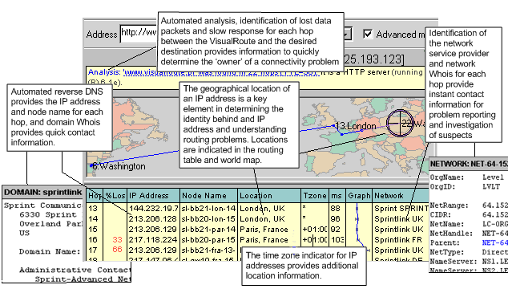 Visual Route shows you the actual path of your Internet connection, identifies any problem areas and the location of the Web site or IP address.

Visual Route’s traceroute provides three types of data: an overall analysis, a data table, and a geographical view of the routing. The analysis section provides the number of hops, where problems occurred, the Web server software running at the destination site, and identifies any routing loops. The data table lists information for each hop, including packet loss, IP address, node name, geographical location, ping response and the major Internet backbone where each server resides.

Analysis of Data collected from Visual Route

For each web site, a total of 10 trace routes were performed (see Table 1). Each trace was done on different days at different times and different locations to get a real sense of network traffic. There was no control over packet size; therefore our measurements of 1500 bytes, 800 bytes, and 80 bytes could not be monitored. Visual Route used the standard packet size of 1500 bytes for each ping it sent. Due to this limitation, our measurements are for 1500 bytes only. The measurements in the table below are for Round Trip Time in millisecond. After getting all the RTT(s), a calculation of the Means, Average number of hops, and Standard Deviation was done so that the data could be analyzed. The first sets of measurements were taken at 7 am on a Monday morning. It was assumed that network traffic would be low at this time and this would be a good indicator of how traffic should be with low usages at each router. To prove or disprove this theory a comparison of the next time interval at 1 pm was taken. What was found was that for some routes, the theory held, but for others it did not. The next comparison was done on Saturday afternoon and compared with Monday’s data to see if the theory would hold. Overall the Saturday round trip times were lower than both times done on Monday and so our theory held on traffic being low at certain times. The next time segment was done on Sunday morning. When we compared this segment with times done at 6 pm, 9 pm and 1:30 am (this was done on different days of the week) we see that network traffic is at it’s lowest during weekends, nights and early morning hours. This fact shows that bandwidth is under utilized during periods, but over utilized during other times.

The next comparison was done while visiting Montego Bay, Jamaica and Atlanta City, NJ to see if location would affect network traffic. The data showed that location does matter; what was surprising about location was that although Atlanta City showed the faster round trip times of the two sites, Jamaica had the lower number of hops to each site (see Table 2). Both locations’ timing was done on a Wednesday at 2 pm a week apart to ensure that the test would be done at a time when the network was load with traffic. Overall, the best round trip time was measured at 1:30 am when very little traffic was on the network.

When viewing the average round trip time, average number of hops and standard deviation, not only does the number of routers that data travels through affect the networks performance but network congestion also affects network performance. This then supports our earlier finding using the eValid software that when Efficiency Rate and Total Wait time for all the pages to download is taken into account, the network performance rate with be lower.

Web Sites | RTT1 (0700) | RTT2 (1300) | RTT3 (Sat) | RTT4  (MBJ) | RTT5 (Sun) | RTT6  (AC) | RTT7 (1800) | RTT8  (0130) | RTT9 (2110) | RTT10 (1500) | Means | Avg # of Hops | StdDev
AIG | 102 | 384 | 293 | 272 | 148 | 51 | 132 | 40 | 90 | 201 | 171.3 | 18 | 114
AT&T | 331 | 283 | 285 | 296 | 422 | 59 | 222 | 54 | 88 | 198 | 223.8 | 18 | 124
Bank of America | 577 | 314 | 306 | 420 | 269 | 57 | 317 | 55 | 81 | 319 | 271.5 | 18 | 167.2
Boeing | 539 | 3248 | 347 | 390 | 365 | 76 | 415 | 75 | 84 | 310 | 584.9 | 21 | 949.3
Cardinal Health System | 321 | 297 | 296 | 230 | 212 | 41 | 245 | 40 | 61 | 239 | 198.2 | 18 | 109.6
CitiGroup | 273 | 279 | 260 | 120 | 213 | 16 | 149 | 22 | 49 | 117 | 149.8 | 12 | 102.4
Exxon Mobil | 385 | 320 | 322 | 94 | 342 | 51 | 317 | 50 | 60 | 110 | 205.1 | 19 | 141.7
FAA | 320 | 313 | 311 | 640 | 412 | 36 | 314 | 20 | 50 | 246 | 266.2 | 19 | 191.8
Fannie Mae | 272 | 258 | 269 | 173 | 273 | 20 | 213 | 18 | 33 | 268 | 179.7 | 16 | 112.3
Ford Motor | 325 | 307 | 292 | 97 | 288 | 30 | 189 | 27 | 88 | 299 | 194.2 | 17 | 122.4
General Electric | 272 | 269 | 266 | 312 | 267 | 110 | 256 | 24 | 30 | 274 | 208 | 20 | 109.2
General Motors | 281 | 257 | 270 | 128 | 263 | 170 | 245 | 39 | 69 | 192 | 191.4 | 7 | 87.7
Home Depot | 285 | 298 | 480 | 93 | 300 | 212 | 256 | 46 | 126 | 154 | 225 | 17 | 127
IBM | 281 | 291 | 276 | 93 | 295 | 98 | 112 | 25 | 147 | 281 | 189.9 | 13 | 104.5
Kroger | 484 | 295 | 295 | 115 | 345 | 148 | 259 | 52 | 68 | 512 | 257.3 | 14 | 162.3
Merck | 283 | 280 | 278 | 315 | 288 | 123 | 255 | 23 | 86 | 281 | 221.2 | 15 | 103.1
MIT | 331 | 282 | 266 | 84 | 265 | 129 | 245 | 78 | 201 | 343 | 222.4 | 15 | 96.2
Stanford | 384 | 400 | 345 | 152 | 289 | 100 | 212 | 85 | 208 | 300 | 247.5 | 18 | 113.5
Nat’l Inst of Stds & Tech | 220 | 161 | 295 | 172 | 429 | 130 | 265 | 60 | 109 | 700 | 254.1 | 20 | 189.1
State Farm | 284 | 283 | 283 | 101 | 285 | 212 | 289 | 69 | 102 | 286 | 219.4 | 13 | 92.1
Target | 271 | 266 | 273 | 95 | 272 | 71 | 281 | 32 | 56 | 117 | 173.4 | 17 | 107
U of Hong Kong | 556 | 1385 | 564 | 400 | 518 | 300 | 554 | 321 | 421 | 498 | 551.7 | 22 | 308.3
U of Oxford | 346 | 371 | 378 | 215 | 345 | 201 | 451 | 110 | 200 | 357 | 297.4 | 22 | 107.7
Verizon | 265 | 258 | 254 | 79 | 233 | 189 | 267 | 156 | 211 | 317 | 232.9 | 8 | 68.6
Wal-Mart | 306 | 309 | 316 | 110 | 301 | 110 | 314 | 50 | 141 | 289 | 224.6 | 20 | 107.4
Table 1: Round Trip Times for all sites

Note: All timing measurements are in ms; Average Hops are round up.
Notations: Sat = Saturday; Sun = Sunday; MBJ = Montego Bay, Jamaica; AC = Atlanta City

Web Sites | Number of Hops from Jamaica | Number of Hops from Atlanta City
AIG | 15 | 18
AT&T | 10 | 21
Bank of America | 16 | 17
Boeing | 17 | 19
Cardinal Health System | 17 | 19
CitiGroup | 07 | 12
Exxon Mobil | 14 | 17
Federal Aviation Administration | 16 | 18
Fannie Mae | 10 | 18
Ford Motor | 17 | 19
General Electric | 13 | 17
General Motors | 17 | 16
Home Depot | 14 | 18
IBM | 10 | 18
Kroger | 14 | 17
Merck | 15 | 18
MIT | 13 | 17
Stanford | 17 | 21
Nat’l Inst of Stds & Tech | 15 | 21
State Farm | 32 | 16
Target | 13 | 17
U of Hong Kong | 20 | 31
U of Oxford | 29 | 33
Verizon | 11 | 19
Wal-Mart | 12 | 18

Table 2: Shows number of hops from each location

The ICE T model

To complete our analysis we used the “ICED T” model for testing a single website. We choose the Federal Aviation Administration website because of its overall rating. The question of whether a website is good or not is too broad to be of much use. This is where the "ICED T" Model comes into play. It breaks down the overall subjective measure of the website's quality into five separate groups of related measures. These groups are Intuitive, Consistent, Efficient, Durable, and Thoughtful.

Intuitive – Does the use of this product make sense?
Consistent – Does the product operate in a uniform manner?
Efficient – Is the product quick and swift to use?
Durable – Is the product solid and reliable?
Thoughtful - Does the product anticipate the users needs?

When looking at the Federal Aviation Administration’s website and asking the ICE T questions, if our prior test hold true, we should get favorable results. First we looked at the Intuitiveness of the website to see if the use of this site make sense. Next we exampled the Consistent to see if the website operated in a uniform manner. Then we looked at the Efficient of the website to test the quickness and swiftness of the site. Next we tested the Durability of the website to test how solid and reliable the site really is. Lastly, we looked at the Thoughtfulness of the site to see if it anticipated the users needs.

The scale used in this evaluation is listed below; the overall score was calculated and shown below in table 3. In scoring the site a rating system that score each category from 1 to 5, where 1 was the lowest possible score and 5 was the highest possible score, was used. The highest possible score for this evaluation was 25 points, with the lowest being 5 points. Scores were rated using the following method:

Scoring:

01 – 09: Poor rating
10 – 15: Average rating
16 – 20: Good rating
21 – 25: Great rating

Scale:

- The worst websites I’ve ever visited
- Worst than the average websites I’ve visited
- About the same as other websites I’ve visited
- Better than most websites I’ve visited
- The best website I’ve ever browsed.

To ensure a fair evaluation the following six questions were viewed.

- What information is offered to the user that can be used?
- Is the website user friendly?
- Is the Home page easy to understand?
- Do all the links working?
- Are pages slow in loading?
- Were there any broken or unavailable links that were unreachable?

Intuitive | Consistent | Efficient | Durable | Thoughtful | Total Rating
5 | 4 | 4 | 4 | 5 | 22
Table 3: Federal Aviation Administration website score

The Federal Aviation Administration’s website scored 22 which is in the highest rating range. In scoring the site and answering the six questions, the following conclusions were made about each question.

1. What information is offered to the user that can be used?

On the home page there is information about what the site offers. There are forms, FAQ, Top Requests, Links to News and Updates. There is a search engine for quick searches and there are technical reports, Plans, Studies, Newsletters and more for the user.

2. Is the website user friendly?

The site is very user friendly and uses friendly looking picture to help direct the user to the correct place, based on the user’s need. When browsing the links the site ensures that if information is missing, where to go to find it and how to correct browser problems.

3. Is the Home page easy to understand?

The home page is not only easy to understand and navigate, but there is enough information to guide the user to the links that has any information needed. The information on the home page is uniformed and presented in a easy to follow order.

4. Do all the links working?

All links worked well and were reachable. The system’s response time, when searching different links, was quick.

5. Are pages slow in loading?

All pages load quick for the times that were tested. Most researches were done at four different times in conjunction with the measurements taken earlier and held true to form.

6. Were there any broken or unavailable links that were unreachable?

All links were reachable. A level five-depth search was done for the links with no problems.

Overall, the site responded as expected based on the measurements taken earlier above. These findings supports the overall findings of this document and assists with narrowing the question of whether a website is good or not by putting it into a human perceptive. Not only can we say that a site is good in terms of its number rating, but now the human perceptive is added, which gives the measurement a whole new meaning. How do real people judge your website is really the true measurement of a site, not just the numbers based on models. This study can prove to be very useful when looking to increase a website’s bandwidth. The real question that should be asked and answered, is “How do the user feel about surfing your website; this coupled with the other measurement above should give a company a meaningful tool to answer critical questions.

Comparison of Overhead effect with measurements

When comparing each protocol for efficiency one sees that overhead play a very important part in bandwidth usage. From our measurements taken from the eValid and Visual Route software, couple with our finding on the effect of overhead with respect to protocols, we can conclude that the protocols that were traversed will have an effect on the overhead as well as the latency, and not the number of hops the package takes.

The data supports the reasoning that overhead should be considered when making an allowance for bandwidth increases to a network. When looking at different protocols we found that a Point-to-Point Protocol had a slightly better efficiency rate than an ATM or Ethernet protocol when sending data that was less than 1800 bytes due to layer overhead. But what became evidence was that as the number of bytes sent became smaller, the efficiency rate became the same. Which meant that it did not matter which protocol was use when the frame size was small. The efficiency rate was the same. But, when the packet size was increased, it was shown that another factor came into play that also affected the bandwidth, namely Latency. Because certain latency determines the number of accesses per second, lower latency means that more accesses per second would take place; hence higher bandwidth would be needed, but at a cost because improvement in bandwidth, means that latency will suffer.

Taking this into account, the study proved that overhead and latency together have a greater effect on a network performance than previously thought. This is seen when looking at the data collect using the Visual Route and eValid software. This data shows that both overhead and latency has affect on the overall performance of a network. When examining the data from two different sites (Montego Bay, Jamaica and Atlanta City, NJ) that used different protocols (Ethernet in Jamaica and Point-to-Point in Atlanta City), what becomes evidence is that both location and protocol does matter; what was surprising about location was that although Atlanta City showed the faster round trip times of the two sites, Jamaica had the lower number of hops to each site. This was because the overhead and latency in the Jamaica network was higher, based on factor about overhead in different protocols, therefore causing this network to need more bandwidth thus affecting the efficiency of the network performances. The eValid software provide more evidence to support the finding because the top 20 sites in the eValid ranking taken in Jamaica, ranked the same in Atlantic City when the software was ran. The only different was the times to complete the runs in Jamaica were longer than in Atlantic City. Thus further supporting the findings.

Observations and Comments
There are many aspects of this data that are surprising and unusual. Here are some of our observations:
- Website Quality Is Not Correlated With Company Size. Clearly, Website quality is not apparently connected with company size.
- Some Of The Biggest Companies Have The Biggest Problems. Some of the largest companies rank worst in terms of Website quality. Only one of the top dozen firms in terms of Website quality was in the top dozen largest companies. Perhaps of more concern is the fact that, of the top dozen Websites by company size, four actually rank in the lowest third of the Website quality ranking. Worse yet, two of the tops 12 are very near the bottom of the list!
- The Highest Quality Companies Are Not Known for IT Excellence. Only two of the top 12 qualities Websites are from companies, which you would think of as in the "IT sector". It's interesting that of the top dozen quality ranked companies, four are universities, and two are government agencies. Is there a message here?
- There Were Some Big Surprises. There were lots of surprises in the way the numbers turned out: First, the Federal aviation Administration ranked 1/25 along with a healthcare company Cardinal Health that ranked 2/25. AT&T ranked at the bottom with a ranking of 25/25 and Verizon ranked 24/25 a close second to last. IBM ranked 16/25 that was also an unexpectedly low score.
What does all this mean? Studying the above data carefully can lead to the following conclusions:
- Budget: Big bucks don't necessarily mean a super Website! IBM and Verizon are big operations, but their Websites are both poorly maintained and slow to navigate.
- Technology: Industry savvy about Website tricks and techniques doesn't necessarily mean a highly usable Website. Note that Target has a slow but current site, whereas State Farm Insurance has a fast but relatively ancient site.
- Size: Website size isn't a good indicator of quality. Big Websites may be more valuable but the don't have as high quality as smaller, happier, higher-scoring Websites.
- Currency: The metric used emphasizes sites that are update regularly, based on the relative age of pages. This puts a premium on actively generated pages -- the file dates are always today -- but in most cases such sites do have more current data. Obviously, sites that have lots of very old pages are quite static, as if someone quit paying attention to them.
- Usability: Making usability assessments is a complex process. Usability is more than just speed, quality and currency of information, and ease of navigation. Ultimately, you have to consider EVERYTHING.

Conclusion

In conclusion, while the issues of measuring Website server capacity are many and complex, what becomes clear is that users' perception of effective, and useful response time are two dominant factors in assuring adequate capacity. The response time of a Website often plays an important role in its success or demise. From a user’s perspective, the response time is the time elapsed from when a request is initiated at a client to the time that the response is fully loaded by the client.

Responsive service plays a critical role in determining end-user satisfaction. In fact a customer who experiences a large delay after placing a request at a business’s web server often switches to a competitor who provides faster service. Two factors contribute to the response time as perceived by a client: the network delay and the server-side latency (the time it takes to generate a response from the time the request reaches the web server).

Now not only can we say that a site is good in terms of its number rating, but by using the “ICED T” model the human perceptive can be added, which gives the measurement a whole new meaning. How do real people judge your website is really the true measurement of a site, not just the numbers based on models.
In this report we have looked at overhead that each OSI layer adds to each message that was sent, along with the overhead at each protocol that was used. These finding helped us show the Efficiency Rate of each protocol when sending a certain number of bytes across the network.
We then used a web analysis tool (eValid) to rate websites based on certain criteria mention above and compared our finding by using the Efficiency Rate, and total wait time to rank each site. We then measured the round trip time of each site and compared it with of other findings to see if time and location would make a different. Finally, we use the “ICED T” model to bring the user’s perceptive into our research to give it a real base for judging each site. We have found that when we combine all the different measurements taken with the different tools used in this research, our findings hold true that overhead along with latency has the biggest effect on the network; but the user’s perception will dictate whether he or his will switches to a competitor who provides faster service. More research is need to actual state that the software’s analysis remains consistent on different machines and network connection, but this is out of the scope of this paper.
Acknowledgements
The idea of this research came from discussions with Prof. Larry Bernstein of Stevens Institute of Technology. Prof. Bernstein is also responsible for obtaining the website tool eValid use to evaluate each website. A special thanks goes to Mr. Miller of eValid Inc., for the use of their tool and all technical support that was given.

Glossary of Terms
AAL - ATM Adaptation Layer. AAL is a set of standard protocols, which translate user traffic into a size, and format that can be contained in the payload of an ATM cell (53 bytes).
AAL 2 - ATM Adaptation Layer Type 2. AAL1 is used for connection oriented, delay sensitive services requiring constant bit rates, such as uncompressed video and other isochronous traffic.
AAL3/4 - ATM Adaptation Layer Type3/4. AAL3/4 supports both connectionless and connection-oriented links, but is primarily used for the transmission of SMDS packets over ATM networks.
AAL5 - ATM Adaptation Layer Type 5. Accommodates burst LAN data traffic with less overhead than AAL 3/4.
ADCCP - Advanced Data Communications Control Protocol. ANSI standard bit-oriented data link control protocol.
ATM - Asynchronous Transfer Mode. A high-speed/high bandwidth, low-delay, connection-oriented, packet-like switching and multiplexing technique requiring Byte fixed sized cells.
Bandwidth - Bandwidth is a measure of the carrying capacity (or size/width) of a communication (or operating or transmission) channel.
Baseband - Using entire bandwidth of a medium to carry a single signal.
Baud - Byte at Unit Density. It is a measure of the speed of transmission of data per second. It can also be measured as the number of signal level changes per second where each signal level contains one (or more) bits of information.
BER - Bit Error Ratio. It is the measure of transmission quality, thus indicating the number of incorrect bits in a given bit stream compared to the total number of bits transmitted in a given duration time.
Bit - Binary digit. The smallest unit of information in a digital system (machine).
BPS - Bits per second. Basic unit of data transmission.
Bytes - Abbreviation for binary term, a unit of storage capable of holding a single character. On almost all modern computers, a byte is equal to 8 bits.
CBR - Constant Bit Rate. QoS class defined by the ATM Forum for ATM networks. CBR is used for connections that depend on precise clocking to ensure undistorted delivery.
CHAP – Challenge Handshake Authentication Protocol. An authentication protocol used in PPP protocol. Uses a username and a password.

CID – Channel Identifier.

CLP – Cell Loss Priority.

CPS – Common Part Sublayer.
CPU - Central Processing Unit. It is the main processing element of a switch or microprocessor and thus is the brains of the computer.
CRC - Cyclic Redundancy Check. CRC is a technique to detect errors during data transmission.
Data Link Layer - The OSI level that performs the assembly and transmission of data packets (gets data packets on and off the wire), does error detection and correction, synchronization and retransmission.
DPLL – Digital Phase Locked Loop.
DS-1 - Digital Signal Level 1. Framing specification used for transmitting digital signals over a T-1 facility.
DS-3 - Digital Signal Level 3. Framing specification used for transmitting digital signals at 44.736 Mbps on a T3 facility.
DSL - Digital Subscriber Line. Local digital network loop typically sends high-speed data over standard phone lines.
Ethernet - A very common method of networking computers in a LAN using copper cabling. Ethernet will handle about 10,000,000 bits-per-second and can be used with almost any kind of computer.
Frame - In a data communications context this term refers to a variable length grouping of digital data transmitted between end stations.
FDDI - Fiber Distributed Data Interface) -- A standard for transmitting data on optical fiber cables at a rate of around 100,000,000 bits-per-second (10 times as fast as Ethernet, about twice as fast as T-3).
Frame Relay - High performance interface for packet-switching networks.
IETF – Internet Engineering Task Force.
LCP – Link-layer Control Protocols. Part of the point-to-point protocol (PPP) to establish, configure, and test data-link connections
Latency - A measure of the temporal delay. Typically, in xDSL, latency refers to the delay in time between the sending of a unit of data at the originating end of a connection and the reception of that unit at the destination end.
LLC – Logical Link Control
MTU - The Maximum Transmission Unit is a parameter that determines the largest datagram than can be transmitted by an IP interface (without it needing to be broken down into smaller units).
Nrt-VBR - non real time Variable Bit Rate.
NCP - Network Control Program
PAP – Password Authentication Protocol.
PDU - Protocol Data Unit. OSI term for packet.
PLCP - Physical Layer Convergence Procedure/Protocol
PPP - Point-to-Point Protocol. This protocol is a way to connect your computer to the Internet over telephone lines. PPP is replacing an older protocol, SLIP, as it is more stable and has more error-checking features.
RLP – Received Loss Priority.
SDU – Service data unit.
SLIP - Serial Line Internet Protocol. A SLIP connection lets you use a modem and phone lines to connect to the Internet without connecting to a host computer.
SLP – Submitted Loss Priority.
SONET - Synchronous Optical NETwork
SNAP – Sub network Access Protocol.
SSCS – Service Specific Convergence Sublayer.
SSSAR - Service Specific Segmentation and Reassembly Sublayer
TCP - Transmission Control Protocol
THROUGHPUT – The amount of data that can be sent from one location to another in a specific amount of time, usually measured in Kbps, Mbps, or Gbps.
UDP - User Datagram Protocol
VC - Virtual Channel
10/100 BaseT - 10/100BaseT is the Ethernet standard for baseband LANs using twisted-pair cable carrying 10/100 Mbps. 100BaseT is also called Fast Ethernet.

Appendix A
eValid Site Analysis Reports each sites:
This report was created using eValid v4.0.78. Copyright © 2003 by eValid, Inc.

http://www.aig.com

Site Analysis Summary
Total Links Mapped500
Time Elapsed (DD:HH:MM:SS)0:00:00:52
Total Download Time (DD:HH:MM:SS.ms)0:00:00:39.491
Total Bytes Downloaded1883366
Average Download Rate (bytes/sec)47691.0
Depth Reached 2
Pages Examined100
Pages Remaining309
The Site Analysis is complete

Filtered Reports Summary
Broken Links &/or Unavailable Pages0
Pages Loading Slower than 3000 milliseconds0
Pages Smaller than 1024 bytes24
Pages Older than 1440 Hours (60 days, 0 hours) 0
(Unique) Off-site Links49

Performance/Results Statistics
Average Links per Page5.00
Average Bytes per Page18833.66
Average Download Time per Page (msecs/page)394.91
Broken Links per Page0.00
Slow Pages Visited0.00%
Small Pages Visited24.00%
Old Pages Visited0.00%

User Settings
ModeHTTP Normal
Depth Limit100
Time Limit (mins)120
Mapped Links Limit500
URLs Limit100
Reported Items Limit20
Downloaded Kbytes Limitnone
Extension/Query Limitsno limits
Protocols Limitsno limits
Include Base Siteno
Included Sites/Subsitesnone
Included Sites/Subsites Filenone
Excluded Stringsnone
Excluded Strings Case-Sensitiveno
Excluded Strings Filenone
Auto-close New Browser Windowsno
Skip Top Page Refreshyes
Visit Off-site Linksyes
Cache Controln/a

http://www.att.com

Site Analysis Summary
Total Links Mapped500
Time Elapsed (DD:HH:MM:SS)0:00:00:44
Total Download Time (DD:HH:MM:SS.ms)0:00:00:34.450
Total Bytes Downloaded1335473
Average Download Rate (bytes/sec)38765.5
Depth Reached 2
Pages Examined100
Pages Remaining216
The Site Analysis is complete

Filtered Reports Summary
Broken Links &/or Unavailable Pages46
Pages Loading Slower than 3000 milliseconds1
Pages Smaller than 1024 bytes4
Pages Older than 1440 Hours (60 days, 0 hours) 0
(Unique) Off-site Links19

Performance/Results Statistics
Average Links per Page5.00
Average Bytes per Page13354.73
Average Download Time per Page (msecs/page)344.50
Broken Links per Page0.46
Slow Pages Visited1.00%
Small Pages Visited4.00%
Old Pages Visited0.00%

User Settings
ModeHTTP Normal
Depth Limit100
Time Limit (mins)120
Mapped Links Limit500
URLs Limit100
Reported Items Limit20
Downloaded Kbytes Limitnone
Extension/Query Limitsno limits
Protocols Limitsno limits
Include Base Siteno
Included Sites/Subsitesnone
Included Sites/Subsites Filenone
Excluded Stringsnone
Excluded Strings Case-Sensitiveno
Excluded Strings Filenone
Auto-close New Browser Windowsno
Skip Top Page Refreshyes
Visit Off-site Linksyes
Cache Controln/a

http://www.bankofamerica.com

Site Analysis Summary
Total Links Mapped500
Time Elapsed (DD:HH:MM:SS)0:00:01:47
Total Download Time (DD:HH:MM:SS.ms)0:00:01:37.872
Total Bytes Downloaded803832
Average Download Rate (bytes/sec)8213.1
Depth Reached 2
Pages Examined100
Pages Remaining192
The Site Analysis is complete

Filtered Reports Summary
Broken Links &/or Unavailable Pages2
Pages Loading Slower than 3000 milliseconds8
Pages Smaller than 1024 bytes22
Pages Older than 1440 Hours (60 days, 0 hours) 0
(Unique) Off-site Links3

Performance/Results Statistics
Average Links per Page5.00
Average Bytes per Page8038.32
Average Download Time per Page (msecs/page)978.72
Broken Links per Page0.02
Slow Pages Visited8.00%
Small Pages Visited22.00%
Old Pages Visited0.00%

User Settings
ModeHTTP Normal
Depth Limit100
Time Limit (mins)120
Mapped Links Limit500
URLs Limit100
Reported Items Limit20
Downloaded Kbytes Limitnone
Extension/Query Limitsno limits
Protocols Limitsno limits
Include Base Siteno
Included Sites/Subsitesnone
Included Sites/Subsites Filenone
Excluded Stringsnone
Excluded Strings Case-Sensitiveno
Excluded Strings Filenone
Auto-close New Browser Windowsno
Skip Top Page Refreshyes
Visit Off-site Linksyes
Cache Controln/a

http://www.boeing.com

Site Analysis Summary
Total Links Mapped500
Time Elapsed (DD:HH:MM:SS)0:00:00:47
Total Download Time (DD:HH:MM:SS.ms)0:00:00:37.392
Total Bytes Downloaded2765934
Average Download Rate (bytes/sec)73971.3
Depth Reached 3
Pages Examined100
Pages Remaining189
The Site Analysis is complete

Filtered Reports Summary
Broken Links &/or Unavailable Pages0
Pages Loading Slower than 3000 milliseconds0
Pages Smaller than 1024 bytes4
Pages Older than 1440 Hours (60 days, 0 hours) 0
(Unique) Off-site Links17

Performance/Results Statistics
Average Links per Page5.00
Average Bytes per Page27659.34
Average Download Time per Page (msecs/page)373.92
Broken Links per Page0.00
Slow Pages Visited0.00%
Small Pages Visited4.00%
Old Pages Visited0.00%

User Settings
ModeHTTP Normal
Depth Limit100
Time Limit (mins)120
Mapped Links Limit500
URLs Limit100
Reported Items Limit20
Downloaded Kbytes Limitnone
Extension/Query Limitsno limits
Protocols Limitsno limits
Include Base Siteno
Included Sites/Subsitesnone
Included Sites/Subsites Filenone
Excluded Stringsnone
Excluded Strings Case-Sensitiveno
Excluded Strings Filenone
Auto-close New Browser Windowsno
Skip Top Page Refreshyes
Visit Off-site Linksyes
Cache Controln/a

http://www.cardinalhealthsystem.org

Site Analysis Summary
Total Links Mapped500
Time Elapsed (DD:HH:MM:SS)0:00:00:56
Total Download Time (DD:HH:MM:SS.ms)0:00:00:47.683
Total Bytes Downloaded3438432
Average Download Rate (bytes/sec)72110.2
Depth Reached 2
Pages Examined100
Pages Remaining243
The Site Analysis is complete

Filtered Reports Summary
Broken Links &/or Unavailable Pages8
Pages Loading Slower than 3000 milliseconds2
Pages Smaller than 1024 bytes6
Pages Older than 1440 Hours (60 days, 0 hours) 0
(Unique) Off-site Links9

Performance/Results Statistics
Average Links per Page5.00
Average Bytes per Page34384.32
Average Download Time per Page (msecs/page)476.83
Broken Links per Page0.08
Slow Pages Visited2.00%
Small Pages Visited6.00%
Old Pages Visited0.00%

User Settings
ModeHTTP Normal
Depth Limit100
Time Limit (mins)120
Mapped Links Limit500
URLs Limit100
Reported Items Limit20
Downloaded Kbytes Limitnone
Extension/Query Limitsno limits
Protocols Limitsno limits
Include Base Siteno
Included Sites/Subsitesnone
Included Sites/Subsites Filenone
Excluded Stringsnone
Excluded Strings Case-Sensitiveno
Excluded Strings Filenone
Auto-close New Browser Windowsno
Skip Top Page Refreshyes
Visit Off-site Linksyes
Cache Controln/a

http://www.citigroup.com/citigroup/homepage

Site Analysis Summary
Total Links Mapped404
Time Elapsed (DD:HH:MM:SS)0:00:00:52
Total Download Time (DD:HH:MM:SS.ms)0:00:00:38.834
Total Bytes Downloaded790595
Average Download Rate (bytes/sec)20358.3
Depth Reached 4
Pages Examined102
Pages Remaining228
The Site Analysis is complete

Filtered Reports Summary
Broken Links &/or Unavailable Pages1
Pages Loading Slower than 3000 milliseconds1
Pages Smaller than 1024 bytes44
Pages Older than 1440 Hours (60 days, 0 hours) 0
(Unique) Off-site Links69

Performance/Results Statistics
Average Links per Page3.96
Average Bytes per Page7750.93
Average Download Time per Page (msecs/page)380.73
Broken Links per Page0.01
Slow Pages Visited0.98%
Small Pages Visited43.14%
Old Pages Visited0.00%

User Settings
ModeHTTP Normal
Depth Limit100
Time Limit (mins)120
Mapped Links Limit500
URLs Limit100
Reported Items Limit20
Downloaded Kbytes Limitnone
Extension/Query Limitsno limits
Protocols Limitsno limits
Include Base Siteno
Included Sites/Subsitesnone
Included Sites/Subsites Filenone
Excluded Stringsnone
Excluded Strings Case-Sensitiveno
Excluded Strings Filenone
Auto-close New Browser Windowsno
Skip Top Page Refreshyes
Visit Off-site Linksyes
Cache Controln/a

http://www.exxonmobil.com/corporate

Site Analysis Summary
Total Links Mapped500
Time Elapsed (DD:HH:MM:SS)0:00:01:24
Total Download Time (DD:HH:MM:SS.ms)0:00:01:08.657
Total Bytes Downloaded4189967
Average Download Rate (bytes/sec)61027.5
Depth Reached 2
Pages Examined100
Pages Remaining79
The Site Analysis is complete

Filtered Reports Summary
Broken Links &/or Unavailable Pages11
Pages Loading Slower than 3000 milliseconds5
Pages Smaller than 1024 bytes18
Pages Older than 1440 Hours (60 days, 0 hours) 0
(Unique) Off-site Links66

Performance/Results Statistics
Average Links per Page5.00
Average Bytes per Page41899.67
Average Download Time per Page (msecs/page)686.57
Broken Links per Page0.11
Slow Pages Visited5.00%
Small Pages Visited18.00%
Old Pages Visited0.00%

User Settings
ModeHTTP Normal
Depth Limit100
Time Limit (mins)120
Mapped Links Limit500
URLs Limit100
Reported Items Limit20
Downloaded Kbytes Limitnone
Extension/Query Limitsno limits
Protocols Limitsno limits
Include Base Siteno
Included Sites/Subsitesnone
Included Sites/Subsites Filenone
Excluded Stringsnone
Excluded Strings Case-Sensitiveno
Excluded Strings Filenone
Auto-close New Browser Windowsno
Skip Top Page Refreshyes
Visit Off-site Linksyes
Cache Controln/a

http://www.faa.gov

Site Analysis Summary
Total Links Mapped500
Time Elapsed (DD:HH:MM:SS)0:00:00:51
Total Download Time (DD:HH:MM:SS.ms)0:00:00:40.833
Total Bytes Downloaded1115067
Average Download Rate (bytes/sec)27308.0
Depth Reached 2
Pages Examined100
Pages Remaining101
The Site Analysis is complete

Filtered Reports Summary
Broken Links &/or Unavailable Pages0
Pages Loading Slower than 3000 milliseconds1
Pages Smaller than 1024 bytes38
Pages Older than 1440 Hours (60 days, 0 hours) 0
(Unique) Off-site Links12

Performance/Results Statistics
Average Links per Page5.00
Average Bytes per Page11150.67
Average Download Time per Page (msecs/page)408.33
Broken Links per Page0.00
Slow Pages Visited1.00%
Small Pages Visited38.00%
Old Pages Visited0.00%

User Settings
ModeHTTP Normal
Depth Limit100
Time Limit (mins)120
Mapped Links Limit500
URLs Limit100
Reported Items Limit20
Downloaded Kbytes Limitnone
Extension/Query Limitsno limits
Protocols Limitsno limits
Include Base Siteno
Included Sites/Subsitesnone
Included Sites/Subsites Filenone
Excluded Stringsnone
Excluded Strings Case-Sensitiveno
Excluded Strings Filenone
Auto-close New Browser Windowsno
Skip Top Page Refreshyes
Visit Off-site Linksyes
Cache Controln/a

http://www.fanniemae.com

Site Analysis Summary
Total Links Mapped500
Time Elapsed (DD:HH:MM:SS)0:00:01:10
Total Download Time (DD:HH:MM:SS.ms)0:00:00:41.256
Total Bytes Downloaded3968633
Average Download Rate (bytes/sec)96195.3
Depth Reached 2
Pages Examined100
Pages Remaining177
The Site Analysis is complete

Filtered Reports Summary
Broken Links &/or Unavailable Pages0
Pages Loading Slower than 3000 milliseconds2
Pages Smaller than 1024 bytes21
Pages Older than 1440 Hours (60 days, 0 hours) 0
(Unique) Off-site Links6

Performance/Results Statistics
Average Links per Page5.00
Average Bytes per Page39686.33
Average Download Time per Page (msecs/page)412.56
Broken Links per Page0.00
Slow Pages Visited2.00%
Small Pages Visited21.00%
Old Pages Visited0.00%

User Settings
ModeHTTP Normal
Depth Limit100
Time Limit (mins)120
Mapped Links Limit500
URLs Limit100
Reported Items Limit20
Downloaded Kbytes Limitnone
Extension/Query Limitsno limits
Protocols Limitsno limits
Include Base Siteno
Included Sites/Subsitesnone
Included Sites/Subsites Filenone
Excluded Stringsnone
Excluded Strings Case-Sensitiveno
Excluded Strings Filenone
Auto-close New Browser Windowsno
Skip Top Page Refreshyes
Visit Off-site Linksyes
Cache Controln/a

http://www.ford.com/en

Site Analysis Summary
Total Links Mapped500
Time Elapsed (DD:HH:MM:SS)0:00:01:05
Total Download Time (DD:HH:MM:SS.ms)0:00:00:51.681
Total Bytes Downloaded1979936
Average Download Rate (bytes/sec)38310.7
Depth Reached 2
Pages Examined100
Pages Remaining236
The Site Analysis is complete

Filtered Reports Summary
Broken Links &/or Unavailable Pages2
Pages Loading Slower than 3000 milliseconds1
Pages Smaller than 1024 bytes31
Pages Older than 1440 Hours (60 days, 0 hours) 0
(Unique) Off-site Links43

Performance/Results Statistics
Average Links per Page5.00
Average Bytes per Page19799.36
Average Download Time per Page (msecs/page)516.81
Broken Links per Page0.02
Slow Pages Visited1.00%
Small Pages Visited31.00%
Old Pages Visited0.00%

User Settings
ModeHTTP Normal
Depth Limit100
Time Limit (mins)120
Mapped Links Limit500
URLs Limit100
Reported Items Limit20
Downloaded Kbytes Limitnone
Extension/Query Limitsno limits
Protocols Limitsno limits
Include Base Siteno
Included Sites/Subsitesnone
Included Sites/Subsites Filenone
Excluded Stringsnone
Excluded Strings Case-Sensitiveno
Excluded Strings Filenone
Auto-close New Browser Windowsno
Skip Top Page Refreshyes
Visit Off-site Linksyes
Cache Controln/a

http://www.ge.com

Site Analysis Summary
Total Links Mapped500
Time Elapsed (DD:HH:MM:SS)0:00:00:35
Total Download Time (DD:HH:MM:SS.ms)0:00:00:20.142
Total Bytes Downloaded1700889
Average Download Rate (bytes/sec)84444.9
Depth Reached 2
Pages Examined100
Pages Remaining125
The Site Analysis is complete

Filtered Reports Summary
Broken Links &/or Unavailable Pages0
Pages Smaller than 1024 bytes26
Pages Older than 1440 Hours (60 days, 0 hours) 0
(Unique) Off-site Links4

Performance/Results Statistics
Average Links per Page5.00
Average Bytes per Page17008.89
Average Download Time per Page (msecs/page)201.42
Broken Links per Page0.00
Small Pages Visited26.00%
Old Pages Visited0.00%

User Settings
ModeHTTP Normal
Depth Limit100
Time Limit (mins)120
Mapped Links Limit500
URLs Limit100
Reported Items Limit20
Downloaded Kbytes Limitnone
Extension/Query Limitsno limits
Protocols Limitsno limits
Include Base Siteno
Included Sites/Subsitesnone
Included Sites/Subsites Filenone
Excluded Stringsnone
Excluded Strings Case-Sensitiveno
Excluded Strings Filenone
Auto-close New Browser Windowsno
Skip Top Page Refreshyes
Visit Off-site Linksyes
Cache Controln/a

http://www.homedepot.com/prel80/HDUS/EN_US

Site Analysis Summary
Total Links Mapped351
Time Elapsed (DD:HH:MM:SS)0:00:02:45
Total Download Time (DD:HH:MM:SS.ms)0:00:02:36.325
Total Bytes Downloaded411924
Average Download Rate (bytes/sec)2635.0
Depth Reached 1
Pages Examined100
Pages Remaining251
The Site Analysis is complete

Filtered Reports Summary
Broken Links &/or Unavailable Pages0
Pages Loading Slower than 3000 milliseconds8
Pages Smaller than 1024 bytes3
Pages Older than 1440 Hours (60 days, 0 hours) 0
(Unique) Off-site Links9

Performance/Results Statistics
Average Links per Page3.51
Average Bytes per Page4119.24
Average Download Time per Page (msecs/page)1563.25
Broken Links per Page0.00
Slow Pages Visited8.00%
Small Pages Visited3.00%
Old Pages Visited0.00%

User Settings
ModeHTTP Normal
Depth Limit100
Time Limit (mins)120
Mapped Links Limit500
URLs Limit100
Reported Items Limit20
Downloaded Kbytes Limitnone
Extension/Query Limitsno limits
Protocols Limitsno limits
Include Base Siteno
Included Sites/Subsitesnone
Included Sites/Subsites Filenone
Excluded Stringsnone
Excluded Strings Case-Sensitiveno
Excluded Strings Filenone
Auto-close New Browser Windowsno
Skip Top Page Refreshyes
Visit Off-site Linksyes
Cache Controln/a

http://www.ibm.com/us

Site Analysis Summary
Total Links Mapped65
Time Elapsed (DD:HH:MM:SS)0:00:00:55
Total Download Time (DD:HH:MM:SS.ms)0:00:00:44.332
Total Bytes Downloaded1263194
Average Download Rate (bytes/sec)28494.0
Depth Reached 1
Total Unique URLs on Site64
Pages Remaining0
The Site Analysis is complete

Filtered Reports Summary
Broken Links &/or Unavailable Pages0
Pages Loading Slower than 3000 milliseconds4
Pages Smaller than 1024 bytes12
Pages Older than 1440 Hours (60 days, 0 hours) 0
(Unique) Off-site Links60

Performance/Results Statistics
Average Links per Page1.02
Average Bytes per Page19737.41
Average Download Time per Page (msecs/page)692.69
Broken Links per Page0.00
Slow Pages Visited6.25%
Small Pages Visited18.75%
Old Pages Visited0.00%

User Settings
ModeHTTP Normal
Depth Limit100
Time Limit (mins)120
Mapped Links Limit500
URLs Limit100
Reported Items Limit20
Downloaded Kbytes Limitnone
Extension/Query Limitsno limits
Protocols Limitsno limits
Include Base Siteno
Included Sites/Subsitesnone
Included Sites/Subsites Filenone
Excluded Stringsnone
Excluded Strings Case-Sensitiveno
Excluded Strings Filenone
Auto-close New Browser Windowsno
Skip Top Page Refreshyes
Visit Off-site Linksyes
Cache Controln/a

http://www.kroger.com

Site Analysis Summary
Total Links Mapped500
Time Elapsed (DD:HH:MM:SS)0:00:00:39
Total Download Time (DD:HH:MM:SS.ms)0:00:00:30.391
Total Bytes Downloaded1579751
Average Download Rate (bytes/sec)51980.9
Depth Reached 2
Pages Examined100
Pages Remaining111
The Site Analysis is complete

Filtered Reports Summary
Broken Links &/or Unavailable Pages0
Pages Loading Slower than 3000 milliseconds0
Pages Smaller than 1024 bytes17
Pages Older than 1440 Hours (60 days, 0 hours) 0
(Unique) Off-site Links25

Performance/Results Statistics
Average Links per Page5.00
Average Bytes per Page15797.51
Average Download Time per Page (msecs/page)303.91
Broken Links per Page0.00
Slow Pages Visited0.00%
Small Pages Visited17.00%
Old Pages Visited0.00%

User Settings
ModeHTTP Normal
Depth Limit100
Time Limit (mins)120
Mapped Links Limit500
URLs Limit100
Reported Items Limit20
Downloaded Kbytes Limitnone
Extension/Query Limitsno limits
Protocols Limitsno limits
Include Base Siteno
Included Sites/Subsitesnone
Included Sites/Subsites Filenone
Excluded Stringsnone
Excluded Strings Case-Sensitiveno
Excluded Strings Filenone
Auto-close New Browser Windowsno
Skip Top Page Refreshyes
Visit Off-site Linksyes
Cache Controln/a

http://www.merck.com

Site Analysis Summary
Total Links Mapped500
Time Elapsed (DD:HH:MM:SS)0:00:00:38
Total Download Time (DD:HH:MM:SS.ms)0:00:00:24.148
Total Bytes Downloaded1704464
Average Download Rate (bytes/sec)70584.1
Depth Reached 1
Pages Examined100
Pages Remaining264
The Site Analysis is complete

Filtered Reports Summary
Broken Links &/or Unavailable Pages0
Pages Loading Slower than 3000 milliseconds0
Pages Smaller than 1024 bytes45
Pages Older than 1440 Hours (60 days, 0 hours) 0
(Unique) Off-site Links1

Performance/Results Statistics
Average Links per Page5.00
Average Bytes per Page17044.64
Average Download Time per Page (msecs/page)241.48
Broken Links per Page0.00
Slow Pages Visited0.00%
Small Pages Visited45.00%
Old Pages Visited0.00%

User Settings
ModeHTTP Normal
Depth Limit100
Time Limit (mins)120
Mapped Links Limit500
URLs Limit100
Reported Items Limit20
Downloaded Kbytes Limitnone
Extension/Query Limitsno limits
Protocols Limitsno limits
Include Base Siteno
Included Sites/Subsitesnone
Included Sites/Subsites Filenone
Excluded Stringsnone
Excluded Strings Case-Sensitiveno
Excluded Strings Filenone
Auto-close New Browser Windowsno
Skip Top Page Refreshyes
Visit Off-site Linksyes
Cache Controln/a

http://web.mit.edu

Site Analysis Summary
Total Links Mapped500
Time Elapsed (DD:HH:MM:SS)0:00:00:45
Total Download Time (DD:HH:MM:SS.ms)0:00:00:30.303
Total Bytes Downloaded1688161
Average Download Rate (bytes/sec)55709.4
Depth Reached 2
Pages Examined100
Pages Remaining275
The Site Analysis is complete

Filtered Reports Summary
Broken Links &/or Unavailable Pages0
Pages Loading Slower than 3000 milliseconds1
Pages Smaller than 1024 bytes18
Pages Older than 1440 Hours (60 days, 0 hours) 0
(Unique) Off-site Links14

Performance/Results Statistics
Average Links per Page5.00
Average Bytes per Page16881.61
Average Download Time per Page (msecs/page)303.03
Broken Links per Page0.00
Slow Pages Visited1.00%
Small Pages Visited18.00%
Old Pages Visited0.00%

User Settings
ModeHTTP Normal
Depth Limit100
Time Limit (mins)120
Mapped Links Limit500
URLs Limit100
Reported Items Limit20
Downloaded Kbytes Limitnone
Extension/Query Limitsno limits
Protocols Limitsno limits
Include Base Siteno
Included Sites/Subsitesnone
Included Sites/Subsites Filenone
Excluded Stringsnone
Excluded Strings Case-Sensitiveno
Excluded Strings Filenone
Auto-close New Browser Windowsno
Skip Top Page Refreshyes
Visit Off-site Linksyes
Cache Controln/a

http://www.stanford.edu

Site Analysis Summary
Total Links Mapped500
Time Elapsed (DD:HH:MM:SS)0:00:00:39
Total Download Time (DD:HH:MM:SS.ms)0:00:00:26.821
Total Bytes Downloaded1347654
Average Download Rate (bytes/sec)50246.2
Depth Reached 1
Pages Examined100
Pages Remaining177
The Site Analysis is complete

Filtered Reports Summary
Broken Links &/or Unavailable Pages0
Pages Loading Slower than 3000 milliseconds0
Pages Smaller than 1024 bytes39
Pages Older than 1440 Hours (60 days, 0 hours) 0
(Unique) Off-site Links8

Performance/Results Statistics
Average Links per Page5.00
Average Bytes per Page13476.54
Average Download Time per Page (msecs/page)268.21
Broken Links per Page0.00
Slow Pages Visited0.00%
Small Pages Visited39.00%
Old Pages Visited0.00%

User Settings
ModeHTTP Normal
Depth Limit100
Time Limit (mins)120
Mapped Links Limit500
URLs Limit100
Reported Items Limit20
Downloaded Kbytes Limitnone
Extension/Query Limitsno limits
Protocols Limitsno limits
Include Base Siteno
Included Sites/Subsitesnone
Included Sites/Subsites Filenone
Excluded Stringsnone
Excluded Strings Case-Sensitiveno
Excluded Strings Filenone
Auto-close New Browser Windowsno
Skip Top Page Refreshyes
Visit Off-site Linksyes
Cache Controln/a

http://www.hku.hk

Site Analysis Summary
Total Links Mapped500
Time Elapsed (DD:HH:MM:SS)0:00:02:22
Total Download Time (DD:HH:MM:SS.ms)0:00:02:12.584
Total Bytes Downloaded3552252
Average Download Rate (bytes/sec)26792.5
Depth Reached 3
Pages Examined100
Pages Remaining366
The Site Analysis is complete

Filtered Reports Summary
Broken Links &/or Unavailable Pages2
Pages Smaller than 1024 bytes32
Pages Older than 1440 Hours (60 days, 0 hours) 0
(Unique) Off-site Links21

Performance/Results Statistics
Average Links per Page5.00
Average Bytes per Page35522.52
Average Download Time per Page (msecs/page)1325.84
Broken Links per Page0.02
Small Pages Visited32.00%
Old Pages Visited0.00%

User Settings
ModeHTTP Normal
Depth Limit100
Time Limit (mins)120
Mapped Links Limit500
URLs Limit100
Reported Items Limit20
Downloaded Kbytes Limitnone
Extension/Query Limitsno limits
Protocols Limitsno limits
Include Base Siteno
Included Sites/Subsitesnone
Included Sites/Subsites Filenone
Excluded Stringsnone
Excluded Strings Case-Sensitiveno
Excluded Strings Filenone
Auto-close New Browser Windowsno
Skip Top Page Refreshyes
Visit Off-site Linksyes
Cache Controln/a

http://www.ox.ac.uk

Site Analysis Summary
Total Links Mapped500
Time Elapsed (DD:HH:MM:SS)0:00:00:47
Total Download Time (DD:HH:MM:SS.ms)0:00:00:35.685
Total Bytes Downloaded756918
Average Download Rate (bytes/sec)21211.1
Depth Reached 2
Pages Examined100
Pages Remaining177
The Site Analysis is complete

Filtered Reports Summary
Broken Links &/or Unavailable Pages0
Pages Loading Slower than 3000 milliseconds0
Pages Smaller than 1024 bytes15
Pages Older than 1440 Hours (60 days, 0 hours) 0
(Unique) Off-site Links39

Performance/Results Statistics
Average Links per Page5.00
Average Bytes per Page7569.18
Average Download Time per Page (msecs/page)356.85
Broken Links per Page0.00
Slow Pages Visited0.00%
Small Pages Visited15.00%
Old Pages Visited0.00%

User Settings
ModeHTTP Normal
Depth Limit100
Time Limit (mins)120
Mapped Links Limit500
URLs Limit100
Reported Items Limit20
Downloaded Kbytes Limitnone
Extension/Query Limitsno limits
Protocols Limitsno limits
Include Base Siteno
Included Sites/Subsitesnone
Included Sites/Subsites Filenone
Excluded Stringsnone
Excluded Strings Case-Sensitiveno
Excluded Strings Filenone
Auto-close New Browser Windowsno
Skip Top Page Refreshyes
Visit Off-site Linksyes
Cache Controln/a

http://www.verizon.com

Site Analysis Summary
Total Links Mapped0
Time Elapsed (DD:HH:MM:SS)0:00:00:00
Total Download Time (DD:HH:MM:SS.ms)0:00:00:00.001
Total Bytes Downloaded26449
Average Download Rate (bytes/sec)26449000.0
Depth Reached 0
Total Unique URLs on Site0
Pages Remaining0
The Site Analysis is complete

Filtered Reports Summary
Broken Links &/or Unavailable Pages0
Pages Loading Slower than 3000 milliseconds0
Pages Smaller than 1024 bytes0
Pages Older than 1440 Hours (60 days, 0 hours) 0
(Unique) Off-site Links0

Performance/Results Statistics
Average Links per Page0.00
Average Bytes per Page0.00
Average Download Time per Page (msecs/page)0.00
Broken Links per Page0.00
Slow Pages Visited0.00%
Small Pages Visited0.00%
Old Pages Visited0.00%

User Settings
ModeHTTP Normal
Depth Limit100
Time Limit (mins)120
Mapped Links Limit500
URLs Limit100
Reported Items Limit20
Downloaded Kbytes Limitnone
Extension/Query Limitsno limits
Protocols Limitsno limits
Include Base Siteno
Included Sites/Subsitesnone
Included Sites/Subsites Filenone
Excluded Stringsnone
Excluded Strings Case-Sensitiveno
Excluded Strings Filenone
Auto-close New Browser Windowsno
Skip Top Page Refreshyes
Visit Off-site Linksyes
Cache Controln/a

http://www.walmart.com

Site Analysis Summary
Total Links Mapped500
Time Elapsed (DD:HH:MM:SS)0:00:01:17
Total Download Time (DD:HH:MM:SS.ms)0:00:00:51.051
Total Bytes Downloaded5280076
Average Download Rate (bytes/sec)103427.5
Depth Reached 1
Pages Examined101
Pages Remaining313
The Site Analysis is complete

Filtered Reports Summary
Broken Links &/or Unavailable Pages0
Pages Loading Slower than 3000 milliseconds2
Pages Smaller than 1024 bytes1
Pages Older than 1440 Hours (60 days, 0 hours) 0
(Unique) Off-site Links3

Performance/Results Statistics
Average Links per Page4.95
Average Bytes per Page52277.98
Average Download Time per Page (msecs/page)505.46
Broken Links per Page0.00
Slow Pages Visited1.98%
Small Pages Visited0.99%
Old Pages Visited0.00%

User Settings
ModeHTTP Normal
Depth Limit100
Time Limit (mins)120
Mapped Links Limit500
URLs Limit100
Reported Items Limit20
Downloaded Kbytes Limitnone
Extension/Query Limitsno limits
Protocols Limitsno limits
Include Base Siteno
Included Sites/Subsitesnone
Included Sites/Subsites Filenone
Excluded Stringsnone
Excluded Strings Case-Sensitiveno
Excluded Strings Filenone
Auto-close New Browser Windowsno
Skip Top Page Refreshyes
Visit Off-site Linksyes
Cache Controln/a

Reference:

- [ATM Forum 1996]: ATM forum, “Traffic Management 4.0,” ATM forum document af-tm-0056.0000, April 1996.

- [ATM Forum 2002]: The ATM forum Web site www.atmforum.com

- ATM and the Internet - A Service Provider Perspective, Michael Behringer, July 1996, for ATM - Developing the Broadband Future 1996, 2-4 July 1996, Paris.

- Black, Uyless, “ATM vol 3. “Internetworking with ATM”, Prentice Hall PTR 1998.

- [RFC1661] Simpson, W., Ed., "The Point-To-Point Protocol (PPP)", STD
51, RFC 1661, July 1994.

- [RFC1332] McGregor, G., "The PPP Internet Protocol Control Protocol
(IPCP)", RFC 1332, May 1992.

- Consistent Overhead Byte Stuffing, ToN paper (PDF, April 1999, 15 pages) Stuart Cheshire and Mary Baker, "Consistent Overhead Byte Stuffing." IEEE/ACM Transactions on Networking, April 1999.

- Edoardo Biagioni. A structured TCP in Standard ML. In Proc. of the '94 Symp. on Communications Architectures & Protocols, pages 36{45, University College
London, UK, August 1994. ACM SIGCOMM.

- Kurose, James and Ross, Keith: “Computer Networking: A Top-Down Approach
Featuring the Internet”, 2nd ed. Addison Wesley 2002.

- Stevens, W. Richard, “TCP/IP Illustrated, Vol 1: The Protocols”, Addison Wesley 1994

- Spurgeon, Charles E: Ethernet: The Definitive Guide, O’Reily and Associates, Feb 2000

- Van Jacobson. Compressing TCP/IP headers for low-speed serial links. RFC 1144, Network Working Group, February 1990.

- de Prycker M., Asynchronous Transfer Mode – Solution for Broadband ISDN, Prentice Hall International, 1995.

- Chen, T. M. and Stephen S. L., ATM Switching Systems, Artech House, Inc., 1995

- Andy Roth, Using the “ICET” Model for Testing Subjective Software Qualities, Rational Software, 2004.

[RFC1661] Simpson, W., Ed, “The Point-to-Point Protocol (PPP),” STD 51, RFC 1661, July 1994
Kurose, James and Ross, Keith: “Computer Networking: A Top-Down Approach Featuring the Internet”, 2nd ed. Addison Wesley 2002.
[RFC1332] McGregor, G., “The PPP Internet Protocol Control Protocol (IPCP)”, July 1994.
de Prycker M., Asynchronous Transfer Mode – Solution for Broadband ISDN, Prentice Hall International, 1995, pp. 103 – 142.
Edoardo Biagioni. A structured TCP in Standard ML. In Proc. of the '94 Symp. on Communications Architectures & Protocols, pages 36{45, University College London, UK, August 1994. ACM SIGCOMM.
Black, Uyless, “ATM vol 3. “Internetworking with ATM”, Prentice Hall PTR 1998.
Schicker, P (editor), :B-ISDN ATM Adaptation Layer Type 2 Specification”, ITU-T Recommendation 1.363.2, Feb 1997.
Schicker, P (editor), “B-ISDN ATM Adaptation Layer Type 2 Specification”, ITU-T Recommendation 1.363.2, Feb 1997.
Spurgeon, Charles E: Ethernet: The Definitive Guide. O’Reily and Associates, Feb 2000 p 123.
Stevens, W. Richard, “TCP/IP Illustrated, Vol 1: The Protocols”, Addison Wesley 1994
Lecture Notes 10: Prof Bernstein, Information Network 1, Fall 2003.
http://www.soft.com/eValid/
ICE T was developed at Rational Software Inc and used as a blue print for testing software and websites.

